UNITED STATES

SECURITIES AND EXCHANGE COMMISSION

Washington, D.C. 20549

FORM 10-Q

(Mark One)

- QUARTERLY REPORT PURSUANT TO SECTION 13 OR 15(d) OF THE SECURITIES EXCHANGE ACT OF 1934

For the quarterly period ended June 30, 2024

or
- TRANSITION REPORT PURSUANT TO SECTION 13 OR 15(d) OF THE SECURITIES EXCHANGE ACT OF 1934

For the transition period from to

Commission File Number 1-8036

WEST PHARMACEUTICAL SERVICES, INC.

(Exact name of registrant as specified in its charter)

Pennsylvania

(State or other jurisdiction of incorporation or organization)

23-1210010

(I.R.S. Employer Identification Number)

530 Herman O. West Drive, Exton, PA

(Address of principal executive offices)

19341-1147

(Zip Code)

Registrant’s telephone number, including area code: 610-594-2900

Securities registered pursuant to Section 12(b) of the Act:

Title of each class

Common Stock, par value $0.25 per share

Trading Symbol

WST

Name of each exchange on which registered

New York Stock Exchange

Indicate by check mark whether the registrant (1) has filed all reports required to be filed by Section 13 or 15(d) of the Securities Exchange Act of 1934 during the preceding 12 months (or for such

shorter period that the registrant was required to file such reports), and (2) has been subject to such filing requirements for the past 90 days. Yes ☑ No ☐

Indicate by check mark whether the registrant has submitted electronically every Interactive Data File required to be submitted pursuant to Rule 405 of Regulation S-T (§232.405 of this chapter)

during the preceding 12 months (or for such shorter period that the registrant was required to submit such files). Yes ☑ No ☐

Indicate by check mark whether the registrant is a large accelerated filer, an accelerated filer, a non-accelerated filer, a smaller reporting company, or an emerging growth company. See the definitions of “large accelerated filer,” “accelerated filer,” “smaller reporting company,” and “emerging growth company” in Rule 12b-2 of the Exchange Act.

Large accelerated filer | ☑ | Accelerated filer | ☐
Non-accelerated filer | ☐ | Smaller reporting company | ☐
 |  | Emerging growth company | ☐

If an emerging growth company, indicate by check mark if the registrant has elected not to use the extended transition period for complying with any new or revised financial accounting standards

provided pursuant to Section 13(a) of the Exchange Act. ☐

Indicate by check mark whether the registrant is a shell company (as defined in Rule 12b-2 of the Exchange Act).

Yes ☐ No ☑

As of July 22, 2024, there were 72,541,593 shares of the registrant’s common stock outstanding.

Table of Contents

 |  |  |  |  |  |  |  |  |  | TABLE OF CONTENTS
PART I. FINANCIAL INFORMATION |  |  |  |  |  |  |  |  |  |  |  |  |  |  |  |  |  |  | Page
ITEM 1. |  |  |  | FINANCIAL STATEMENTS (UNAUDITED)
 |  |  |  | Condensed Consolidated Statements of Income for the Three and Six Months ended June 30, 2024 and 2023 |  |  |  |  |  |  |  |  |  |  |  |  |  |  | 3
 |  |  |  | Condensed Consolidated Statements of Comprehensive Income for the Three and Six Months ended June 30, 2024 and |  |  |  |  |  |  |  |  |  |  |  |  |  |  | 4
 |  |  |  | 2023 |  |  |  |  |  |  |  |  |  |  |  |  |  |  | 4
 |  |  |  | Condensed Consolidated Balance Sheets at June 30, 2024 and December 31, 2023 |  |  |  |  |  |  |  |  |  |  |  |  |  |  | 5
 |  |  |  | Condensed Consolidated Statements of Cash Flows for the Six Months ended June 30, 2024 and 2023 |  |  |  |  |  |  |  |  |  |  |  |  |  |  | 6
 |  |  |  | Notes to Condensed Consolidated Financial Statements |  |  |  |  |  |  |  |  |  |  |  |  |  |  | 7
ITEM 2. |  |  |  | MANAGEMENT’S DISCUSSION AND ANALYSIS OF FINANCIAL CONDITION AND RESULTS OF |  |  |  |  |  |  |  |  |  |  |  |  |  |  | 28
 |  |  |  | OPERATIONS
ITEM 3. |  |  |  | QUANTITATIVE AND QUALITATIVE DISCLOSURES ABOUT MARKET RISK |  |  |  |  |  |  |  |  |  |  |  |  |  |  | 40
ITEM 4. |  |  |  | CONTROLS AND PROCEDURES |  |  |  |  |  |  |  |  |  |  |  |  |  |  | 41
PART II. OTHER INFORMATION
ITEM 1. |  |  |  | LEGAL PROCEEDINGS |  |  |  |  |  |  |  |  |  |  |  |  |  |  | 41
ITEM 1A. |  |  |  | RISK FACTORS |  |  |  |  |  |  |  |  |  |  |  |  |  |  | 41
ITEM 2. |  |  |  | UNREGISTERED SALES OF EQUITY SECURITIES AND USE OF PROCEEDS |  |  |  |  |  |  |  |  |  |  |  |  |  |  | 42
ITEM 6. |  |  |  | EXHIBITS |  |  |  |  |  |  |  |  |  |  |  |  |  |  | 43
SIGNATURE |  |  |  |  |  |  |  |  |  |  |  |  |  |  |  |  |  |  | 44

2

Table of Contents

PART I. FINANCIAL INFORMATION
ITEM 1. FINANCIAL STATEMENTS
CONDENSED CONSOLIDATED STATEMENTS OF INCOME (UNAUDITED)
West Pharmaceutical Services, Inc. and Subsidiaries
(in millions, except per share data)
 |  | Three Months Ended |  |  |  |  |  | Six Months Ended
 |  | June 30, |  |  |  |  |  | June 30,
 | 2024 |  |  |  | 2023 |  |  | 2024 |  |  | 2023
Net sales | $ | 702.1 |  | $ | 753.8 |  | $ | 1,397.5 |  | $ | 1,470.4
Cost of goods and services sold |  | 472.1 |  |  | 462.4 |  |  | 937.3 |  |  | 907.7
Gross profit |  | 230.0 |  |  | 291.4 |  |  | 460.2 |  |  | 562.7
Research and development |  | 17.5 |  |  | 16.5 |  |  | 35.1 |  |  | 33.6
Selling, general and administrative expenses |  | 83.0 |  |  | 88.4 |  |  | 169.7 |  |  | 174.4
Other expense (income) (Note 14) |  | 3.3 |  |  | 4.0 |  |  | 6.4 |  |  | 16.9
Operating profit |  | 126.2 |  |  | 182.5 |  |  | 249.0 |  |  | 337.8
Interest expense, net |  | 1.5 |  |  | 2.7 |  |  | 3.1 |  |  | 4.9
Interest income |  | (4.0) |  |  | (5.0) |  |  | (10.2) |  |  | (9.8)
Other nonoperating (income) expense |  | — |  |  | (0.1) |  |  | — |  |  | (0.1)
Income before income taxes and equity in net income of affiliated companies |  | 128.7 |  |  | 184.9 |  |  | 256.1 |  |  | 342.8
Income tax expense |  | 21.9 |  |  | 34.8 |  |  | 38.3 |  |  | 58.4
Equity in net income of affiliated companies |  | (4.5) |  |  | (5.0) |  |  | (8.8) |  |  | (10.7)
Net income | $ | 111.3 |  | $ | 155.1 |  | $ | 226.6 |  | $ | 295.1
Net income per share:
Basic | $ | 1.52 |  | $ | 2.08 |  | $ | 3.09 |  | $ | 3.96
Diluted | $ | 1.51 |  | $ | 2.06 |  | $ | 3.06 |  | $ | 3.91
Weighted average shares outstanding:
Basic |  | 73.0 |  |  | 74.3 |  |  | 73.3 |  |  | 74.4
Diluted |  | 73.7 |  |  | 75.4 |  |  | 74.0 |  |  | 75.5

See accompanying notes to condensed consolidated financial statements.

3

Table of Contents

CONDENSED CONSOLIDATED STATEMENTS OF COMPREHENSIVE INCOME (UNAUDITED)

West Pharmaceutical Services, Inc. and Subsidiaries

(in millions)

 |  | Three Months Ended |  |  |  |  |  | Six Months Ended
 |  | June 30, |  |  |  |  |  | June 30,
 | 2024 |  |  |  | 2023 |  |  | 2024 |  |  | 2023
Net income | $ | 111.3 |  | $ | 155.1 |  | $ | 226.6 |  | $ | 295.1
Other comprehensive (loss) income, net of tax:
Foreign currency translation adjustments, net of tax of $0.7, $1.3, $1.7 and $1.5,
respectively |  | (21.7) |  |  | (11.3) |  |  | (68.0) |  |  | 4.0
Defined benefit pension and other postretirement plan adjustments, net of tax of $(0.1),
$(0.3), $(0.1), and $(0.5), respectively |  | (0.2) |  |  | (0.9) |  |  | (0.4) |  |  | (1.4)
Net loss on equity affiliate accumulated other comprehensive income, net of tax of $0.0,
$0.0, $0.0 and $0.0, respectively |  | (0.1) |  |  | (0.1) |  |  | (0.2) |  |  | (0.1)
Net loss on derivatives, net of tax of $0.3, $(1.0), $(0.4) and $(1.1), respectively |  | (2.6) |  |  | (2.8) |  |  | (4.5) |  |  | (3.0)
Other comprehensive (loss) income, net of tax |  | (24.6) |  |  | (15.1) |  |  | (73.1) |  |  | (0.5)
Comprehensive income | $ | 86.7 |  | $ | 140.0 |  | $ | 153.5 |  | $ | 294.6

See accompanying notes to condensed consolidated financial statements.

4

Table of Contents

CONDENSED CONSOLIDATED BALANCE SHEETS (UNAUDITED)

West Pharmaceutical Services, Inc. and Subsidiaries

(in millions, except per share data) | June 30, |  |  |  | December 31,
(in millions, except per share data) | 2024 |  |  |  | 2023
ASSETS
Current assets:
Cash and cash equivalents | $ | 446.2 |  | $ | 853.9
Accounts receivable, net |  | 479.4 |  |  | 512.0
Inventories |  | 419.2 |  |  | 434.7
Other current assets |  | 138.2 |  |  | 135.8
Total current assets |  | 1,483.0 |  |  | 1,936.4
Property, plant and equipment |  | 2,863.6 |  |  | 2,738.0
Less: accumulated depreciation and amortization |  | 1,369.9 |  |  | 1,324.7
Property, plant and equipment, net |  | 1,493.7 |  |  | 1,413.3
Operating lease right-of-use assets |  | 110.3 |  |  | 99.2
Investments in affiliated companies |  | 198.2 |  |  | 210.0
Goodwill |  | 107.3 |  |  | 108.5
Intangible assets, net |  | 12.9 |  |  | 15.1
Deferred income taxes |  | 33.9 |  |  | 25.7
Other noncurrent assets |  | 50.1 |  |  | 21.3
Total Assets | $ | 3,489.4 |  | $ | 3,829.5
LIABILITIES AND EQUITY
Current liabilities:
Notes payable and other current debt | $ | 132.9 |  | $ | 134.0
Accounts payable |  | 211.7 |  |  | 242.4
Accrued salaries, wages and benefits |  | 82.9 |  |  | 105.9
Income taxes payable |  | 16.9 |  |  | 16.6
Operating lease liabilities |  | 20.3 |  |  | 17.7
Other current liabilities |  | 169.0 |  |  | 155.2
Total current liabilities |  | 633.7 |  |  | 671.8
Long-term debt |  | 72.9 |  |  | 72.8
Deferred income taxes |  | 13.7 |  |  | 12.7
Pension and other postretirement benefits |  | 29.1 |  |  | 29.6
Operating lease liabilities |  | 84.6 |  |  | 84.5
Deferred compensation benefits |  | 15.5 |  |  | 18.6
Other long-term liabilities |  | 63.1 |  |  | 58.5
Total Liabilities |  | 912.6 |  |  | 948.5
Commitments and contingencies (Note 16)
Equity:
Preferred stock, 3.0 million shares authorized; 0 shares issued and outstanding |  | — |  |  | —
Common stock, par value $0.25 per share; 200.0 million shares authorized; shares issued: 75.3 million and 75.3 million as of June 30,2024 and |  | 18.8 |  |  | 18.8
December 31, 2023, respectively; shares outstanding: 72.6 million and 73.5 million as of June 30, 2024 and December 31, 2023, respectively |  | 18.8 |  |  | 18.8
Capital in excess of par value |  | 33.5 |  |  | 120.2
Retained earnings |  | 3,720.9 |  |  | 3,523.4
Accumulated other comprehensive loss |  | (216.9) |  |  | (143.8)
Treasury stock, at cost (2.7 million and 1.8 million shares) |  | (979.5) |  |  | (637.6)
Total Equity |  | 2,576.8 |  |  | 2,881.0
Total Liabilities and Equity | $ | 3,489.4 |  | $ | 3,829.5

See accompanying notes to condensed consolidated financial statements.

5

Table of Contents

CONDENSED CONSOLIDATED STATEMENTS OF CASH FLOWS (UNAUDITED)

West Pharmaceutical Services, Inc. and Subsidiaries

(in millions)

Six Months Ended
June 30,

 | 2024 |  |  |  | 2023
Cash flows from operating activities:
Net income | $ | 226.6 |  | $ | 295.1
Adjustments to reconcile net income to net cash provided by operating activities:
Depreciation |  | 72.7 |  |  | 64.3
Amortization |  | 1.8 |  |  | 1.4
Stock-based compensation |  | 9.3 |  |  | 16.0
Loss on disposal of plant |  | — |  |  | 11.6
Asset impairments |  | 0.9 |  |  | 3.4
Other non-cash items, net |  | (7.6) |  |  | (12.4)
Changes in assets and liabilities |  | (20.5) |  |  | (72.1)
Net cash provided by operating activities |  | 283.2 |  |  | 307.3
Cash flows from investing activities:
Capital expenditures |  | (190.8) |  |  | (157.5)
Other, net |  | (1.0) |  |  | (6.7)
Net cash used in investing activities |  | (191.8) |  |  | (164.2)
Cash flows from financing activities:
Borrowings of long-term debt |  | 35.0 |  |  | —
Repayments of long-term debt |  | (36.1) |  |  | (1.1)
Principal repayments on finance leases |  | (22.9) |  |  | —
Dividend payments |  | (29.3) |  |  | (28.2)
Proceeds from stock-based compensation awards |  | 19.9 |  |  | 24.0
Employee stock purchase plan contributions |  | 3.7 |  |  | 3.5
Shares purchased under share repurchase programs |  | (454.1) |  |  | (233.5)
Shares repurchased for employee tax withholdings |  | (5.5) |  |  | (12.5)
Net cash used in financing activities |  | (489.3) |  |  | (247.8)
Effect of exchange rates on cash |  | (9.8) |  |  | 6.7
Net decrease in cash and cash equivalents |  | (407.7) |  |  | (98.0)
Cash, including cash equivalents at beginning of period |  | 853.9 |  |  | 894.3
Cash, including cash equivalents at end of period | $ | 446.2 |  | $ | 796.3

See accompanying notes to condensed consolidated financial statements.

6

Table of Contents

NOTES TO CONDENSED CONSOLIDATED FINANCIAL STATEMENTS (UNAUDITED)

Note 1: Basis of Presentation

Basis of Presentation: The condensed consolidated financial statements included in this report are unaudited and have been prepared in accordance with United States (“U.S.”) generally accepted accounting principles (“U.S. GAAP”) for interim financial reporting and U.S. Securities and Exchange Commission (“SEC”) regulations. The year-end condensed consolidated balance sheet data was derived from audited financial statements, but does not include all disclosures required by U.S. GAAP. Certain information and footnote disclosures normally included in annual financial statements prepared in accordance with U.S. GAAP have been condensed or omitted. In the opinion of management, these financial statements include all adjustments, which are of a normal recurring nature, necessary for a fair statement of the financial position, results of operations, cash flows and the change in equity for the periods presented. The condensed consolidated financial statements for the three and six months ended June 30, 2024, should be read in conjunction with the consolidated financial statements and notes thereto of West Pharmaceutical Services, Inc. and its majority-owned subsidiaries (which may be referred to as “West”, the “Company”, “we”, “us” or “our”) appearing in our Annual Report on Form 10-K for the year ended December 31, 2023 (the “2023 Annual Report”). The results of operations for any interim period are not necessarily indicative of results for the full year.

Note 2: New Accounting Standards

Standards Issued Not Yet Adopted

In November 2023, the Financial Accounting Standards Board ("FASB") issued guidance that seeks to improve reportable segment disclosure requirements, primarily through enhanced disclosures about significant segment expenses. The amendment enhances interim disclosure requirements, clarifies circumstances in which an entity can disclose multiple segment measures of profit or loss, provides new segment disclosure requirements for entities with a single reportable segment, and contains other disclosure requirements. This guidance is effective for fiscal years beginning after December 15, 2023 and interim periods beginning after December 15, 2024. We are currently evaluating the impact of this guidance on our financial statements and disclosures. The Company does not expect the adoption to have a material impact on the consolidated financial statements and disclosures.

In December 2023, the FASB issued guidance that seeks to enhance income tax disclosures to provide information to better assess how an entity's operations and related tax risks affect its tax rate and prospects for future cash flows. Within the income tax rate reconciliation, the amendment requires disclosure of additional categories and greater detail about individual reconciling items over a specified threshold. It also requires information pertaining to taxes paid to be disaggregated for federal, state, and foreign taxes and further disaggregated for specific jurisdictions over a specified threshold. This guidance is effective for fiscal years beginning after December 15, 2024. We are currently evaluating the impact of this guidance on our financial statements and disclosures, but we do not expect the adoption to have a material impact on the consolidated financial statements other than the expanded footnote disclosure.

Note 3: Revenue

Our revenue results from the sale of goods or services and reflects the consideration to which we expect to be entitled in exchange for those goods or services. We record revenue based on a five-step model, in accordance with Accounting Standards Codification (“ASC”) 606. Following the identification of a contract with a customer, we identify the performance obligations (goods or services) in the contract, determine the transaction price, allocate the transaction price to the performance obligations in the contract, and recognize the revenue when (or as) we satisfy the performance obligations by transferring the promised goods or services to our customers. A good or service is transferred when (or as) the customer obtains control of that good or service.

7

Table of Contents

The following table presents the approximate percentage of our net sales by market group:
 |  | Three Months Ended |  |  |  |  |  | Six Months Ended
 |  | June 30, |  |  |  |  |  | June 30,
 | 2024 | 2023 |  |  |  |  | 2024 |  |  |  | 2023
Biologics |  | 36 % |  |  | 37 % |  |  | 37 % |  |  | 36 %
Generics |  | 18 % |  |  | 20 % |  |  | 18 % |  |  | 20 %
Pharma |  | 26 % |  |  | 25 % |  |  | 25 % |  |  | 26 %
Contract-Manufactured Products |  | 20 % |  |  | 18 % |  |  | 20 % |  |  | 18 %
 |  | 100 % |  |  | 100 % |  |  | 100 % |  |  | 100 %
The following table presents the approximate percentage of our net sales by product category:
 |  | Three Months Ended |  |  |  |  |  | Six Months Ended
 |  | June 30, |  |  |  |  |  | June 30,
 | 2024 | 2023 |  |  |  |  | 2024 |  |  |  | 2023
High-Value Product Components |  | 46 % |  |  | 49 % |  |  | 46 % |  |  | 50 %
High-Value Product Delivery Devices |  | 11 % |  |  | 12 % |  |  | 11 % |  |  | 10 %
Standard Packaging |  | 23 % |  |  | 21 % |  |  | 23 % |  |  | 22 %
Contract-Manufactured Products |  | 20 % |  |  | 18 % |  |  | 20 % |  |  | 18 %
 |  | 100 % |  |  | 100 % |  |  | 100 % |  |  | 100 %

Due to the Company's reassessment of product categories, beginning in the second quarter of 2023 certain product types have been moved from High-Value Product Components to High-Value Product Delivery Devices. No adjustments were made to the product categorization prior to the second quarter of 2023.

The following table presents the approximate percentage of our net sales by geographic location:
 |  | Three Months Ended |  |  |  |  | Six Months Ended
 |  | June 30, |  |  |  |  | June 30,
 |  | 2024 |  |  | 2023 |  | 2024 |  |  |  | 2023
Americas |  | 43 % |  |  | 44 % |  | 43 % |  |  |  | 44 %
Europe, Middle East, Africa |  | 48 % |  |  | 46 % |  | 48 % |  |  |  | 47 %
Asia Pacific |  | 9 % |  |  | 10 % |  | 9 % |  |  |  | 9 %
 |  | 100 % |  |  | 100 % |  | 100 % |  |  |  | 100 %
Contract Assets and Liabilities
The following table summarizes our contract assets and liabilities:
 |  |  |  |  |  |  | ($ |  |  |  | in millions)
Contract assets, December 31, 2023 |  |  |  |  |  |  |  | $ |  |  | 21.5
Contract assets, June 30, 2024 |  |  |  |  |  |  |  |  |  |  | 22.6
Change in contract assets - increase (decrease) |  |  |  |  |  |  |  | $ |  |  | 1.1
Deferred income, December 31, 2023 |  |  |  |  |  |  | $ |  |  |  | (53.9)
Deferred income, June 30, 2024 |  |  |  |  |  |  |  |  |  |  | (52.2)
Change in deferred income - decrease (increase) |  |  |  |  |  |  |  | $ |  |  | 1.7

8

Table of Contents

Contract assets are included within other current assets and deferred income is included within other current liabilities and other long-term liabilities. During the six months ended June 30, 2024, $24.2 million of revenue was recognized that was included in deferred income at the beginning of the year.

The majority of the performance obligations within our contracts are satisfied within one year or less. Performance obligations satisfied beyond one year are not material as of June 30, 2024.

Note 4: Net Income Per Share

The following table reconciles the shares used in the calculation of basic net income per share to those used for diluted net income per share:

 |  | Three Months Ended |  |  |  |  |  | Six Months Ended
 |  | June 30, |  |  |  |  |  | June 30,
(in millions) |  | 2024 |  |  | 2023 |  |  | 2024 |  |  | 2023
Net income | $ | 111.3 |  | $ | 155.1 |  | $ | 226.6 |  | $ | 295.1
Weighted average common shares outstanding
Weighted average common shares outstanding |  | 73.0 |  |  | 74.3 |  |  | 73.3 |  |  | 74.4
Dilutive effect of equity awards, based on the treasury stock method |  | 0.7 |  |  | 1.1 |  |  | 0.7 |  |  | 1.1
Weighted average shares assuming dilution |  | 73.7 |  |  | 75.4 |  |  | 74.0 |  |  | 75.5

During the three months ended June 30, 2024 and 2023, there were 0.3 million and 0.1 million shares, respectively, from stock-based compensation plans not included in the computation of diluted net income per share because their impact was antidilutive. There were 0.3 million and 0.1 million antidilutive shares outstanding during the six months ended June 30, 2024 and 2023, respectively.

In February 2023, the Board of Directors approved a share repurchase program under which we may repurchase up to $1.0 billion in shares of common stock. The share repurchase program does not have an expiration date under which we may repurchase common stock on the open market or in privately-negotiated transactions. The number of shares to be repurchased and the timing of such transactions will depend on a variety of factors, including market conditions.

During the three months ended June 30, 2024, we purchased 509,336 shares of our common stock under the program at a cost of $187.1 million, or an average price of $367.48 per share. During the six months ended June 30, 2024, we purchased 1,239,015 shares of our common stock under the program at a cost of $454.1 million, or an average price of $366.53 per share.

During the three months ended June 30, 2023, we purchased 492,710 shares of our common stock under the program at a cost of $173.4 million, or an average price of $351.82 per share. During the six months ended June 30, 2023, we purchased 676,070 shares of our common stock under the program at a cost of $233.5 million, or an average price of $345.33 per share.

9

Table of Contents

Note 5: Inventories
Inventories are valued at the lower of cost (on a first-in, first-out basis) or net realizable value. Inventory balances were as follows:
 | June 30, |  |  |  | December 31,
($ in millions) | 2024 |  |  |  | 2023
Raw materials | $ | 173.7 |  | $ | 172.3
Work in process |  | 81.1 |  |  | 87.3
Finished goods |  | 164.4 |  |  | 175.1
 | $ | 419.2 |  | $ | 434.7

Note 6: Leases

A lease exists when a contract conveys to the customer the right to control the use of identified property, plant, or equipment for a period of time in exchange for consideration. The definition of a lease embodies two conditions: 1) there is an identified asset in the contract that is land or a depreciable asset (i.e., property, plant, and equipment); and 2) the customer has the right to control the use of the identified asset. Lease payments included in the measurement of the lease right-of-use assets and lease liabilities are comprised of fixed payments (including in-substance fixed payments), variable payments that depend on an index or rate, and the exercise price of a lessee option to purchase the underlying asset if the lessee is reasonably certain to exercise.

The components of lease expense were as follows:
 |  | Three Months Ended |  |  |  |  |  | Six Months Ended
 |  | June 30, |  |  |  |  |  | June 30,
($ in millions) | 2024 |  |  | 2023 |  |  | 2024 |  |  |  | 2023
Operating lease cost | $ | 6.1 |  | $ | 4.8 |  | $ | 11.7 |  | $ | 10.7
Finance lease - amortization of right-of-use (ROU) assets |  | 0.3 |  |  | — |  |  | 0.3 |  |  | —
Short-term lease cost |  | 0.6 |  |  | 1.2 |  |  | 1.1 |  |  | 2.5
Variable lease cost |  | 1.9 |  |  | 1.3 |  |  | 3.8 |  |  | 3.0
Total lease cost | $ | 8.9 |  | $ | 7.3 |  | $ | 16.9 |  | $ | 16.2

The following table summarizes the finance lease amounts in the Consolidated Balance Sheets:
 |  | Finance Leases
($ in millions) | Balance Sheet Classification |  |  |  | June 30, 2024
ROU assets, net | Other noncurrent assets |  |  | $ | 31.0
Lease liabilities (current) | Other current liabilities | $ |  |  | 0.9
Lease liabilities (noncurrent) | Other long-term liabilities | $ |  |  | 2.4

10

Table of Contents

Supplemental cash flow information related to leases were as follows:
 |  | Three Months Ended |  |  |  |  |  | Six Months Ended
 |  | June 30, |  |  |  |  |  | June 30,
($ in millions) | 2024 |  |  |  | 2023 |  |  | 2024 |  | 2023
Cash paid for amounts included in the measurement of lease liabilities:
Operating cash flows from operating leases | $ | 15.0 |  | $ | 5.0 |  | $ | 20.3 | $ | 9.9
Financing cash flows from finance leases | $ | 22.9 |  | $ | — |  | $ | 22.9 | $ | —
Right-of-use assets obtained in exchange for new lease liabilities
Operating leases | $ | 29.9 |  | $ | 2.9 |  | $ | 34.1 | $ | 3.5
Finance Leases | $ | 24.3 |  | $ | — |  | $ | 24.3 | $ | —

As of June 30, 2024 and December 31, 2023, the weighted average remaining lease term for operating leases was 8.6 years and 9.8 years, respectively. As of June 30, 2024, the weighted average remaining lease term for finance leases was 7.6 years. As of December 31, 2023, finance leases were not material.

As of June 30, 2024 and December 31, 2023, the weighted average discount rate for operating leases was 3.96% and 3.55%, respectively. As of June 30, 2024, the weighted average discount rate for finance leases was 4.94%. As of December 31, 2023, finance leases were not material.

11

Table of Contents

Maturities of operating lease liabilities were as follows:
($ in millions) |  | June 30, |  |  | December 31,
Year |  | 2024 |  |  | 2023
2024 (remaining period as of) | $ | 12.1 |  | $ | 20.9
2025 |  | 22.7 |  |  | 18.7
2026 |  | 19.8 |  |  | 15.7
2027 |  | 15.3 |  |  | 11.2
2028 |  | 13.8 |  |  | 9.5
Thereafter |  | 36.2 |  |  | 42.1
 |  | 119.9 |  |  | 118.1
Less: imputed lease interest |  | (15.0) |  |  | (15.9)
Total lease liabilities | $ | 104.9 |  | $ | 102.2
Maturities of finance lease liabilities were as follows:
($ in millions) |  |  |  |  | June 30,
Year |  |  |  |  | 2024
2024 (remaining period as of) |  |  |  | $ | 0.4
2025 |  |  |  |  | 0.9
2026 |  |  |  |  | 0.9
2027 |  |  |  |  | 0.8
2028 |  |  |  |  | 0.5
Thereafter |  |  |  |  | 0.1
 |  |  |  |  | 3.6
Less: imputed lease interest |  |  |  |  | (0.3)
Total lease liabilities |  |  |  | $ | 3.3

As of December 31, 2023, finance leases were not material.

Note 7: Affiliated Companies

At June 30, 2024 and December 31, 2023, the aggregate carrying amount of our investment in affiliated companies that are accounted for under the equity method was $191.0 million and $203.2 million, respectively, and the aggregate carrying amount of our investment in affiliated companies that are not accounted for under the equity method was $7.2 million and $6.8 million, respectively. We have elected to record these investments, for which fair value was not readily determinable, at cost, less impairment, adjusted for subsequent observable price changes. We test these investments for impairment whenever circumstances indicate that the carrying value of the investments may not be recoverable.

Our purchases from, and royalty payments made to, affiliates totaled $24.9 million and $53.5 million, respectively, for the three and six months ended June 30, 2024, as compared to $39.9 million and $84.1 million, respectively, for the same period in 2023. As of June 30, 2024 and December 31, 2023, the payable balance due to affiliates was $20.4 million and $25.9 million, respectively. The majority of these transactions related to a distributorship agreement with Daikyo Seiko, Ltd. ("Daikyo") that allows us to purchase and re-sell Daikyo products.

Sales to affiliates were $4.0 million and $7.2 million, respectively, for the three and six months ended June 30, 2024, as compared to $2.7 million and $6.0 million, respectively, for the same periods in 2023. As of June 30, 2024 and December 31, 2023, the receivable balance due from affiliates was $2.4 million and $1.6 million, respectively.

12

Table of Contents

Note 8: Debt

The following table summarizes our long-term debt obligations, net of unamortized debt issuance costs and current maturities. The interest rates shown in parentheses are as of June 30, 2024.

 |  | June 30, |  |  | December 31,
($ in millions) |  | 2024 |  |  | 2023
Term Loan, due December 31, 2024 (8.50%) | $ | 79.9 |  | $ | 81.0
Series B notes, due July 5, 2024 (3.82%) |  | 53.0 |  |  | 53.0
Series C notes, due July 5, 2027 (4.02%) |  | 73.0 |  |  | 73.0
 |  | 205.9 |  |  | 207.0
Less: unamortized debt issuance costs |  | 0.1 |  |  | 0.2
Total debt |  | 205.8 |  |  | 206.8
Less: current portion of long-term debt |  | 132.9 |  |  | 134.0
Long-term debt, net | $ | 72.9 |  | $ | 72.8

Credit Facility

At June 30, 2024, the borrowing capacity available under our $500.0 million multi-currency revolving credit facility (the “Credit Facility”), including outstanding letters of credit of $2.4 million, was $497.6 million.

Term Loan

At June 30, 2024, we had $79.9 million in borrowings under the Term Loan, of which $79.9 million was classified as current. Please refer to Note 9, Derivative Financial Instruments, for a discussion of the foreign currency hedge associated with the Term Loan.

Pursuant to the financial covenants in our debt agreements, we are required to maintain established interest coverage ratios and to not exceed established leverage ratios. In addition, the agreements contain other customary covenants, none of which we consider restrictive to our operations. At June 30, 2024, we were in compliance with all of our debt covenants.

Note 9: Derivative Financial Instruments

Our ongoing business operations expose us to various risks, such as fluctuating interest rates, foreign currency exchange rates and increasing commodity prices. To manage these market risks, we periodically enter into derivative financial instruments, such as interest rate swaps, options and foreign exchange contracts for periods consistent with, and for notional amounts equal to or less than, the related underlying exposures. We do not purchase or hold any derivative financial instruments for investment or trading purposes. All derivatives are recorded in our condensed consolidated balance sheet at fair value.

13

Table of Contents

Foreign Exchange Rate Risk

We have entered into forward exchange contracts, designated as fair value hedges, to manage our exposure to fluctuating foreign exchange rates on cross-currency intercompany loans. As of both June 30, 2024 and December 31, 2023, the total amount of these forward exchange contracts was Singapore Dollar (“SGD”) 601.5 million and $13.4 million. We have also entered into forward exchange contracts, designated as fair value hedges, to manage our exposure to fluctuating foreign exchange rates on cross-currency intercompany demand notes which were executed at various times throughout 2023 and 2024. As of June 30, 2024, the total amount of these forward exchange contracts was Euro ("EUR") 290.2 million, SGD 98.1 million, $178.3 million, and EUR 23.5 million. As of December 31, 2023, the total amount of these forward exchange contracts was EUR 278.6 million and SGD 94.0 million.

In addition, we have entered into several foreign currency contracts, designated as cash flow hedges, for periods of up to eighteen months, intended to hedge the currency risk associated with a portion of our forecasted transactions denominated in foreign currencies. As of June 30, 2024, we had outstanding foreign currency contracts to purchase and sell certain pairs of currencies, as follows:

(in millions) |  |  |  |  | Sell
Currency | Purchase |  |  | USD | EUR | SGD
EUR |  | 30.5 |  | 33.4 | — | —
Yen |  | 5,750.0 |  | 27.6 | 11.2 | 1.4
SGD |  | 41.1 |  | 14.9 | 14.6 | —

In December 2019, we entered into a cross-currency swap for $90 million, which we designated as a hedge of our net investment in Daikyo. As of June 30, 2024, the notional amount of the cross-currency swap is ¥8.7 billion ($79.9 million) and the swap termination date is December 31, 2024. Under the cross-currency swap, we receive floating interest rate payments based on USD compounded Secured Overnight Financing Rate ("SOFR") plus a margin, in return for paying floating interest rate payments based on Japanese Yen (“Yen”) Tokyo Overnight Average Rate ("TONAR") plus a margin.

Additionally, we will periodically enter into forward exchange contracts to mitigate our exposure to fluctuating foreign exchange rates on assets and liabilities, other than the intercompany loans and demand notes referenced above, which are denominated in foreign currencies. The Company has elected not to designate these forward contracts in hedging relationships, and any change in the value of the contracts is recognized in income.

Commodity Price Risk

Many of our proprietary products are made from synthetic elastomers, which are derived from the petroleum refining process. We purchase the majority of our elastomers via long-term supply contracts, some of which contain clauses that provide for surcharges related to fluctuations in crude oil prices. The following economic hedges did not qualify for hedge accounting treatment since they did not meet the highly effective requirement at inception.

From November 2017 through June 2024, we purchased several series of call options for a total of 1,079,145 barrels of crude oil to mitigate our exposure to such oil-based surcharges and protect operating cash flows with regard to a portion of our forecasted elastomer purchases.

14

Table of Contents

As of June 30, 2024, we had outstanding contracts to purchase 201,801 barrels of crude oil from June 2024 to December 2025, at a weighted-average strike price of $86.26 per barrel.

Effects of Derivative Instruments on Financial Position and Results of Operations

Please refer to Note 10, Fair Value Measurements, for the balance sheet location and fair values of our derivative instruments as of June 30, 2024 and December 31, 2023.

The following table summarizes the effects of derivative instruments designated as fair value hedges on the condensed consolidated statements of income:

 |  | Amount of Gain (Loss) Recognized in |  |  |  |  |  | Amount of Gain (Loss) Recognized in
 |  | Income for the |  |  |  |  |  | Income for the
 |  | Three Months Ended |  |  |  |  |  | Six Months Ended |  |  |  |  | Location on Statement of Income
 |  | June 30, |  |  |  |  |  | June 30, |  |  |  |  | Location on Statement of Income
($ in millions) |  | 2024 |  |  | 2023 |  |  | 2024 |  |  | 2023
Fair Value Hedges:
Hedged item (intercompany loan) | $ | 2.9 |  | $ | 7.4 |  | $ | 10.4 |  | $ | 9.9 |  | Other expense (income)
Derivative designated as hedging instrument |  | (2.9) |  |  | (8.2) |  |  | (10.4) |  |  | (10.7) |  | Other expense (income)
Amount excluded from effectiveness testing |  | (1.7) |  |  | (0.1) |  |  | (3.5) |  |  | 1.1 |  | Other expense (income)
Total | $ | (1.7) |  | $ | (0.9) |  | $ | (3.5) |  | $ | 0.3

We recognize in earnings the initial value of forward point components for hedges of intercompany loans on a straight-line basis over the life of the fair value hedge. The value of forward point components for hedges of intercompany demand notes is recognized currently in earnings using a market approach. The expense recognized in earnings, pre-tax, for forward point components for the three and six months ended June 30, 2024 was $1.7 million and $3.5 million, respectively. The income recognized in earnings, pre-tax, for forward point components for the three and six months ended June 30, 2023 was $0.2 million and $1.4 million, respectively.

15

Table of Contents

The following tables summarize the effects of derivative instruments designated as fair value, cash flow, and net investment hedges on other comprehensive income (“OCI”) and earnings, net of tax:

 |  | Amount of Gain (Loss) Recognized in |  |  |  |  | Amount of (Gain) Loss Reclassified from
 |  | OCI for the |  |  |  |  | Accumulated OCI into Income for the
 |  | Three Months Ended |  |  |  |  | Three Months Ended |  |  |  |  |  | Location of (Gain) Loss Reclassified from
 |  | June 30, |  |  |  |  |  | June 30, |  |  |  |  | Accumulated OCI into Income
($ in millions) |  | 2024 |  |  | 2023 |  | 2024 |  |  | 2023
Fair Value Hedges
Foreign currency hedge contracts | $ | 0.5 |  | $ | (2.2) |  | $ | (0.7) |  | $ | 1.9 |  | Other expense (income)
Total | $ | 0.5 |  | $ | (2.2) |  | $ | (0.7) |  | $ | 1.9
Cash Flow Hedges:
Foreign currency hedge contracts | $ | — |  | $ | (0.8) |  | $ | (0.1) |  | $ | 0.4 |  | Net sales
Foreign currency hedge contracts |  | (3.7) |  |  | (2.6) |  |  | 1.4 |  |  | 0.4 |  | Cost of goods and services sold
Forward treasury locks |  | — |  |  | — |  |  | — |  |  | 0.1 |  | Interest expense
Total | $ | (3.7) |  | $ | (3.4) |  | $ | 1.3 |  | $ | 0.9
Net Investment Hedges:
Cross-currency swap | $ | 3.8 |  | $ | 5.5 |  | $ | — |  | $ | — |  | Other expense (income)
Total | $ | 3.8 |  | $ | 5.5 |  | $ | — |  | $ | —
 |  | Amount of Gain (Loss) Recognized in |  |  |  |  | Amount of (Gain) Loss Reclassified from
 |  | OCI for the |  |  |  |  | Accumulated OCI into Income for the
 |  | Six Months Ended |  |  |  |  | Six Months Ended |  |  |  |  |  | Location of (Gain) Loss Reclassified from
 |  | June 30, |  |  |  |  |  | June 30, |  |  |  |  | Accumulated OCI into Income
($ in millions) |  | 2024 |  |  | 2023 |  | 2024 |  |  | 2023
Fair Value Hedges
Foreign currency hedge contracts | $ | 0.2 |  | $ | (2.0) |  | $ | (0.7) |  | $ | 1.9 |  | Other expense (income)
Total | $ | 0.2 |  | $ | (2.0) |  | $ | (0.7) |  | $ | 1.9
Cash Flow Hedges:
Foreign currency hedge contracts | $ | 0.1 |  | $ | (0.9) |  | $ | (0.2) |  | $ | 1.1 |  | Net sales
Foreign currency hedge contracts |  | (6.6) |  |  | (3.6) |  |  | 2.6 |  |  | 0.4 |  | Cost of goods and services sold
Forward treasury locks |  | — |  |  | — |  |  | 0.1 |  |  | 0.1 |  | Interest expense
Total | $ | (6.5) |  | $ | (4.5) |  | $ | 2.5 |  | $ | 1.6
Net Investment Hedges:
Cross-currency swap | $ | 8.4 |  | $ | 7.2 |  | $ | — |  | $ | — |  | Other expense (income)
Total | $ | 8.4 |  | $ | 7.2 |  | $ | — |  | $ | —

16

Table of Contents

Refer to the above table which summarizes the effects of derivative instruments designated as fair value hedges within the other expense (income) line in our condensed consolidated statements of income for the three and six months ended June 30, 2024 and June 30, 2023. The following table summarizes the effects of derivative instruments designated as cash flow and net investment hedges by line item in our condensed consolidated statements of income:
 |  | Three Months Ended |  |  |  |  |  | Six Months Ended
 |  | June 30, |  |  |  |  |  | June 30,
($ in millions) |  | 2024 |  |  | 2023 |  |  | 2024 |  |  | 2023
Net sales | $ | (0.1) |  | $ | 0.4 |  | $ | (0.2) |  | $ | 1.1
Cost of goods and services sold |  | 1.4 |  |  | 0.4 |  |  | 2.6 |  |  | 0.4
Interest expense |  | — |  |  | 0.1 |  |  | 0.1 |  |  | 0.1

The following table summarizes the effects of derivative instruments not designated as hedges on the condensed consolidated statements of income:

 |  | Amount of Gain (Loss) Recognized in |  |  |  |  |  | Amount of Gain (Loss) Recognized in
 |  | Income for the |  |  |  |  |  | Income for the
 |  | Three Months Ended |  |  |  |  |  | Six Months Ended |  |  |  |  | Location on Statement of Income
 |  | June 30, |  |  |  |  |  | June 30, |  |  |  |  | Location on Statement of Income
($ in millions) |  | 2024 |  |  | 2023 |  |  | 2024 |  |  | 2023
Commodity call options | $ | (0.2) |  | $ | (0.4) |  | $ | (0.1) |  | $ | (1.0) |  | Other expense (income)
Currency forwards |  | 0.1 |  |  | (0.2) |  |  | 0.5 |  |  | (0.2) |  | Other expense (income)
Total | $ | (0.1) |  | $ | (0.6) |  | $ | 0.4 |  | $ | (1.2)

For the three and six months ended June 30, 2024 and 2023, there was no material ineffectiveness related to our hedges.

Note 10: Fair Value Measurements

Fair value is defined as the price that would be received to sell an asset or paid to transfer a liability (an exit price) in the principal or most advantageous market for the asset or liability in an orderly transaction between market participants on the measurement date. The following fair value hierarchy classifies the inputs to valuation techniques used to measure fair value into one of three levels:

- Level 1: Unadjusted quoted prices in active markets for identical assets or liabilities.

- Level 2: Inputs other than quoted prices that are observable for the asset or liability, either directly or indirectly. These include quoted prices for similar assets or liabilities in active markets and quoted prices for identical or similar assets or liabilities in markets that are not active.

- Level 3: Unobservable inputs that reflect the reporting entity’s own assumptions.

17

Table of Contents

The following tables present the assets and liabilities recorded at fair value on a recurring basis:
 |  |  | Balance at |  |  |  | Basis of Fair Value Measurements
 |  |  | June 30,
($ in millions) |  |  | 2024 |  |  | Level 1 |  |  | Level 2 |  |  |  | Level 3
Assets:
Deferred compensation assets |  |  | $ | 10.4 |  | $ | 10.4 |  | $ | — |  | $ | —
Foreign currency contracts |  |  |  | 7.4 |  |  | — |  |  | 7.4 |  |  | —
Cross-currency swap |  |  |  | 25.7 |  |  | — |  |  | 25.7 |  |  | —
Commodity call options |  |  |  | 0.7 |  |  | — |  |  | 0.7
 |  |  | $ | 44.2 |  | $ | 10.4 |  | $ | 33.8 |  | $ | —
Liabilities:
Contingent consideration |  |  | $ | 3.8 |  | $ | — |  | $ | — |  | $ | 3.8
Deferred compensation liabilities |  |  |  | 10.6 |  |  | 10.6 |  |  | — |  |  | —
Foreign currency contracts |  |  |  | 14.7 |  |  | — |  |  | 14.7 |  |  | —
 |  |  | $ | 29.1 |  | $ | 10.6 |  | $ | 14.7 |  | $ | 3.8
 |  |  | Balance at |  |  |  | Basis of Fair Value Measurements
 |  |  | December 31,
($ in millions) |  |  | 2023 |  |  | Level 1 |  |  | Level 2 |  |  |  | Level 3
Assets:
Deferred compensation assets |  |  | $ | 10.2 |  | $ | 10.2 |  | $ | — |  | $ | —
Foreign currency contracts |  |  |  | 5.0 |  |  | — |  |  | 5.0 |  |  | —
Cross-currency swap |  |  |  | 18.4 |  |  | — |  |  | 18.4 |  |  | —
Commodity call options |  |  |  | 0.6 |  |  | — |  |  | 0.6 |  |  | —
 |  |  | $ | 34.2 |  | $ | 10.2 |  | $ | 24.0 |  | $ | —
Liabilities:
Contingent consideration |  |  | $ | 3.6 |  | $ | — |  | $ | — |  | $ | 3.6
Deferred compensation liabilities |  |  |  | 10.4 |  |  | 10.4 |  |  | — |  |  | —
Foreign currency contracts |  |  |  | 2.2 |  |  | — |  |  | 2.2 |  |  | —
 |  |  | $ | 16.2 |  | $ | 10.4 |  | $ | 2.2 |  | $ | 3.6

Deferred compensation assets are included within other noncurrent assets and are valued using a market approach based on quoted market prices in an active market. The fair value of our foreign currency contracts, included within other current and other noncurrent assets, as well as other current and other long-term liabilities as of June 30, 2024, is valued using an income approach based on quoted forward foreign exchange rates and spot rates at the reporting date. The fair value of the cross-currency swap, included within other current assets, is valued using a market approach. Please refer to Note 9, Derivative Financial Instruments, for further discussion of our derivatives. The fair value of our commodity call options, included within other current and other noncurrent assets, is valued using a market approach. The fair value of the contingent consideration liability, within current and long-term liabilities, related to the SmartDose® technology platform (the “SmartDose® contingent consideration”) was initially determined using a probability-weighted income approach, and is revalued at each reporting date or more frequently if circumstances dictate. Changes in the fair value of this obligation are recorded as income or expense within other expense (income) in our condensed consolidated statements of income. The fair value of deferred compensation liabilities is based on quoted prices of the underlying employees’ investment selections and is included within other long-term liabilities.

18

Table of Contents

Other Financial Instruments

We believe that the carrying amounts of our cash and cash equivalents and accounts receivable approximate their fair values due to their near-term maturities.

The estimated fair value of short-term and long-term debt is based on quoted market prices for debt issuances with similar terms and maturities and is classified as Level 2 within the fair value hierarchy. At June 30, 2024, the estimated fair value of short-term and long-term debt was $203.0 million compared to a carrying amount of $205.8 million. At December 31, 2023, the estimated fair value of short-term and long-term debt was $204.4 million and the carrying amount was $206.8 million.

Note 11: Accumulated Other Comprehensive Loss

The following table presents the changes in the components of accumulated other comprehensive income ("AOCI") (loss), net of tax, for the six months ended June 30, 2024:

 |  |  |  |  | Change in equity affiliate |  | Defined benefit |  |  |  | Foreign
 |  |  |  |  |  |  | pension and other |  |  |  | currency
($ in millions) |  | Derivatives |  |  | investment AOCI |  | postretirement plans |  |  |  | translation |  |  | Total
Balance, December 31, 2023 | $ | — |  | $ | 2.3 |  | $ | (10.1) |  | $ | (136.0) |  | $ | (143.8)
Other comprehensive (loss) income before
reclassifications |  | (6.3) |  |  | (0.2) |  |  | — |  |  | (68.0) |  |  | (74.5)
Amounts reclassified out from accumulated other
comprehensive (loss) income |  | 1.8 |  |  | — |  |  | (0.4) |  |  | — |  |  | 1.4
Other comprehensive (loss) income, net of tax |  | (4.5) |  |  | (0.2) |  |  | (0.4) |  |  | (68.0) |  |  | (73.1)
Balance, June 30, 2024 | $ | (4.5) |  | $ | 2.1 |  | $ | (10.5) |  | $ | (204.0) |  | $ | (216.9)

The following table presents the changes in the components of accumulated other comprehensive income ("AOCI") (loss), net of tax, for the six months ended June 30, 2023:

 |  |  |  |  | Change in equity affiliate |  | Defined benefit |  |  |  | Foreign
 |  |  |  |  |  |  | pension and other |  |  |  | currency
($ in millions) |  | Derivatives |  |  | investment AOCI |  | postretirement plans |  |  |  | translation |  |  | Total
Balance, December 31, 2022 | $ | 0.2 |  | $ | 1.6 |  | $ | (9.4) |  | $ | (175.4) |  | $ | (183.0)
Other comprehensive (loss) income before
reclassifications |  | (6.5) |  |  | (0.1) |  |  | (0.5) |  |  | 4.0 |  |  | (3.1)
Amounts reclassified out from accumulated other
comprehensive (loss) income |  | 3.5 |  |  | — |  |  | (0.9) |  |  | — |  |  | 2.6
Other comprehensive (loss) income, net of tax |  | (3.0) |  |  | (0.1) |  |  | (1.4) |  |  | 4.0 |  |  | (0.5)
Balance, June 30, 2023 | $ | (2.8) |  | $ | 1.5 |  | $ | (10.8) |  | $ | (171.4) |  | $ | (183.5)

19

Table of Contents

A summary of the reclassifications out from accumulated other comprehensive loss is presented in the following table:

 |  |  | Three Months Ended |  |  |  |  |  | Six Months Ended
($ in millions) |  |  | June 30, |  |  |  |  |  | June 30,
Detail of components |  |  | 2024 |  |  | 2023 |  |  | 2024 |  | 2023 |  |  | Location on Statement of Income
(Losses) gains on derivatives:
Foreign currency contracts |  | $ | 0.1 |  | $ | (0.6) |  | $ | 0.2 |  | $ | (1.3) |  | Net sales
Foreign currency contracts |  |  | (1.8) |  |  | (0.6) |  |  | (3.4) |  |  | (0.6) |  | Cost of goods and services sold
Foreign currency contracts |  |  | 1.0 |  |  | (2.8) |  |  | 1.0 |  |  | (2.8) |  | Other expense (income)
Forward treasury locks |  |  | — |  |  | — |  |  | (0.1) |  |  | (0.1) |  | Interest expense
Total before tax |  |  | (0.7) |  |  | (4.0) |  |  | (2.3) |  |  | (4.8)
Tax benefit |  |  | 0.1 |  |  | 1.2 |  |  | 0.5 |  |  | 1.3
Net of tax |  | $ | (0.6) |  | $ | (2.8) |  | $ | (1.8) |  | $ | (3.5)
Amortization of defined benefit pension and other postretirement
plans:
Actuarial gains |  | $ | 0.2 |  | $ | 0.4 |  | $ | 0.5 |  | $ | 0.8 |  | (a)
Other |  |  | — |  |  | 0.4 |  |  | — |  |  | 0.4
Total before tax |  |  | 0.2 |  |  | 0.8 |  |  | 0.5 |  |  | 1.2
Tax expense |  |  | — |  |  | (0.2) |  |  | (0.1) |  |  | (0.3)
Net of tax |  | $ | 0.2 |  | $ | 0.6 |  | $ | 0.4 |  | $ | 0.9
Total reclassifications for the period, net of tax |  | $ | (0.4) |  | $ | (2.2) |  | $ | (1.4) |  | $ | (2.6)

(a) This component is included in the computation of net periodic benefit cost.

20

Table of Contents

Note 12: Shareholders’ Equity
The following table presents the changes in shareholders’ equity for the six months ended June 30, 2024:
 | Common |  |  | Common |  |  | Capital in |  | Number of |  |  | Treasury |  |  | Retained |  |  | Accumulated Other
 | Shares |  |  |  |  | Excess of Par |  |  | Treasury
(in millions) | Issued |  |  | Stock |  |  | Value |  | Shares |  |  | Stock |  |  | Earnings |  | Comprehensive Loss |  |  |  | Total
Balance, December 31, 2023 | 75.3 |  | $ | 18.8 |  | $ | 120.2 |  | 1.8 |  | $ | (637.6) |  | $ | 3,523.4 |  | $ | (143.8) |  | $ | 2,881.0
Net income | — |  |  | — |  |  | — |  | — |  |  | — |  |  | 115.3 |  |  | — |  |  | 115.3
Activity related to stock-based compensation | — |  |  | — |  |  | (65.0) |  | (0.2) |  |  | 79.4 |  |  | — |  |  | — |  |  | 14.4
Shares purchased under share repurchase program | — |  |  | — |  |  | — |  | 0.7 |  |  | (267.0) |  |  | — |  |  | — |  |  | (267.0)
Dividends declared ($0.20 per share) | — |  |  | — |  |  | — |  | — |  |  | — |  |  | (14.6) |  |  | — |  |  | (14.6)
Other comprehensive loss, net of tax | — |  |  | — |  |  | — |  | — |  |  | — |  |  | — |  |  | (48.5) |  |  | (48.5)
Balance, March 31, 2024 | 75.3 |  | $ | 18.8 |  | $ | 55.2 |  | 2.3 |  | $ | (825.2) |  | $ | 3,624.1 |  | $ | (192.3) |  | $ | 2,680.6
Net income
Net income | — |  |  | — |  |  | — |  | — |  |  | — |  |  | 111.3 |  |  | — |  |  | 111.3
Activity related to stock-based compensation | — |  |  | — |  |  | (21.7) |  | (0.1) |  |  | 32.8 |  |  | — |  |  | — |  |  | 11.1
Shares purchased under share repurchase program | — |  |  | — |  |  | — |  | 0.5 |  |  | (187.1) |  |  | — |  |  | — |  |  | (187.1)
Dividends declared ($0.20 per share) | — |  |  | — |  |  | — |  | — |  |  | — |  |  | (14.5) |  |  | — |  |  | (14.5)
Other comprehensive loss, net of tax | — |  |  | — |  |  | — |  | — |  |  | — |  |  | — |  |  | (24.6) |  |  | (24.6)
Balance, June 30, 2024 | 75.3 |  | $ | 18.8 |  | $ | 33.5 |  | 2.7 |  | $ | (979.5) |  | $ | 3,720.9 |  | $ | (216.9) |  | $ | 2,576.8

21

Table of Contents

The following table presents the changes in shareholders’ equity for the six months ended June 30, 2023:

 | Common |  |  | Common |  |  | Capital in |  | Number of |  |  | Treasury |  |  | Retained |  |  | Accumulated Other
 | Shares |  |  |  |  | Excess of Par |  |  | Treasury
(in millions) | Issued |  |  | Stock |  |  | Value |  | Shares |  |  | Stock |  |  | Earnings |  | Comprehensive Loss |  |  |  | Total
Balance, December 31, 2022 | 75.3 |  | $ | 18.8 |  | $ | 232.2 |  | 1.2 |  | $ | (370.9) |  | $ | 2,987.8 |  | $ | (183.0) |  | $ | 2,684.9
Net income | — |  |  | — |  |  | — |  | — |  |  | — |  |  | 140.0 |  |  | — |  |  | 140.0
Activity related to stock-based compensation | — |  |  | — |  |  | (50.8) |  | (0.3) |  |  | 61.8 |  |  | — |  |  | — |  |  | 11.0
Shares purchased under share repurchase program | — |  |  | — |  |  | — |  | 0.2 |  |  | (60.1) |  |  | — |  |  | — |  |  | (60.1)
Dividends declared ($0.19 per share) | — |  |  | — |  |  | — |  | — |  |  | — |  |  | (14.2) |  |  | — |  |  | (14.2)
Other comprehensive income, net of tax | — |  |  | — |  |  | — |  | — |  |  | — |  |  | — |  |  | 14.6 |  |  | 14.6
Balance, March 31, 2023 | 75.3 |  | $ | 18.8 |  | $ | 181.4 |  | 1.1 |  | $ | (369.2) |  | $ | 3,113.6 |  | $ | (168.4) |  | $ | 2,776.2
Net income
Net income | — |  |  | — |  |  | — |  | — |  |  | — |  |  | 155.1 |  |  | — |  |  | 155.1
Activity related to stock-based compensation | — |  |  | — |  |  | (23.2) |  | (0.2) |  |  | 41.2 |  |  | — |  |  | — |  |  | 18.0
Shares purchased under share repurchase program | — |  |  | — |  |  | — |  | 0.5 |  |  | (173.4) |  |  | — |  |  | — |  |  | (173.4)
Dividends declared ($0.19 per share) | — |  |  | — |  |  | — |  | — |  |  | — |  |  | (14.1) |  |  | — |  |  | (14.1)
Other comprehensive loss, net of tax | — |  |  | — |  |  | — |  | — |  |  | — |  |  | — |  |  | (15.1) |  |  | (15.1)
Balance, June 30, 2023 | 75.3 |  | $ | 18.8 |  | $ | 158.2 |  | 1.4 |  | $ | (501.4) |  | $ | 3,254.6 |  | $ | (183.5) |  | $ | 2,746.7

22

Table of Contents

Note 13: Stock-Based Compensation

The West Pharmaceutical Services, Inc. 2016 Omnibus Incentive Compensation Plan (the “2016 Plan”) provides for the granting of stock options, stock appreciation rights, restricted stock awards and performance awards to employees and non-employee directors. A committee of the Board of Directors determines the terms and conditions of awards to be granted. Vesting requirements vary by award. At June 30, 2024, there were 1,339,458 shares remaining in the 2016 Plan for future grants.

During the six months ended June 30, 2024, we granted 85,263 stock options at a weighted average exercise price of $350.28 per share based on the grant-date fair value of our stock to employees under the 2016 Plan. The weighted average grant date fair value of options granted was $134.93 per share as determined by the Black-Scholes option valuation model using the following weighted average assumptions: a risk-free interest rate of 4.3%; expected life of 6.0 years based on prior experience; stock volatility of 32.0% based on historical data; and a dividend yield of 0.3%. Stock option expense is recognized over the vesting period, net of forfeitures.

During the six months ended June 30, 2024, we granted 32,876 stock-settled performance share unit (“PSU”) awards at a weighted average grant-date fair value of $350.28 per share to eligible employees. These awards are earned based on the Company’s performance against pre-established targets, including annual growth rate of revenue and return on invested capital, over a specified performance period. Depending on the achievement of the targets, recipients of stock-settled PSU awards are entitled to receive a certain number of shares of common stock. Shares earned under PSU awards may vary from 0% to 200% of an employee’s targeted award. The fair value of stock-settled PSU awards is based on the market price of our stock at the grant date and is recognized as expense over the performance period, adjusted for estimated target outcomes and net of forfeitures.

During the six months ended June 30, 2024, we granted 7,019 stock-settled restricted share unit (“RSU”) awards at a weighted average grant-date fair value of $350.65 per share to eligible employees. These awards are earned over a specified performance period. The fair value of stock-settled RSU awards is based on the market price of our stock at the grant date and is recognized as expense over the vesting period, net of forfeitures.

Stock-based compensation expense was $4.3 million and $9.3 million for the three and six months ended June 30, 2024, respectively. For the three and six months ended June 30, 2023, stock-based compensation expense was $7.5 million and $16.0 million, respectively.

Note 14: Other Expense (Income)
Other expense (income) consists of:
 |  | Three Months Ended |  |  |  |  |  | Six Months Ended
 |  | June 30, |  |  |  |  |  | June 30,
($ in millions) |  | 2024 |  |  | 2023 |  |  | 2024 |  |  | 2023
Loss on disposal of plant | $ | — |  | $ | 2.2 |  | $ | — |  | $ | 11.6
Foreign exchange transaction losses |  | 2.0 |  |  | 0.3 |  |  | 3.2 |  |  | 1.2
Contingent consideration |  | 1.0 |  |  | 0.5 |  |  | 2.0 |  |  | 0.8
Asset impairments |  | 0.3 |  |  | 1.5 |  |  | 0.9 |  |  | 3.4
Restructuring and related charges |  | — |  |  | (0.8) |  |  | — |  |  | (0.8)
Other items |  | — |  |  | 0.3 |  |  | 0.3 |  |  | 0.7
Total other expense (income) | $ | 3.3 |  | $ | 4.0 |  | $ | 6.4 |  | $ | 16.9

23

Table of Contents

Loss on Disposal of Plant

During the three and six months ended June 30, 2023, the Company recorded expense of $2.2 million and $11.6 million, respectively, within other expense (income), as a result of the sale of one of the Company’s manufacturing facilities within the Proprietary Products segment. The transaction closed during the second quarter of 2023.

Contingent Consideration

Contingent consideration represents changes in the fair value of the SmartDose® contingent consideration. Please refer to Note 10, Fair Value Measurements, for additional details.

Restructuring and Related Charges

In December 2022, the Company approved a restructuring plan to adjust our operating cost base to better respond to the macroeconomic factors influencing our business. These changes are expected to be implemented over a period of up to twenty-four months from the date of approval. The plan is expected to require restructuring and related charges of approximately $22 million to $24 million, with annualized savings in the range of $22 million to $24 million.

The following table presents activity related to our restructuring obligations related to our 2022 restructuring plan:
 |  | Severance
($ in millions) |  | and benefits |  |  | Other charges |  |  | Total
Balance, December 31, 2023 | $ | 3.0 |  | $ | — |  | $ | 3.0
(Credits) Charges |  | — |  |  | — |  |  | —
Cash payments |  | (0.3) |  |  | — |  |  | (0.3)
Balance, June 30, 2024 | $ | 2.7 |  | $ | — |  | $ | 2.7

Note 15: Income Taxes

The tax provision for interim periods is determined using the estimated annual effective consolidated tax rate, based on the current estimate of full-year earnings before taxes, adjusted for the impact of discrete quarterly items.

The provision for income taxes was $21.9 million and $34.8 million for the three months ended June 30, 2024 and 2023, respectively, and the effective tax rate was 17.0% and 18.8%, respectively. The decrease in the effective tax rate is primarily due to a shift in the forecasted geographic earnings mix, offset by a decrease in the tax benefit related to stock-based compensation for three months ended June 30, 2024 as compared to the same period in 2023.

The provision for income taxes was $38.3 million and $58.4 million for the six months ended June 30, 2024 and 2023, respectively, and the effective tax rate was 15.0% and 17.0%, respectively. The decrease in the effective tax rate is primarily due to a shift in the forecasted geographic earnings mix, offset by a decrease in the tax benefit related to stock-based compensation for six months ended June 30, 2024, as compared to the same period in 2023.

The Company continues to address the change in tax laws enacted pursuant to the Organization for Economic Cooperation and Development (OECD)’s 15% global minimum tax initiative (Pillar 2).

The 2024 forecasted impact of Pillar 2 is not expected to be material to the Company.

24

Table of Contents

Note 16: Commitments and Contingencies

From time to time, we are involved in product liability matters and other legal proceedings and claims generally incidental to our normal business activities. We accrue for loss contingencies when it is probable that a liability has been incurred and the amount of the loss can be reasonably estimated. While the outcome of current proceedings cannot be accurately predicted, we believe their ultimate resolution should not have a material adverse effect on our business, financial condition, results of operations or liquidity.

There have been no significant changes to commitments and contingencies since December 31, 2023.

Note 17: Segment Information

Our business operations are organized into two reportable segments, Proprietary Products and Contract-Manufactured Products. Our Proprietary Products reportable segment offers proprietary packaging, containment solutions and drug delivery products, along with analytical lab services and other integrated services and solutions, primarily to biologic, generic and pharmaceutical drug customers. Our Contract-Manufactured Products reportable segment serves as a fully integrated business, focused on the design, manufacture, and automated assembly of complex devices, primarily for pharmaceutical, diagnostic, and medical device customers.

The Chief Operating Decision Maker ("CODM") evaluates the performance of our segments based upon, among other things, segment net sales and operating profit. Segment operating profit excludes general corporate costs, which include executive and director compensation, stock-based compensation, certain pension and other retirement benefit costs, and other corporate facilities and administrative expenses not allocated to the segments. Also excluded are items that the CODM considers not representative of ongoing operations. Such items are referred to as other unallocated items and generally include restructuring and related charges, certain asset impairments and other specifically-identified income or expense items. The segment operating profit metric is what the CODM uses in evaluating our results of operations and the financial measure that provides a valuable insight into our overall performance and financial position.

The following table presents information about our reportable segments, reconciled to consolidated totals:

 |  | Three Months Ended |  |  |  |  |  | Six Months Ended
 |  | June 30, |  |  |  |  |  | June 30,
($ in millions) | 2024 |  |  | 2023 |  |  |  | 2024 |  |  | 2023
Net sales:
Proprietary Products | $ | 559.7 |  | $ | 618.0 |  | $ | 1,119.2 |  | $ | 1,201.1
Contract-Manufactured Products |  | 142.4 |  |  | 135.8 |  |  | 278.3 |  |  | 269.3
Consolidated net sales | $ | 702.1 |  | $ | 753.8 |  | $ | 1,397.5 |  | $ | 1,470.4

25

Table of Contents

The following table provides summarized financial information for our segments:
 |  | Three Months Ended |  |  |  |  |  | Six Months Ended
 |  | June 30, |  |  |  |  |  | June 30,
($ in millions) |  | 2024 |  |  | 2023 |  |  | 2024 |  |  | 2023
Operating profit (loss):
Proprietary Products | $ | 131.0 |  | $ | 194.2 |  | $ | 257.3 |  | $ | 364.9
Contract-Manufactured Products |  | 17.2 |  |  | 14.9 |  |  | 34.3 |  |  | 32.3
Total business segment operating profit | $ | 148.2 |  | $ | 209.1 |  | $ | 291.6 |  | $ | 397.2
Corporate and Unallocated
Stock-based compensation expense | $ | (4.3) |  | $ | (7.5) |  | $ | (9.3) |  | $ | (16.0)
Corporate general costs ⁽¹⁾ |  | (17.5) |  |  | (16.6) |  |  | (32.9) |  |  | (31.3)
Unallocated Items:
Amortization of acquisition-related intangible assets ⁽²⁾ |  | (0.2) |  |  | (0.2) |  |  | (0.4) |  |  | (0.4)
Loss on disposal of plant ⁽³⁾ |  | — |  |  | (2.2) |  |  | — |  |  | (11.6)
Restructuring and other charges ⁽⁴⁾ |  | — |  |  | (0.1) |  |  | — |  |  | (0.1)
Total Corporate and Unallocated |  | (22.0) |  |  | (26.6) |  |  | (42.6) |  |  | (59.4)
Total consolidated operating profit | $ | 126.2 |  | $ | 182.5 |  | $ | 249.0 |  | $ | 337.8
Interest (income) expense, net and other nonoperating (income) expense, net |  | (2.5) |  |  | (2.4) |  |  | (7.1) |  |  | (5.0)
Income before income taxes and equity in net income of affiliated companies | $ | 128.7 |  | $ | 184.9 |  | $ | 256.1 |  | $ | 342.8

- Corporate general costs includes executive and director compensation, certain pension and other retirement benefit costs, and other corporate facilities and administrative expenses not allocated to the segments.

- During the three and six months ended June 30, 2024, the Company recorded $0.2 million and $0.4 million, respectively, of amortization expense within operating profit associated with an intangible asset acquired during the second quarter of 2020. During the three and six months ended June 30, 2023, the Company recorded $0.2 million and $0.4 million, respectively, of amortization expense within operating profit associated with an intangible asset acquired during the second quarter of 2020.

- During the three and six months ended June 30, 2023, the Company recorded expense of $2.2 million and $11.6 million, respectively, within other expense (income), as a result of the sale of one of the Company’s manufacturing facilities within the Proprietary Products segment. The transaction closed during the second quarter of 2023.

- Restructuring and other charges of $0.1 million for both the three and six months ended June 30, 2023 represents the net impact of an inventory write down of $0.9 million within cost of goods and services sold and a $0.8 million benefit within other expense (income) for revised severance estimates in connection with its 2022 restructuring plan.

Please refer to Note 14, Other Expense (Income), for further discussion of certain unallocated items referenced above.

26

Table of Contents

Note 18: Subsequent Events

On July 2, 2024, the Company entered into the Third Amendment to the Credit Facility Agreement, which amended the Existing Credit Facility Agreement. Among other changes to the existing credit agreement, the Third Amendment established an incremental term loan in the stated principal amount of $130.0 million (the “New Term Loan”), which was fully drawn at closing and matures on July 2, 2027. The entire stated principal amount of the New Term Loan is due at maturity and there is no scheduled amortization prior to such date. Together with cash on hand, proceeds from the New Term Loan were used to repay an outstanding term loan under the Existing Credit Facility Agreement in the principal amount of $79.9 million and to repay an aggregate principal amount of $53.0 million of the Company’s 3.82% Series B Senior Notes due July 5, 2024 issued under that certain Note Purchase Agreement dated as of July 5, 2012.

27

Table of Contents

ITEM 2. MANAGEMENT’S DISCUSSION AND ANALYSIS OF FINANCIAL CONDITION AND RESULTS OF OPERATIONS

OVERVIEW

The following discussion is intended to further the reader’s understanding of the consolidated financial condition and results of operations of our Company. It should be read in conjunction with our condensed consolidated financial statements and accompanying notes elsewhere in this Quarterly Report on Form 10-Q (“Form 10-Q”) as well as Management’s Discussion and Analysis of Financial Condition and Results of Operations and the consolidated financial statements and accompanying notes included in our 2023 Annual Report. Our historical financial statements may not be indicative of our future performance. This Management’s Discussion and Analysis of Financial Condition and Results of Operations contains a number of forward-looking statements, all of which are based on our current expectations and could be affected by the uncertainties and risks discussed in Part I, Item 1A of our 2023 Annual Report and in Part II, Item 1A of this Form 10-Q.

Throughout this section, references to “Notes” refer to the notes to our condensed consolidated financial statements (unaudited) in Part I, Item 1 of this Form 10-Q, unless otherwise indicated.

Non-U.S. GAAP Financial Measures

For the purpose of aiding the comparison of our year-over-year results, we may refer to net sales and other financial results excluding the effects of changes in foreign currency exchange rates. Organic net sales exclude the impact from acquisitions and/or divestitures and translate the current-period reported sales of subsidiaries whose functional currency is other than USD at the applicable foreign exchange rates in effect during the comparable prior-year period. We may also refer to adjusted consolidated operating profit and adjusted consolidated operating profit margin, which exclude the effects of unallocated items. The unallocated items are not representative of ongoing operations, and generally include restructuring and related charges, certain asset impairments, and other specifically-identified income or expense items. The re-measured results excluding effects from currency translation, the impact from acquisitions and/or divestitures, and excluding the effects of unallocated items are not in conformity with U.S. Generally Accepted Accounting Principles ("GAAP") and should not be used as a substitute for the comparable U.S. GAAP financial measures. The non-U.S. GAAP financial measures are incorporated in our discussion and analysis as management uses them in evaluating our results of operations and believes that this information provides users with a valuable insight into our overall performance and financial position.

Our Operations

We are a leading global manufacturer in the design and production of technologically advanced, high-quality, integrated containment and delivery systems for injectable drugs and healthcare products. Our products include a variety of primary proprietary packaging, containment solutions, reconstitution and transfer systems, and drug delivery systems, as well as contract manufacturing, analytical lab services and integrated solutions. Our customers include leading biologic, generic, pharmaceutical, diagnostic, and medical device companies around the world. Our top priority is delivering quality products that meet the exact product specifications and quality standards customers require and expect. This focus on quality includes a commitment to excellence in manufacturing, scientific and technical expertise and management, which enables us to partner with our customers in order to deliver safe, effective drug products to patients quickly and efficiently.

Our business operations are organized into two global segments, Proprietary Products and Contract-Manufactured Products. Our Proprietary Products reportable segment offers proprietary packaging, containment solutions and drug delivery systems, along with analytical lab services and other integrated services and solutions, primarily to biologic, generic and pharmaceutical drug customers. Our Contract-Manufactured Products reportable segment serves as a fully integrated business, focused on the design, manufacture, and automated assembly of complex devices, primarily for pharmaceutical, diagnostic, and medical device customers. We also maintain collaborations to share technologies and market products with affiliates in Japan and Mexico.

28

Table of Contents

Macroeconomic Factors

We have operations based in Israel that conduct research and development activities and manufacture certain components for our devices. Our Israel-based facilities continue to substantially operate as they had prior to the conflict in Israel and surrounding area. We continue to monitor the impact of the conflict in Israel and surrounding areas on our operations and those of our suppliers, the possible expansion of such conflict and potential geopolitical consequences, if any, on our business and operations.

Financial Performance Summary

The following tables present a reconciliation from U.S. GAAP to non-U.S. GAAP financial measures for the three and six months ended June 30, 2024:

($ in millions, except per share data) |  | Operating profit |  |  | Income tax expense |  |  | Net income |  |  | Diluted EPS
Three months ended June 30, 2024 GAAP | $ | 126.2 |  | $ | 21.9 |  | $ | 111.3 |  | $ | 1.51
Unallocated items:
Amortization of acquisition-related intangible assets ⁽¹⁾ |  | 0.2 |  |  | — |  |  | 0.7 |  |  | 0.01
Three months ended June 30, 2024 adjusted amounts (non-U.S. GAAP) | $ | 126.4 |  | $ | 21.9 |  | $ | 112.0 |  | $ | 1.52
($ in millions, except per share data) |  | Operating profit |  |  | Income tax expense |  |  | Net income |  |  | Diluted EPS
Six months ended June 30, 2024 GAAP | $ | 249.0 |  | $ | 38.3 |  | $ | 226.6 |  | $ | 3.06
Unallocated items:
Amortization of acquisition-related intangible assets ⁽¹⁾ |  | 0.4 |  |  | — |  |  | 1.4 |  |  | 0.02
Six months ended June 30, 2024 adjusted amounts (non-U.S. GAAP) | $ | 249.4 |  | $ | 38.3 |  | $ | 228.0 |  | $ | 3.08

During the three and six months ended June 30, 2024, we recorded a tax benefit of $5.7 million and $16.6 million, respectively, associated with stock-based compensation.

The following tables present a reconciliation from U.S. GAAP to non-U.S. GAAP financial measures for the three and six months ended June 30, 2023:

($ in millions, except per share data) |  | Operating profit |  |  | Income tax expense |  |  | Net income |  |  | Diluted EPS
Three months ended June 30, 2023 GAAP | $ | 182.5 |  | $ | 34.8 |  | $ | 155.1 |  | $ | 2.06
Unallocated items:
Amortization of acquisition-related intangible assets ⁽¹⁾ |  | 0.2 |  |  | — |  |  | 0.7 |  |  | 0.01
Loss on disposal of plant ⁽²⁾ |  | 2.2 |  |  | (0.7) |  |  | 2.9 |  |  | 0.04
Restructuring and other charges ⁽³⁾ |  | 0.1 |  |  | (0.3) |  |  | 0.4 |  |  | —
Three months ended June 30, 2023 adjusted amounts (non-U.S. GAAP) | $ | 185.0 |  | $ | 33.8 |  | $ | 159.1 |  | $ | 2.11

29

Table of Contents

($ in millions, except per share data) |  | Operating profit |  |  | Income tax expense |  |  | Net income |  |  | Diluted EPS
Six months ended June 30, 2023 GAAP | $ | 337.8 |  | $ | 58.4 |  | $ | 295.1 |  | $ | 3.91
Unallocated items:
Amortization of acquisition-related intangible assets ⁽¹⁾ |  | 0.4 |  |  | — |  |  | 1.4 |  |  | 0.02
Loss on disposal of plant ⁽²⁾ |  | 11.6 |  |  | (0.7) |  |  | 12.3 |  |  | 0.16
Restructuring and other charges ⁽³⁾ |  | 0.1 |  |  | (0.3) |  |  | 0.4 |  |  | —
Six months ended June 30, 2023 adjusted amounts (non-U.S. GAAP) | $ | 349.9 |  | $ | 57.4 |  | $ | 309.2 |  | $ | 4.09

During the three and six months ended June 30, 2023, we recorded a tax benefit of $7.7 million and $19.3 million, respectively, associated with stock-based compensation.

- During the three and six months ended June 30, 2024 and 2023, the Company recorded $0.2 million and $0.4 million, respectively, of amortization expense within operating profit associated with an intangible asset acquired during the second quarter of 2020. During the three and six months ended June 30, 2024 and 2023, the Company recorded $0.5 million and $1.0 million, respectively, of amortization expense in association with an acquisition of increased ownership interest in Daikyo.

- During the three and six months ended June 30, 2023, the Company recorded expense of $2.2 million and $11.6 million, respectively, within other expense (income), as a result of the sale of one of the Company’s manufacturing facilities within the Proprietary Products segment. The transaction closed during the second quarter of 2023.

- Restructuring and other charges of $0.1 million for both the three and six months ended June 30, 2023 represents the net impact of an inventory write down of $0.9 million within cost of goods and services sold and a $0.8 million benefit within other expense (income) for revised severance estimates in connection with its 2022 restructuring plan.

RESULTS OF OPERATIONS

We evaluate the performance of our segments based upon, among other things, segment net sales and operating profit. Segment operating profit excludes general corporate costs, which include executive and director compensation, stock-based compensation, certain pension and other retirement benefit costs, and other corporate facilities and administrative expenses not allocated to the segments. Also excluded are items that we consider not representative of ongoing operations. Such items are referred to as other unallocated items for which further information can be found above in the reconciliation from U.S. GAAP to non-U.S. GAAP financial measures.

Percentages in the following tables and throughout the Results of Operations section may reflect rounding adjustments.

30

Table of Contents

Net Sales
The following table presents net sales, consolidated and by reportable segment, for the three months ended June 30, 2024 and 2023:
 |  | Three Months Ended
 |  | June 30, |  |  |  |  | Percentage Change
($ in millions) |  | 2024 |  |  | 2023 |  | As-Reported |  |  | Organic
Proprietary Products | $ | 559.7 |  | $ | 618.0 |  | (9.4)% |  |  | (8.4)%
Contract-Manufactured Products |  | 142.4 |  |  | 135.8 |  | 4.9 % |  |  | 5.4 %
Consolidated net sales | $ | 702.1 |  | $ | 753.8 |  | (6.9)% |  |  | (5.9)%

Consolidated net sales decreased by $51.7 million, or 6.9%, for the three months ended June 30, 2024, as compared to the same period in 2023, including an unfavorable foreign currency translation impact of $6.1 million. Excluding foreign currency translation effects and removal of the 2023 sales impact related to one of our plants that was disposed of in the second quarter of 2023 of $1.1 million, consolidated net sales for the three months ended June 30, 2024 decreased by $44.5 million, or 5.9%, as compared to the same period in 2023.

Proprietary Products – Proprietary Products net sales decreased by $58.3 million, or 9.4%, for the three months ended June 30, 2024, as compared to the same period in 2023, including an unfavorable foreign currency translation impact of $5.4 million. Excluding foreign currency translation effects and removal of the 2023 sales impact related to one of our plants that was disposed of in the second quarter of 2023 of $1.1 million, net sales for the three months ended June 30, 2024 decreased by $51.8 million, or 8.4%, as compared to the same period in 2023, due to a decline in sales of certain high-value product offerings due to customer inventory management, primarily Westar® components, Daikyo Crystal Zenith® and FluroTec® products. These reductions were partially offset by an increase in sales of self-injection device platforms and Envision® products, as well as increased sales prices.

Contract-Manufactured Products – Contract-Manufactured Products net sales increased by $6.6 million, or 4.9%, for the three months ended June 30, 2024, as compared to the same period in 2023, including an unfavorable foreign currency translation impact of $0.7 million. Excluding foreign currency translation effects, net sales for the three months ended June 30, 2024 increased by $7.3 million, or 5.4%, as compared to the same period in 2023, primarily due to an increase in sales of components associated with injection-related devices and sales price increases.

The following table presents net sales, consolidated and by reportable segment, for the six months ended June 30, 2024 and 2023:

 |  | Six Months Ended
 |  | June 30, |  |  |  |  | Percentage Change
($ in millions) |  | 2024 |  |  | 2023 |  | As-Reported |  |  | Organic
Proprietary Products | $ | 1,119.2 |  | $ | 1,201.1 |  | (6.8)% |  |  | (6.3)%
Contract-Manufactured Products |  | 278.3 |  |  | 269.3 |  | 3.3 % |  |  | 3.4 %
Consolidated net sales | $ | 1,397.5 |  | $ | 1,470.4 |  | (5.0)% |  |  | (4.5)%

Consolidated net sales decreased by $72.9 million, or 5.0%, for the six months ended June 30, 2024, as compared to the same period in 2023, including an unfavorable foreign currency translation impact of $2.7 million. Excluding foreign currency translation effects and removal of the 2023 sales impact related to one of our plants that was disposed of in the second quarter of 2023 of $4.3 million, consolidated net sales for the six months ended June 30, 2024 decreased by $65.9 million, or 4.5%, as compared to the same period in 2023.

31

Table of Contents

Proprietary Products – Proprietary Products net sales decreased by $81.9 million, or 6.8%, for the six months ended June 30, 2024, as compared to the same period in 2023, including an unfavorable foreign currency translation impact of $2.6 million. Excluding foreign currency translation effects and removal of the 2023 sales impact related to one of our plants that was disposed of in the second quarter of 2023 of $4.3 million, net sales for the six months ended June 30, 2024 decreased by $75.0 million, or 6.3%, as compared to the same period in 2023, due to a decline in sales of certain high-value product offerings due to customer inventory management, primarily Westar® components, FluroTec® products and Daikyo Crystal Zenith®. These reductions were partially offset by an increase in sales of NovaPure® products and self-injection device platforms, as well as increased sales prices.

Contract-Manufactured Products – Contract-Manufactured Products net sales increased by $9.0 million, or 3.3%, for the six months ended June 30, 2024, as compared to the same period in 2023, including an unfavorable foreign currency translation impact of $0.1 million. Excluding foreign currency translation effects, net sales for the six months ended June 30, 2024 increased by $9.1 million, or 3.4%, as compared to the same period in 2023, primarily due to an increase in sales of components associated with injection-related devices and sales price increases.

Gross Profit
The following table presents gross profit and related gross profit margins, consolidated and by reportable segment:
 |  | Three Months Ended |  |  |  |  |  | Six Months Ended
 |  | June 30, |  |  |  |  |  | June 30,
($ in millions) |  | 2024 |  |  | 2023 |  |  | 2024 |  |  | 2023
Proprietary Products:
Gross profit | $ | 207.0 |  | $ | 271.4 |  | $ | 414.1 |  | $ | 519.2
Gross profit margin |  | 37.0 % |  |  | 43.9 % |  |  | 37.0 % |  |  | 43.2 %
Contract-Manufactured Products:
Gross profit | $ | 23.0 |  | $ | 20.9 |  | $ | 46.1 |  | $ | 44.4
Gross profit margin |  | 16.2 % |  |  | 15.4 % |  |  | 16.6 % |  |  | 16.5 %
Unallocated items | $ | — |  | $ | (0.9) |  | $ | — |  | $ | (0.9)
Consolidated gross profit | $ | 230.0 |  | $ | 291.4 |  | $ | 460.2 |  | $ | 562.7
Consolidated gross profit margin |  | 32.8 % |  |  | 38.7 % |  |  | 32.9 % |  |  | 38.3 %

Consolidated gross profit decreased by $61.4 million, or 21.1%, for the three months ended June 30, 2024, as compared to the same period in 2023, including an unfavorable foreign currency translation impact of $2.2 million. Consolidated gross profit margin decreased by 5.9 margin points for the three months ended June 30, 2024, as compared to the same period in 2023.

Consolidated gross profit decreased by $102.5 million, or 18.2% for the six months ended June 30, 2024, as compared to the same period in 2023, including an unfavorable foreign currency translation impact of $0.9 million. Consolidated gross profit margin decreased by 5.4 margin points for the six months ended June 30, 2024, as compared to the same period in 2023.

Proprietary Products - Proprietary Products gross profit decreased by $64.4 million, or 23.7%, for the three months ended June 30, 2024, as compared to the same period in 2023, including an unfavorable foreign currency translation impact of $2.1 million. Proprietary Products gross profit margin decreased by 6.9 margin points for the three months ended June 30, 2024, as compared to the same period in 2023, primarily due to lower plant absorption from reduced customer demand and an unfavorable mix of products sold. These headwinds were partially offset by increased sales prices.

32

Table of Contents

Proprietary Products gross profit decreased by $105.1 million, or 20.2%, for the six months ended June 30, 2024, as compared to the same period in 2023, including an unfavorable foreign currency translation impact of $0.9 million. Proprietary Products gross profit margin decreased by 6.2 margin points for the six months ended June 30, 2024, as compared to the same period in 2023, primarily due to lower plant absorption from reduced customer demand and an unfavorable mix of products sold. These headwinds were partially offset by increased sales prices.

Contract-Manufactured Products - Contract-Manufactured Products gross profit increased by $2.1 million, or 10.0%, for the three months ended June 30, 2024, as compared to the same period in 2023, including an unfavorable foreign currency translation impact of $0.1 million. Contract-Manufactured Products gross profit margin increased by 0.8 margin points for the three months ended June 30, 2024, as compared to the same period in 2023, primarily due to increased sales prices.

Contract-Manufactured Products gross profit increased by $1.7 million, or 3.8%, for the six months ended June 30, 2024, as compared to the same period in 2023. Contract-Manufactured Products gross profit margin increased by 0.1 margin points for the six months ended June 30, 2024, as compared to the same period in 2023, primarily due to increased sales prices.

Research and Development (“R&D”) Costs
The following table presents consolidated R&D costs:
 |  | Three Months Ended |  |  |  |  |  | Six Months Ended
 |  | June 30, |  |  |  |  |  | June 30,
($ in millions) | 2024 |  |  |  | 2023 |  |  | 2024 |  |  | 2023
Consolidated R&D costs | $ | 17.5 |  | $ | 16.5 |  | $ | 35.1 |  | $ | 33.6

Consolidated R&D costs increased by $1.0 million, or 6.1%, and $1.5 million, or 4.5% for the three and six months ended June 30, 2024, respectively, as compared to the same period in 2023, due to additional research performed to identify new product opportunities. Efforts remain focused on the continued investment in elastomeric packaging components, formulation development, drug containment systems, self-injection systems and drug administration consumables.

All of the R&D costs incurred the three and six months ended June 30, 2024 and 2023 related to Proprietary Products.

Selling, General and Administrative (“SG&A”) Costs
The following table presents SG&A costs, consolidated and by reportable segment and corporate and unallocated items:
 |  | Three Months Ended |  |  |  |  |  | Six Months Ended
 |  | June 30, |  |  |  |  |  | June 30,
($ in millions) | 2024 |  |  | 2023 |  |  |  | 2024 |  |  | 2023
Proprietary Products | $ | 56.1 |  | $ | 58.9 |  | $ | 116.8 |  | $ | 115.4
Contract-Manufactured Products |  | 6.2 |  |  | 6.1 |  |  | 12.4 |  |  | 12.1
Corporate and unallocated items |  | 20.7 |  |  | 23.4 |  |  | 40.5 |  |  | 46.9
Consolidated SG&A costs | $ | 83.0 |  | $ | 88.4 |  | $ | 169.7 |  | $ | 174.4
SG&A as a % of net sales |  | 11.8 % |  |  | 11.7 % |  |  | 12.1 % |  |  | 11.9 %

Consolidated SG&A costs decreased by $5.4 million, or 6.1%, for the three months ended June 30, 2024, as compared to the same period in 2023, due primarily to a decrease in expense related to stock-based compensation, lower annual incentive compensation and a favorable foreign currency translation impact of $0.4 million, offset by increased compensation costs.

33

Table of Contents

Consolidated SG&A costs decreased by $4.7 million, or 2.7%, for the six months ended June 30, 2024, as compared to the same period in 2023, due primarily to a decrease in expense related to stock-based compensation and a favorable foreign currency translation impact of $0.3 million, offset by increased compensation costs and increased costs related to professional services.

Proprietary Products - Proprietary Products SG&A costs decreased by $2.8 million, or 4.8%, for the three months ended June 30, 2024, as compared to the same period in 2023. Proprietary Products SG&A costs decreased primarily due to lower annual incentive compensation and a favorable foreign currency translation impact of $0.4 million, offset by increased compensation costs.

Proprietary Products SG&A costs increased by $1.4 million, or 1.2%, for the six months ended June 30, 2024, as compared to the same period in 2023. Proprietary Products SG&A costs increased primarily due to increased compensation costs and an increase in costs related to professional services, offset by a favorable foreign currency translation impact of $0.3 million.

Contract-Manufactured Products - Contract-Manufactured Products SG&A costs increased by $0.1 million, or 1.6% for the three months ended June 30, 2024, as compared to the same period in 2023, and increased by $0.3 million, or 2.5% for the six months ended June 30, 2024, as compared to the same period in 2023.

Corporate and unallocated items - Corporate SG&A costs decreased by $2.7 million, or 11.5%, for the three months ended June 30, 2024, as compared to the same period in 2023, primarily due to a decrease in expense related to stock-based compensation and lower annual incentive compensation, offset by increased compensation costs.

Corporate SG&A costs decreased by $6.4 million, or 13.6%, for the six months ended June 30, 2024, as compared to the same period in 2023, primarily due to a decrease in expense related to stock-based compensation, offset by increased compensation costs.

Other Expense (Income)
The following table presents other expense and income items, consolidated and by reportable segment, corporate and unallocated items:
 |  | Three Months Ended |  |  |  |  |  | Six Months Ended
Expense (Income) |  | June 30, |  |  |  |  |  | June 30,
($ in millions) | 2024 |  |  | 2023 |  |  | 2024 |  |  |  | 2023
Proprietary Products | $ | 2.4 |  | $ | 1.8 |  | $ | 4.9 |  | $ | 5.3
Contract-Manufactured Products |  | (0.4) |  |  | (0.1) |  |  | (0.6) |  |  | —
Corporate and unallocated |  | 1.3 |  |  | 2.3 |  |  | 2.1 |  |  | 11.6
Consolidated other expense (income) | $ | 3.3 |  | $ | 4.0 |  | $ | 6.4 |  | $ | 16.9

Other expense and income items consist of a loss on disposal of plant, asset impairments, foreign exchange transaction gains and losses, contingent consideration and miscellaneous income and charges.

Consolidated other expense (income) changed by $0.7 million for the three months ended June 30, 2024, as compared to the same period in 2023, and changed by $10.5 million for the six months ended June 30, 2024, as compared to the same period in 2023, due to the factors described below.

Proprietary Products - Proprietary Products other expense (income) changed by $0.6 million for the three months ended June 30, 2024, as compared to the same period in 2023, primarily due to increased losses on foreign exchange transactions being recorded in the three months ended June 30, 2024, as compared to the same period in 2023. This was offset by an increase in asset impairments recorded in the three months ended June 30, 2023, as compared to the same period in 2024.

34

Table of Contents

Proprietary Products other expense (income) changed by $0.4 million for the six months ended June 30, 2024, as compared to the same period in 2023, primarily due to additional asset impairments being recorded in the six months ended June 30, 2023, as compared to the same period in 2024. This was offset by increased losses on foreign exchange transactions and increased contingent consideration expense being recorded in the six months ended June 30, 2024, as compared to the same period in 2023.

Contract-Manufactured Products - Contract-Manufactured Products other expense (income) changed by $0.3 million for the three months ended June 30, 2024, as compared to the same period in 2023 and changed by $0.6 million for the six months ended June 30, 2024, as compared to the same period in 2023.

Corporate and unallocated items - Corporate and unallocated items changed by $1.0 million for the three months ended June 30, 2024, as compared to the same period in 2023, primarily due to the Company recording expense of $2.2 million as a result of the sale of one of the Company’s manufacturing facilities within the Proprietary Products segment, offset by the Company recording a benefit of $0.8 million for revised estimates associated with its restructuring plans in the three months ended June 30, 2023 that did not repeat in 2024.

Corporate and unallocated items changed by $9.5 million for the six months ended June 30, 2024, as compared to the same period in 2023, primarily due to the Company recording expense of $11.6 million as a result of the sale of one of the Company’s manufacturing facilities within the Proprietary Products segment, offset by the Company recording a benefit of $0.8 million for revised estimates associated with its restructuring plans in the six months ended June 30, 2023 that did not repeat in 2024.

Operating Profit
The following table presents adjusted operating profit, consolidated and by reportable segment, corporate and unallocated items:
 |  | Three Months Ended |  |  |  |  |  | Six Months Ended
 |  | June 30, |  |  |  |  |  | June 30,
($ in millions) | 2024 |  |  | 2023 |  |  | 2024 |  |  |  | 2023
Proprietary Products | $ | 131.0 |  | $ | 194.2 |  | $ | 257.3 |  | $ | 364.9
Contract-Manufactured Products |  | 17.2 |  |  | 14.9 |  |  | 34.3 |  |  | 32.3
Corporate and unallocated items |  | (22.0) |  |  | (26.6) |  |  | (42.6) |  |  | (59.4)
Consolidated operating profit | $ | 126.2 |  | $ | 182.5 |  | $ | 249.0 |  | $ | 337.8
Consolidated operating profit margin |  | 18.0 % |  |  | 24.2 % |  |  | 17.8 % |  |  | 23.0 %
Unallocated items
Unallocated items |  | 0.2 |  |  | 2.5 |  |  | 0.4 |  |  | 12.1
Adjusted consolidated operating profit | $ | 126.4 |  | $ | 185.0 |  | $ | 249.4 |  | $ | 349.9
Adjusted consolidated operating profit margin |  | 18.0 % |  |  | 24.5 % |  |  | 17.8 % |  |  | 23.8 %

Consolidated operating profit decreased by $56.3 million, or 30.8%, for the three months ended June 30, 2024, as compared to the same period in 2023, including an unfavorable foreign currency translation impact of $1.9 million for the three months ended June 30, 2024, as compared to the same period in 2023.

Consolidated operating profit decreased by $88.8 million, or 26.3%, for the six months ended June 30, 2024, as compared to the same period in 2023, including an unfavorable foreign currency translation impact of $0.6 million for the six months ended June 30, 2024, as compared to the same period in 2023.

Proprietary Products - Proprietary Products operating profit decreased by $63.2 million, or 32.5%, for the three months ended June 30, 2024, as compared to the same period in 2023, including an unfavorable foreign currency translation impact of $1.7 million, due to the factors described above, most notably lower gross profit driven by lower sales volume and an unfavorable mix of products sold.

35

Table of Contents

Proprietary Products operating profit decreased by $107.6 million, or 29.5%, for the six months ended June 30, 2024, as compared to the same period in 2023, including an unfavorable foreign currency translation impact of $0.6 million, due to the factors described above, most notably lower gross profit driven by lower sales volume and an unfavorable mix of products sold.

Contract-Manufactured Products - Contract-Manufactured Products operating profit increased by $2.3 million, or 15.4%, for the three months ended June 30, 2024, as compared to the same period in 2023, including an unfavorable foreign currency translation impact of $0.2 million, due to the factors described above, most notably the increased sales prices.

Contract-Manufactured Products operating profit increased by $2.0 million, or 6.2%, for the six months ended June 30, 2024, as compared to the same period in 2023, due to the factors described above, most notably the increased sales prices.

Corporate and unallocated - Excluding the unallocated items, Corporate costs decreased by $2.3 million, or 9.5%, for the three months ended June 30, 2024, as compared to the same period in 2023, due to the factors described above, most notably the decrease in expense related to stock-based compensation.

Excluding the unallocated items, Corporate costs decreased by $5.1 million, or 10.8%, for the six months ended June 30, 2024, as compared to the same period in 2023, due to the factors described above, most notably the decrease in expense related to stock-based compensation.

For unallocated items, please refer to the Financial Performance Summary section above for details.

Interest Expense, Net and Interest Income

The following table presents interest expense, net, and interest income by significant component:

 |  | Three Months Ended |  |  |  |  |  | Six Months Ended
 |  | June 30, |  |  |  |  |  | June 30,
($ in millions) |  | 2024 |  |  | 2023 |  |  | 2024 |  |  | 2023
Interest expense | $ | 3.6 |  | $ | 4.0 |  | $ | 7.2 |  | $ | 7.3
Capitalized interest |  | (2.1) |  |  | (1.3) |  |  | (4.1) |  |  | (2.4)
Interest expense, net | $ | 1.5 |  | $ | 2.7 |  | $ | 3.1 |  | $ | 4.9
Interest income | $ | (4.0) |  | $ | (5.0) |  | $ | (10.2) |  | $ | (9.8)

Interest expense, net, decreased by $1.2 million, for the three months ended June 30, 2024, as compared to the same period in 2023, and decreased by $1.8 million, for the six months ended June 30, 2024, as compared to the same period in 2023, due to an increase in capitalized interest.

Interest income decreased by $1.0 million for the three months ended June 30, 2024, as compared to the same period in 2023, primarily due to the Company having a lower average cash balance in three months ended June 30, 2024, as compared to the same period in 2023. Interest income increased by $0.4 million for the six months ended June 30, 2024, as compared to the same period in 2023, due primarily from 2024 investments in liquid low-risk money market funds or bank deposits in the U.S., Europe, and South America yielding higher interest rates compared to 2023.

36

Table of Contents

Income Tax Expense

The provision for income taxes was $21.9 million and $34.8 million for the three months ended June 30, 2024 and 2023, respectively, and the effective tax rate was 17.0% and 18.8%, respectively. The decrease in the effective tax rate is primarily due to a shift in the forecasted geographic earnings mix, offset by a decrease in the tax benefit related to stock-based compensation for the three months ended June 30, 2024 as compared to the same period in 2023.

The provision for income taxes was $38.3 million and $58.4 million for the six months ended June 30, 2024 and 2023, respectively, and the effective tax rate was 15.0% and 17.0%, respectively. The decrease in the effective tax rate is primarily due to a shift in the forecasted geographic earnings mix, offset by a decrease in the tax benefit related to stock-based compensation for the for the six months ended June 30, 2024, as compared to the same period in 2023.

Equity in Net Income of Affiliated Companies

Equity in net income of affiliated companies decreased by $0.5 million for the three months ended June 30, 2024, as compared to the same period in 2023, due to less favorable operating results at Daikyo.

Equity in net income of affiliated companies decreased by $1.9 million for the six months ended June 30, 2024, as compared to the same period in 2023, due to less favorable operating results at Daikyo.

FINANCIAL CONDITION, LIQUIDITY AND CAPITAL RESOURCES
Cash Flows
The following table presents cash flow data for the six months ended June 30:
($ in millions) |  | 2024 |  |  | 2023
Net cash provided by operating activities | $ | 283.2 |  | $ | 307.3
Net cash used in investing activities | $ | (191.8) |  | $ | (164.2)
Net cash used in financing activities | $ | (489.3) |  | $ | (247.8)

Net Cash Provided by Operating Activities – Net cash provided by operating activities decreased by $24.1 million for the six months ended June 30, 2024, as compared to the same period in 2023, primarily due to a decline in operating results, offset by favorable working capital management.

Net Cash Used in Investing Activities – Net cash used in investing activities increased by $27.6 million for the six months ended June 30, 2024, as compared to the same period in 2023, due to an increase in capital expenditures for additional manufacturing capacity to meet customer demand.

Net Cash Used in Financing Activities – Net cash used in financing activities increased by $241.5 million for the six months ended June 30, 2024, as compared to the same period in 2023, primarily due to an increase in purchases under our share repurchase program in 2024, as compared to 2023.

37

Table of Contents

Liquidity and Capital Resources
The table below presents selected liquidity and capital measures:
 |  | June 30, |  |  | December 31,
($ in millions) |  | 2024 |  |  | 2023
Cash and cash equivalents | $ | 446.2 |  | $ | 853.9
Accounts receivable, net | $ | 479.4 |  | $ | 512.0
Inventories | $ | 419.2 |  | $ | 434.7
Accounts payable | $ | 211.7 |  | $ | 242.4
Debt | $ | 205.8 |  | $ | 206.8
Equity | $ | 2,576.8 |  | $ | 2,881.0
Working capital | $ | 849.3 |  | $ | 1,264.6

Cash and cash equivalents include all instruments that have maturities of ninety days or less when purchased. Working capital is defined as current assets less current liabilities.

Cash and cash equivalents – Our cash and cash equivalents balance at June 30, 2024 consisted of cash held in depository accounts with banks around the world and cash invested in high-quality, short-term investments. The cash and cash equivalents balance at June 30, 2024 included $140.9 million of cash held by subsidiaries within the U.S., and $305.3 million of cash held by subsidiaries outside of the U.S. During the six months ended June 30, 2024, we purchased 1,239,015 shares of our common stock under the share repurchase program at a cost of $454.1 million, or an average price of $366.53 per share.

Working capital – Working capital at June 30, 2024 decreased by $415.3 million, or 32.8%, as compared to December 31, 2023, which includes an unfavorable foreign currently translation impact of $23.1 million. Excluding the impact of currency exchange rates, cash and cash equivalents, accounts receivable and total current liabilities decreased by $398.3 million, $22.7 million and $27.7 million, respectively.

The decrease in cash and cash equivalents was due to capital expenditures and share repurchases, offset by cash from operations during the six months ended June 30, 2024. The decrease in accounts receivable is primarily due to reduced net sales leading up to the June 30, 2024 balance sheet date as compared to the December 31, 2023 balance sheet date. The decrease in total current liabilities was primarily caused by a decline in accounts payable and the payout of the 2023 annual incentive plan accrual during the six months ended June 30, 2024.

Debt and credit facilities – The $1.0 million decrease in total debt at June 30, 2024, as compared to December 31, 2023, resulted from debt repayments under our Term Loan.

Our sources of liquidity include our Credit Facility. At June 30, 2024, we had no outstanding borrowings under the Credit Facility. At June 30, 2024, the borrowing capacity available under the Credit Facility, including outstanding letters of credit of $2.4 million, was $497.6 million. We do not expect any significant limitations on our ability to access this source of funds.

Pursuant to the financial covenants in our debt agreements, we are required to maintain established interest coverage ratios and not to exceed established leverage ratios. In addition, the agreements contain other customary covenants, none of which we consider restrictive to our operations. At June 30, 2024, we were in compliance with all of our debt covenants.

We believe that cash on hand and cash generated from operations, together with availability under our Credit Facility, will be adequate to address our foreseeable liquidity needs based on our current expectations of our business operations, capital expenditures and scheduled payments of debt obligations.

38

Table of Contents

Commitments and Contractual Obligations

A summary of future material cash payments resulting from commitments and contractual obligations was provided in our 2023 Annual Report. During the three months ended June 30, 2024, there were no material changes outside of the ordinary course of business to our commitments and contractual obligations.

OFF-BALANCE SHEET ARRANGEMENTS

At June 30, 2024, we had no off-balance sheet financing arrangements other than unconditional purchase obligations incurred in the ordinary course of business and outstanding letters of credit related to various insurance programs, as noted in our 2023 Annual Report.

CRITICAL ACCOUNTING POLICIES AND ESTIMATES

There have been no changes to the Critical Accounting Policies and Estimates disclosed in Part II, Item 7 of our 2023 Annual Report.

NEW ACCOUNTING STANDARDS

There were no new accounting standards adopted during the three months ended June 30, 2024, see Note 2, New Accounting Standards.

CAUTIONARY STATEMENT REGARDING FORWARD-LOOKING STATEMENTS

Our disclosure and analysis in this Form 10-Q contains some forward-looking statements that are based on management’s beliefs and assumptions, current expectations, estimates and forecasts. We also provide forward-looking statements in other materials we release to the public, as well as oral forward-looking statements. Such statements provide our current expectations or forecasts of future events. They do not relate strictly to historical or current facts. We have attempted, wherever possible, to identify forward-looking statements by using words such as “plan,” “expect,” “believe,” “intend,” “will,” “estimate,” “continue” and other words of similar meaning in conjunction with, among other things, discussions of future operations and financial performance, as well as our strategy for growth, product development, market position and expenditures. All statements that address operating performance or events or developments that we expect or anticipate will occur in the future - including statements relating to sales and earnings per share growth, cash flows or uses, and statements expressing views about future operating results - are forward-looking statements.

Forward-looking statements are based on current expectations of future events. The forward-looking statements are, and will be, based on management’s then-current views and assumptions regarding future events and operating performance, and speak only as of their dates. Investors should realize that, if underlying assumptions prove inaccurate or unknown risks or uncertainties materialize, actual results could vary materially from our expectations and projections. Investors are therefore cautioned not to place undue reliance on any forward-looking statements.

The following are some important factors that could cause our actual results to differ from our expectations in any forward-looking statements:

- sales demand and our ability to meet that demand;

- competition from other providers in our businesses, including customers’ in-house operations, and from lower-cost producers in emerging markets, which can impact unit volume, price and profitability;

- customers’ changing inventory requirements and manufacturing plans that alter existing orders or ordering patterns for the products we supply to them;

- interruptions or weaknesses in our supply chain, including from reasons beyond our control such as extreme weather, longer-term climate changes, natural disasters, pandemic, war, accidental damage, or

39

Table of Contents

unauthorized access to our or our customers’ information and systems, which could cause delivery delays or restrict the availability of raw materials, key purchased components and finished products;

- the timing, regulatory approval and commercial success of customer products that incorporate our products and systems;

- whether customers agree to incorporate our products and delivery systems with their new and existing drug products, the ultimate timing and successful commercialization of those products and systems, which involves substantial evaluations of the functional, operational, clinical and economic viability of our products, and the rate, timing and success of regulatory approval for the drug products that incorporate our components and systems;

- the timely and adequate availability of filling capacity, which is essential to conducting definitive stability trials and the timing of first commercialization of customers’ products in Crystal Zenith prefilled syringes;

- profitability, or mix, of the products sold in any reporting period, including lower-than-expected sales growth of our high-value proprietary product offerings;

- maintaining or improving production efficiencies and overhead absorption;

- dependence on third-party suppliers and partners, some of which are single-source suppliers of critical materials and products, including our Japanese partner and affiliate, Daikyo;

- the loss of key personnel or highly-skilled employees;

- the availability and cost of skilled employees required to meet increased production, managerial, research and other needs, including professional employees and persons employed under collective bargaining agreements;

- the successful and timely implementation of price increases necessary to offset rising production costs, including raw material prices, particularly petroleum-based raw materials;

- the cost and progress of development, regulatory approval and marketing of new products;

- our ability to obtain and maintain licenses in any jurisdiction in which we do business;

- the relative strength of USD in relation to other currencies, particularly the Euro, SGD, the Danish Krone, Yen, Colombian Peso, Brazilian Real, and the South Korean Won; and

- the potential adverse effects of global healthcare legislation on customer demand, product pricing and profitability.

This list sets forth many, but not all, of the factors that could affect our ability to achieve results described in any forward-looking statements. Investors should understand that it is not possible to predict or identify all of the factors and should not consider this list to be a complete statement of all potential risks and uncertainties. For further discussion of these and other factors, see the risk factors disclosed in Part I, Item 1A of our 2023 Annual Report as well as Part II, section 1A of this quarterly report.

Except as required by law or regulation, we undertake no obligation to publicly update any forward-looking statements, whether as a result of new information, future events or otherwise.

ITEM 3. QUANTITATIVE AND QUALITATIVE DISCLOSURES ABOUT MARKET RISK

There have been no material changes in our exposure to market risk or the information provided in Part II, Item 7A of our 2023 Annual Report.

40

Table of Contents

ITEM 4. CONTROLS AND PROCEDURES

Disclosure controls are controls and procedures designed to reasonably ensure that information required to be disclosed in our reports filed under the Exchange Act, such as this quarterly report, is recorded, processed, summarized and reported within the time periods specified in the SEC’s rules and forms. Disclosure controls include, without limitation, controls and procedures designed to ensure that information required to be disclosed in our reports filed under the Securities Exchange Act of 1934, as amended, is accumulated and communicated to our management, including our Chief Executive Officer (“CEO”) and Chief Financial Officer (“CFO”), or persons performing similar functions, as appropriate, to allow timely decisions regarding required disclosure.

Evaluation of Disclosure Controls and Procedures

An evaluation was performed under the supervision and with the participation of our management, including our CEO and CFO, of the effectiveness of our disclosure controls and procedures (as defined in Rule 13a-15(e) under the Securities Exchange Act of 1934), as of the end of the period covered by this quarterly report on Form 10-Q. Based on this evaluation, our CEO and CFO have concluded that, as of June 30, 2024, our disclosure controls and procedures are effective.

Changes in Internal Controls

During the quarter ended June 30, 2024, there have been no changes to our internal control over financial reporting that have materially affected, or are reasonably likely to materially affect, our internal control over financial reporting.

PART II. OTHER INFORMATION

ITEM 1. LEGAL PROCEEDINGS

None.

ITEM 1A. RISK FACTORS

There are no material changes to the risk factors disclosed in Part I, Item 1A of our 2023 Annual Report.

41

Table of Contents

ITEM 2. UNREGISTERED SALES OF EQUITY SECURITIES AND USE OF PROCEEDS

The following table shows information with respect to purchases of our common stock made during the three months ended June 30, 2024 by us or any of our “affiliated purchasers” as defined in

Rule 10b-18(a)(3) under the Exchange Act:

 |  |  |  |  |  |  | Total number of shares purchased as |  | Approximate dollar value of shares
 |  |  |  |  |  |  | part of publicly announced plans or |  | that may yet be purchased under the
Period |  | Total number of shares purchased (1) |  |  | Average price paid per share (1) |  | programs (1) |  | plans or programs (1)
April 1 - 30, 2024 |  | 244,913 |  | $ | 384.04 |  | 244,913 |  | 200,600,000
May 1 - 31, 2024 |  | 217,672 |  |  | 357.64 |  | 217,672 |  | 122,800,000
June 1 - 30, 2024 |  | 46,751 |  |  | 326.54 |  | 46,751 |  | 107,500,000
Total |  | 509,336 |  | $ | 367.48 |  | 509,336 |  | 107,500,000

- In February 2023, the Board of Directors approved a share repurchase program under which we may repurchase up to $1.0 billion in shares of common stock. The share repurchase program does not have an expiration date under which we may repurchase common stock on the open market or in privately-negotiated transactions. The number of shares to be repurchased and the timing of such transactions will depend on a variety of factors, including market conditions.

42

Table of Contents

ITEM 6. EXHIBITS

Exhibit Number |  | Description
3.1 |  | Our Amended and Restated Articles of Incorporation, effective April 24, 2024, attached hereto as Exhibit 3.1.
3.2 |  | Our Amended and Restated Bylaws, effective October 23, 2023 (incorporated by reference to Exhibit 3.2 to the Company's Form 10-Q report for the quarter ended September 30,
 |  | 2023, filed October 26, 2023).
4.1 |  | Form of stock certificate for common stock (incorporated by reference to Exhibit 4 to the Company's 1998 Form 10-K, filed May 6, 1999).
4.2 |  | Articles 5, 7, 8 and 9 of our Amended and Restated Articles of Incorporation, effective April 24, 2024, attached hereto as Exhibit 3.1.
4.3 |  | Articles I and IV of our Bylaws, as amended through October 23, 2023 (incorporated by reference to Exhibit 3.2 to the Company's Form 10-Q report for the quarter ended
 |  | September 30, 2023, filed October 26, 2023).
4.4 ⁽¹⁾
4.4 ⁽¹⁾ |  | Instruments defining the rights of holders of long-term debt securities of West and its subsidiaries have been omitted.
10.1 |  | Third Amendment and Incremental Facility Amendment, dated as of July 2, 2024, among the Company, as borrower's representative, each of the lenders party thereto and Bank of
 |  | America, N.A., as the administrative agent (incorporated by reference from our Form 8-k, filed July 8, 2024).
31.1 |  | Certification by the Chief Executive Officer Pursuant to Section 302 of the Sarbanes-Oxley Act of 2002.
31.2 |  | Certification by the Chief Financial Officer Pursuant to Section 302 of the Sarbanes-Oxley Act of 2002.
32.1* |  | Certification by the Chief Executive Officer Pursuant to 18 U.S.C. Section 1350, as Adopted Pursuant to Section 906 of the Sarbanes-Oxley Act of 2002.
32.2* |  | Certification by the Chief Financial Officer Pursuant to 18 U.S.C. Section 1350, as Adopted Pursuant to Section 906 of the Sarbanes-Oxley Act of 2002.
101.INS |  | The instance document does not appear in the interactive data file because its XBRL tags are embedded within the inline XBRL document.
101.SCH |  | Inline XBRL Taxonomy Extension Schema Document
101.CAL |  | Inline XBRL Taxonomy Extension Calculation Linkbase Document
101.LAB |  | Inline XBRL Taxonomy Extension Label Linkbase Document
101.PRE |  | Inline XBRL Taxonomy Extension Presentation Linkbase Document
101.DEF |  | Inline XBRL Taxonomy Extension Definition Linkbase Document
  - Inline XBRL for the cover page of this Quarterly Report on Form 10-Q, included in the Exhibit 101 Inline XBRL Document Set.

- We agree to furnish to the SEC, upon request, a copy of each instrument with respect to issuances of long-term debt of the Company and its subsidiaries. * Furnished, not filed.

43

Table of Contents

SIGNATURE

Pursuant to the requirements of the Securities Exchange Act of 1934, West Pharmaceutical Services, Inc. has duly caused this report to be signed on its behalf by the undersigned thereunto duly authorized.

WEST PHARMACEUTICAL SERVICES, INC.

(Registrant)

By: /s/ Bernard J. Birkett

Bernard J. Birkett

Senior Vice President, Chief Financial Officer

July 25, 2024

44

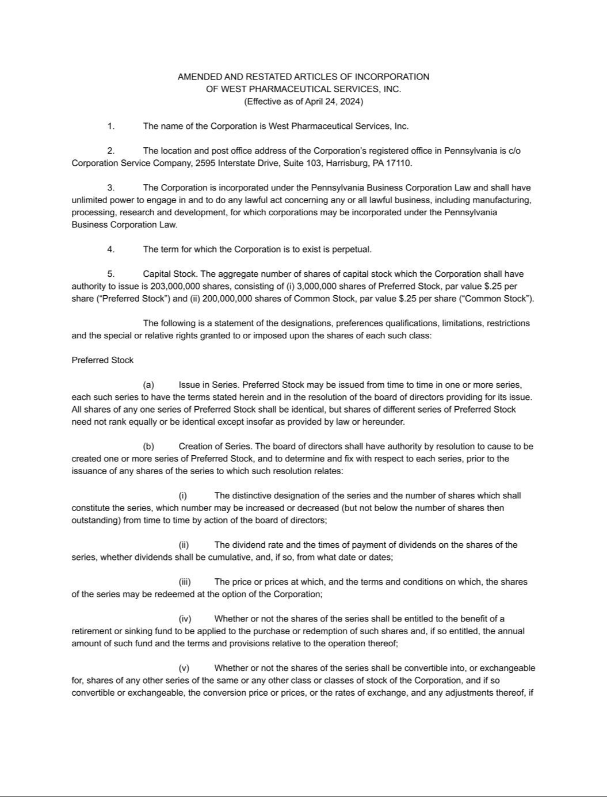

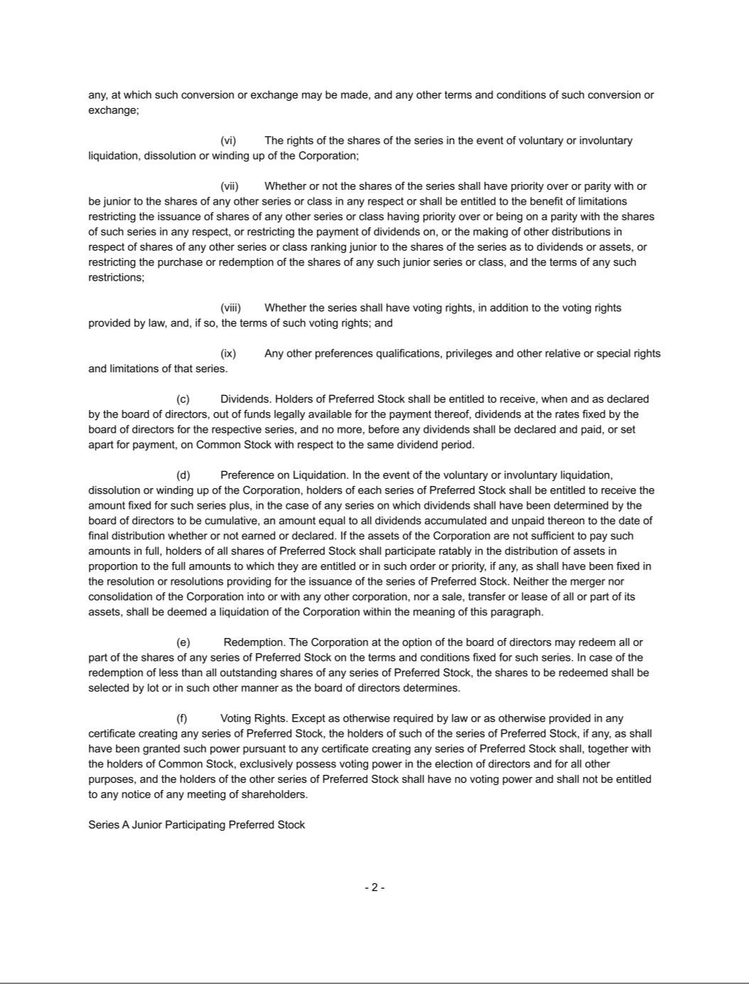

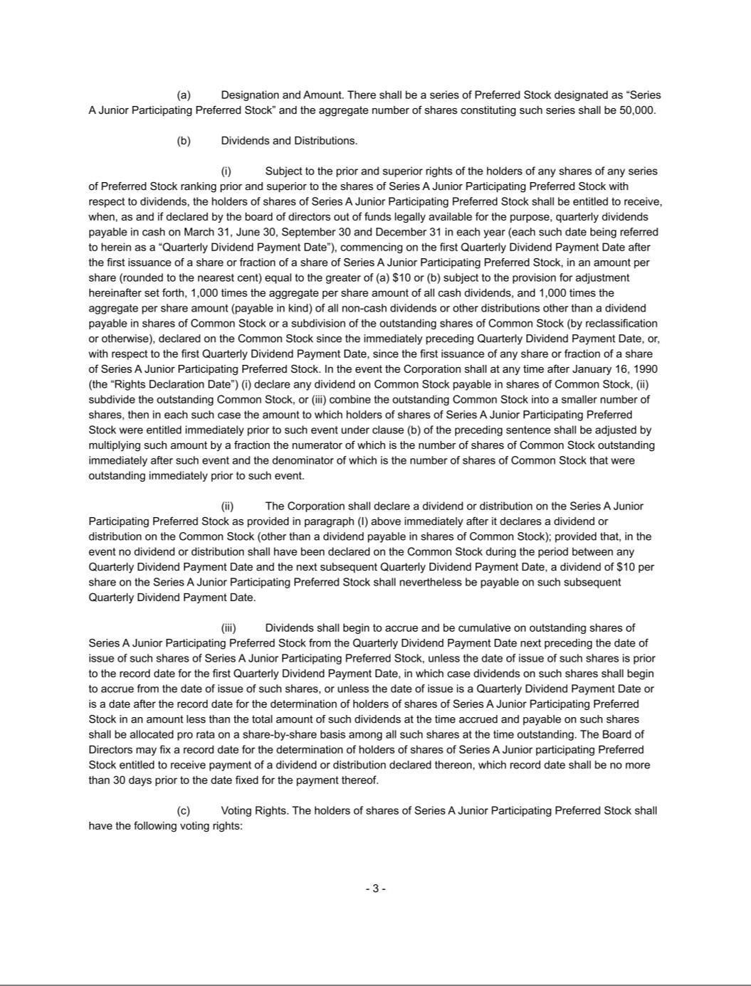

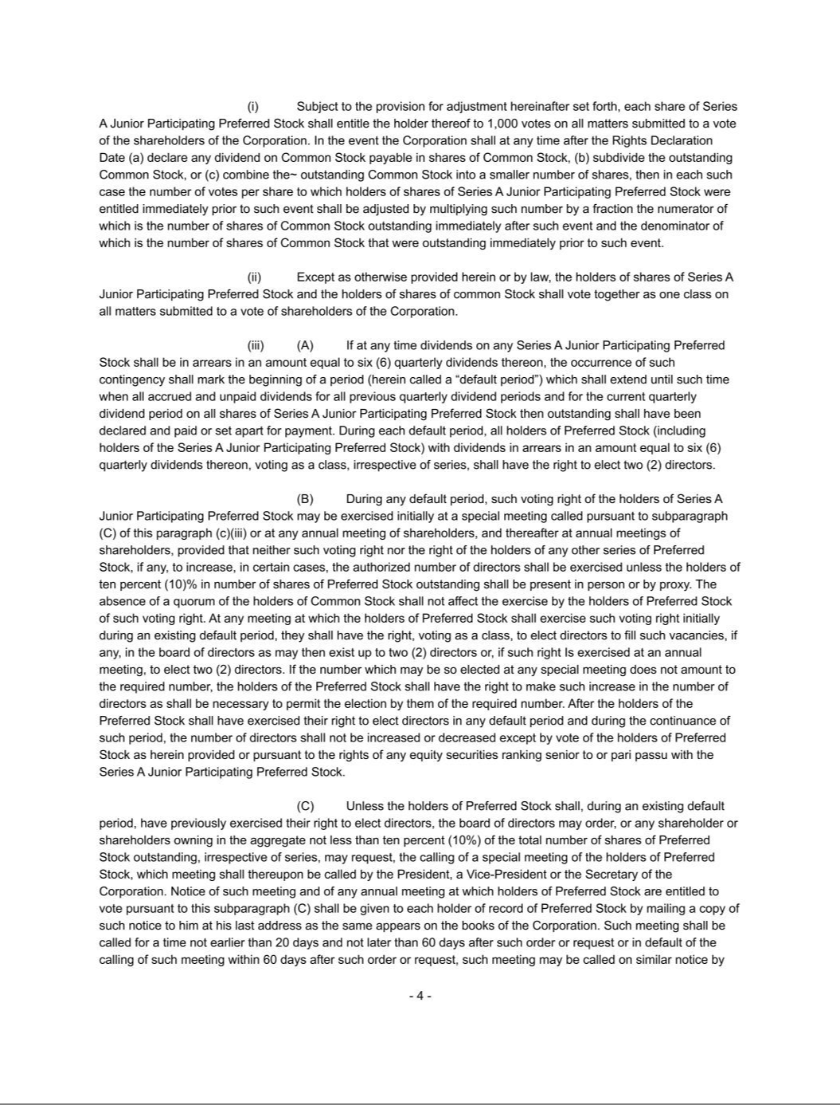

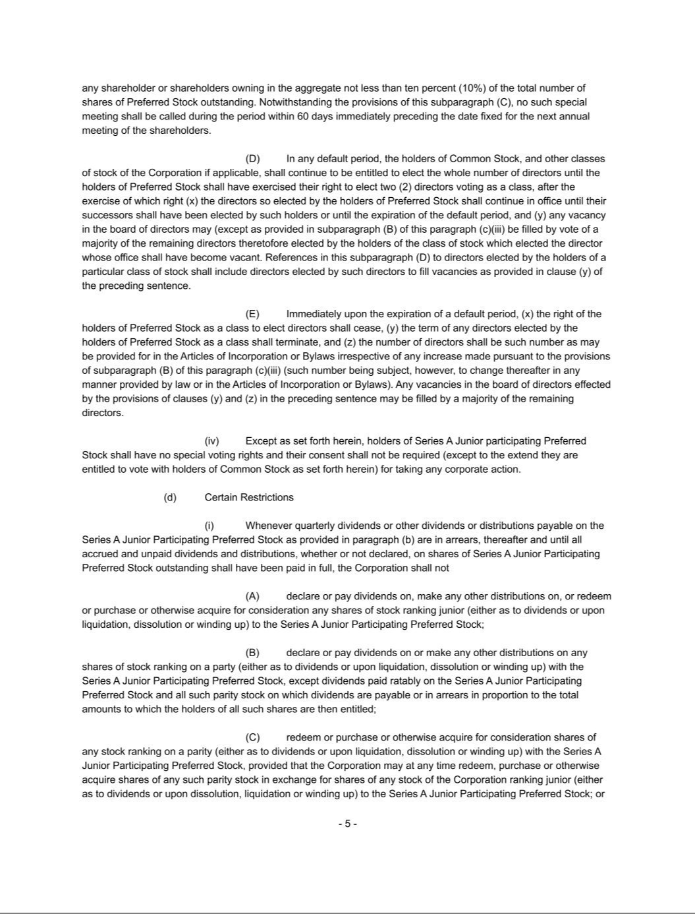

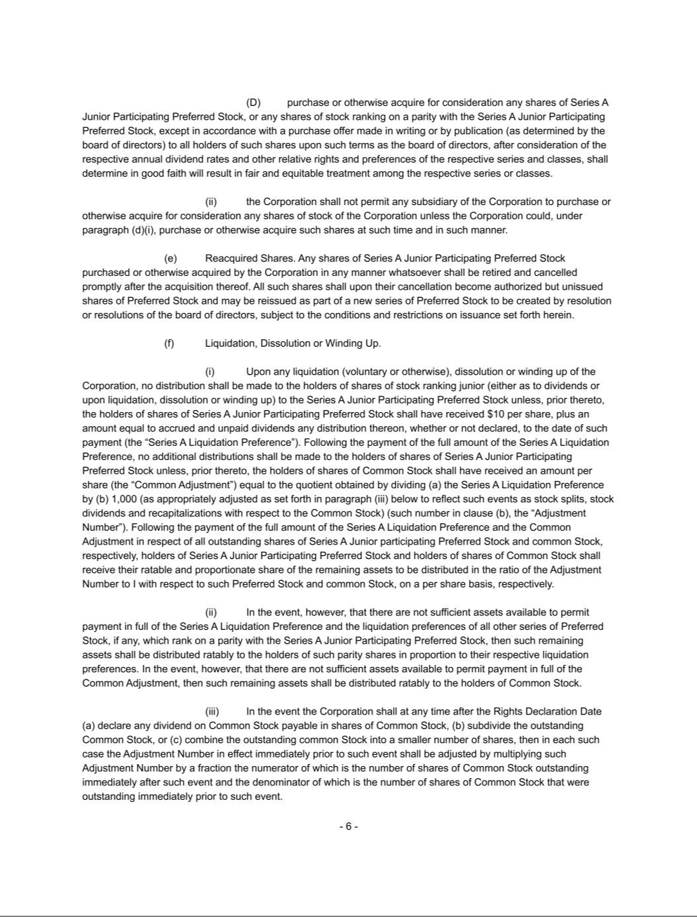

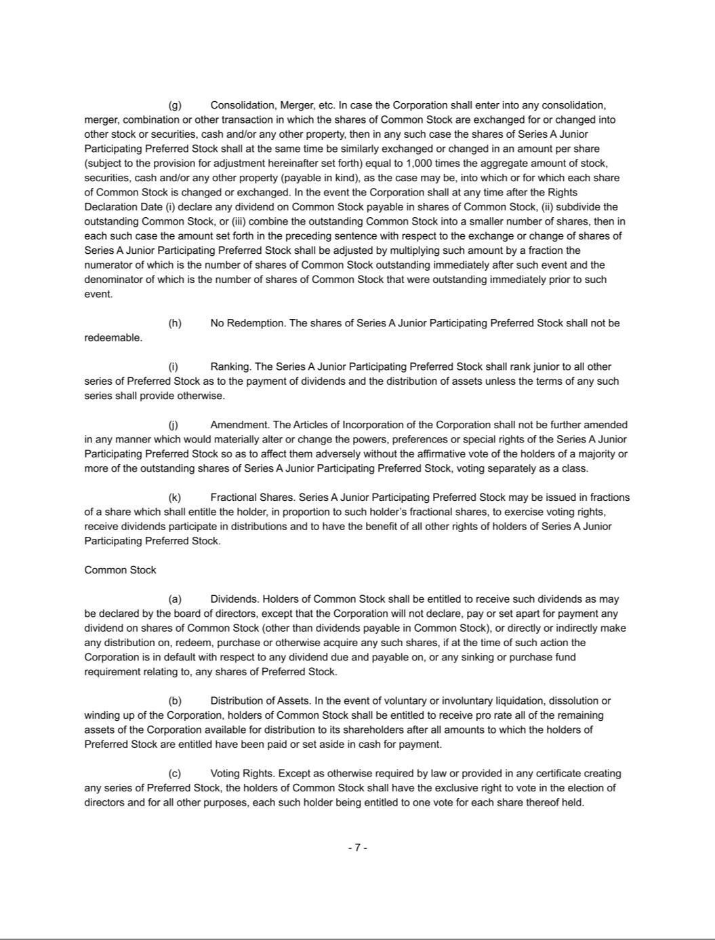

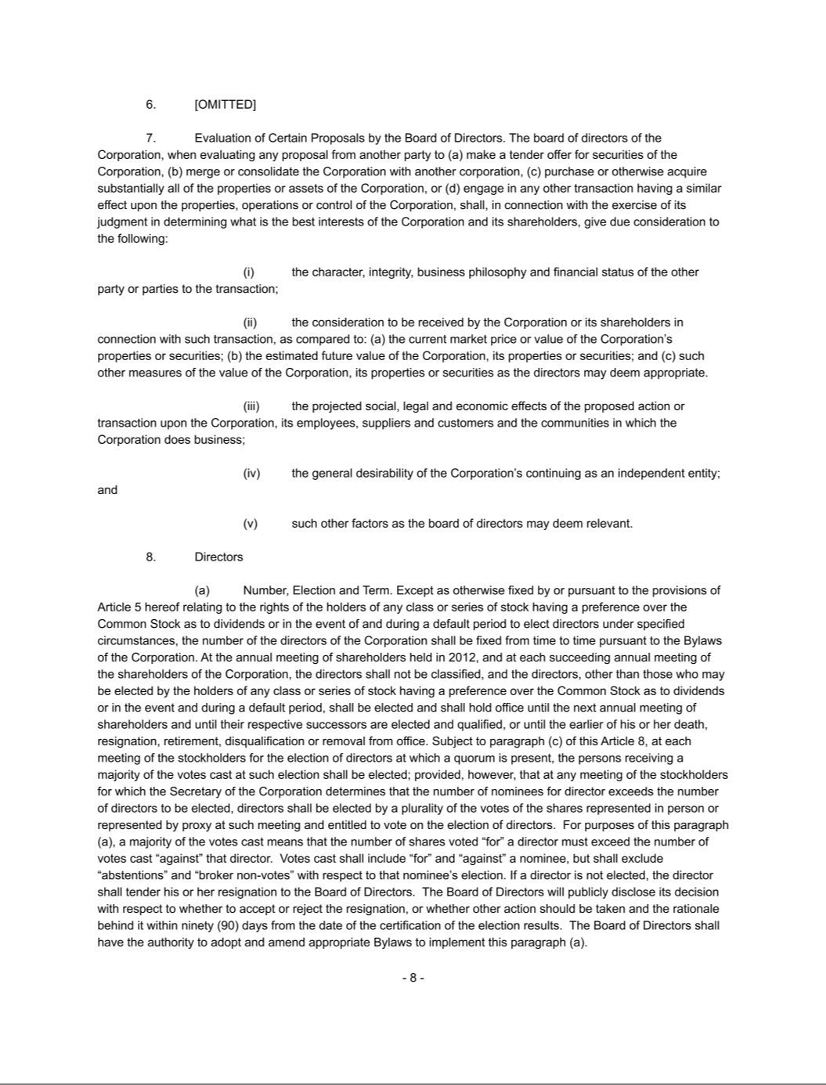

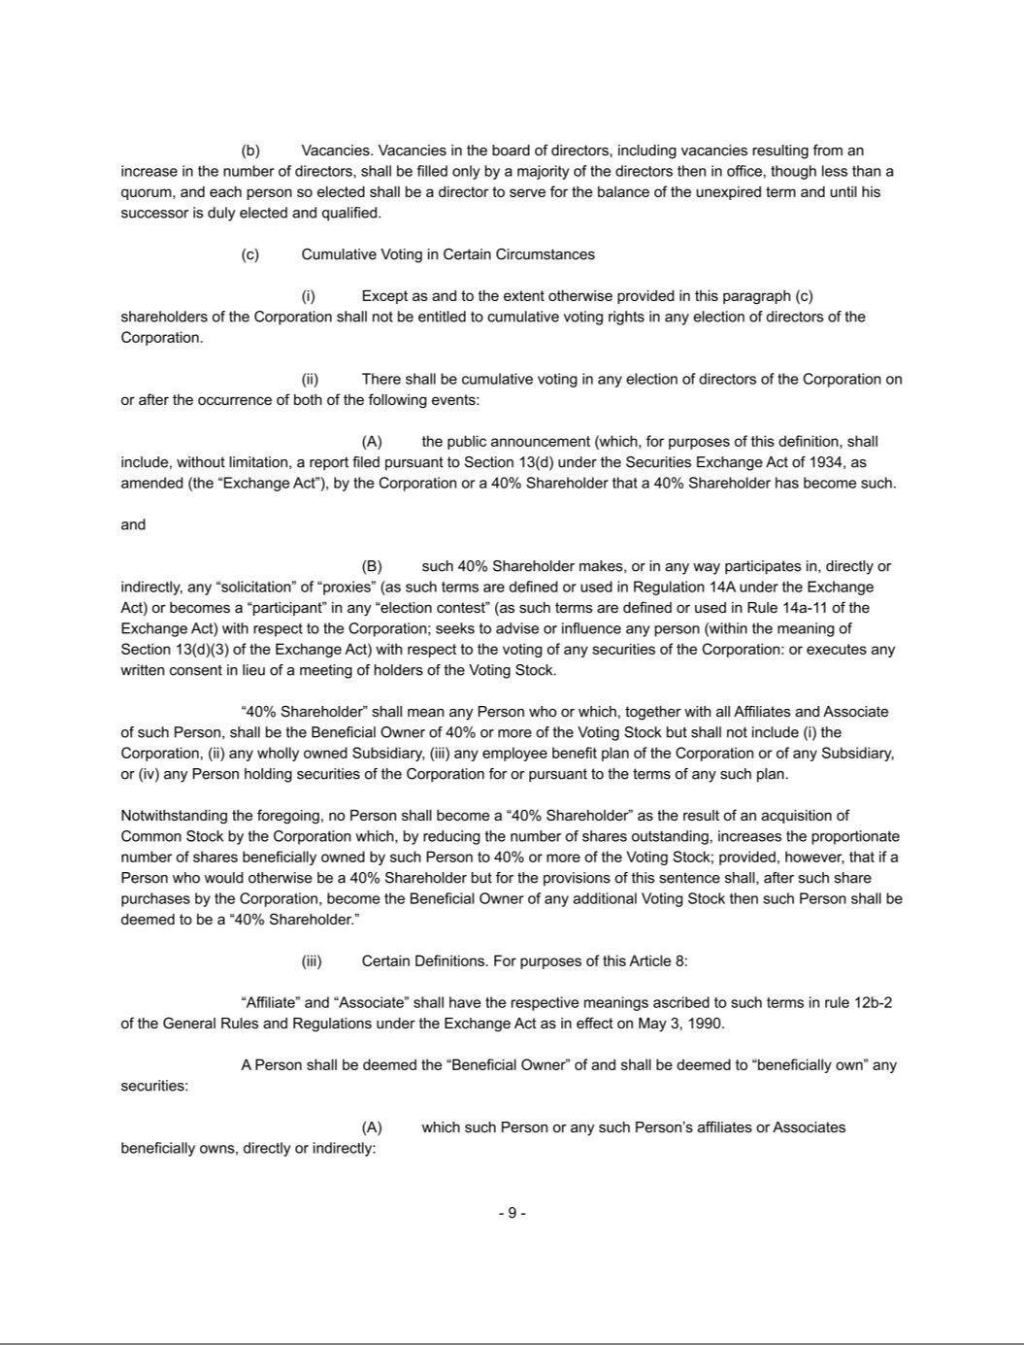

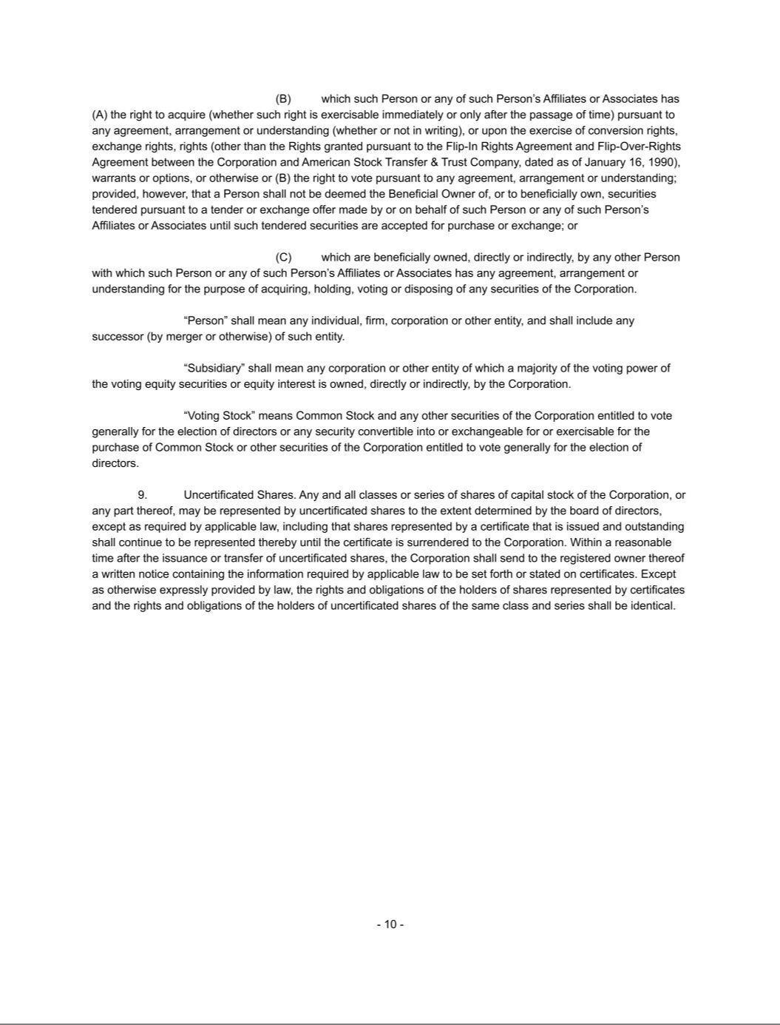

EXHIBIT 31.1

CERTIFICATION

I, Eric M. Green, certify that:

- I have reviewed this quarterly report on Form 10-Q of West Pharmaceutical Services, Inc.;

- Based on my knowledge, this report does not contain any untrue statement of a material fact or omit to state a material fact necessary to make the statements made, in light of the circumstances under which such statements were made, not misleading with respect to the period covered by this report;

- Based on my knowledge, the financial statements, and other financial information included in this report, fairly present in all material respects the financial condition, results of operations and cash flows of the registrant as of, and for, the periods presented in this report;

- The registrant's other certifying officer(s) and I are responsible for establishing and maintaining disclosure controls and procedures (as defined in Exchange Act Rules 13a-15(e) and 15d-15(e)) and internal control over financial reporting (as defined in Exchange Act Rules 13a-15(f) and 15d-15(f)) for the registrant and have:

  - Designed such disclosure controls and procedures, or caused such disclosure controls and procedures to be designed under our supervision, to ensure that material information relating to the registrant, including its consolidated subsidiaries, is made known to us by others within those entities, particularly during the period in which this report is being prepared;

  - Designed such internal control over financial reporting, or caused such internal control over financial reporting to be designed under our supervision, to provide reasonable assurance regarding the reliability of financial reporting and the preparation of financial statements for external purposes in accordance with generally accepted accounting principles;

  - Evaluated the effectiveness of the registrant's disclosure controls and procedures and presented in this report our conclusions about the effectiveness of the disclosure controls and procedures, as of the end of the period covered by this report based on such evaluation; and

  - Disclosed in this report any change in the registrant's internal control over financial reporting that occurred during the registrant's most recent fiscal quarter (the registrant's fourth fiscal quarter in the case of an annual report) that has materially affected, or is reasonably likely to materially affect, the registrant's internal control over financial reporting; and

- The registrant's other certifying officer(s) and I have disclosed, based on our most recent evaluation of internal control over financial reporting, to the registrant's auditors and the audit committee of the registrant's board of directors (or persons performing the equivalent functions):

  - All significant deficiencies and material weaknesses in the design or operation of internal control over financial reporting which are reasonably likely to adversely affect the registrant's ability to record, process, summarize and report financial information; and

  - Any fraud, whether or not material, that involves management or other employees who have a significant role in the registrant's internal control over financial reporting.

/s/ Eric M. Green

Eric M. Green

President and Chief Executive Officer, Chair of the Board of Directors

Date: July 25, 2024

EXHIBIT 31.2

CERTIFICATION

I, Bernard J. Birkett, certify that:

- I have reviewed this quarterly report on Form 10-Q of West Pharmaceutical Services, Inc.;

- Based on my knowledge, this report does not contain any untrue statement of a material fact or omit to state a material fact necessary to make the statements made, in light of the circumstances under which such statements were made, not misleading with respect to the period covered by this report;

- Based on my knowledge, the financial statements, and other financial information included in this report, fairly present in all material respects the financial condition, results of operations and cash flows of the registrant as of, and for, the periods presented in this report;

- The registrant's other certifying officer(s) and I are responsible for establishing and maintaining disclosure controls and procedures (as defined in Exchange Act Rules 13a-15(e) and 15d-15(e)) and internal control over financial reporting (as defined in Exchange Act Rules 13a-15(f) and 15d-15(f)) for the registrant and have:

  - Designed such disclosure controls and procedures, or caused such disclosure controls and procedures to be designed under our supervision, to ensure that material information relating to the registrant, including its consolidated subsidiaries, is made known to us by others within those entities, particularly during the period in which this report is being prepared;

  - Designed such internal control over financial reporting, or caused such internal control over financial reporting to be designed under our supervision, to provide reasonable assurance regarding the reliability of financial reporting and the preparation of financial statements for external purposes in accordance with generally accepted accounting principles;

  - Evaluated the effectiveness of the registrant's disclosure controls and procedures and presented in this report our conclusions about the effectiveness of the disclosure controls and procedures, as of the end of the period covered by this report based on such evaluation; and

  - Disclosed in this report any change in the registrant's internal control over financial reporting that occurred during the registrant's most recent fiscal quarter (the registrant's fourth fiscal quarter in the case of an annual report) that has materially affected, or is reasonably likely to materially affect, the registrant's internal control over financial reporting; and

- The registrant's other certifying officer(s) and I have disclosed, based on our most recent evaluation of internal control over financial reporting, to the registrant's auditors and the audit committee of the registrant's board of directors (or persons performing the equivalent functions):

  - All significant deficiencies and material weaknesses in the design or operation of internal control over financial reporting which are reasonably likely to adversely affect the registrant's ability to record, process, summarize and report financial information; and

  - Any fraud, whether or not material, that involves management or other employees who have a significant role in the registrant's internal control over financial reporting.

/s/ Bernard J. Birkett

Bernard J. Birkett

Senior Vice President, Chief Financial Officer

Date: July 25, 2024

EXHIBIT 32.1

CERTIFICATION PURSUANT TO 18 U.S.C. SECTION 1350

AS ADOPTED PURSUANT TO SECTION 906 OF

THE SARBANES-OXLEY ACT OF 2002

In connection with the Quarterly Report on Form 10-Q of West Pharmaceutical Services, Inc. (the “Company”) for the period ended June 30, 2024, as filed with the Securities and Exchange Commission on the date hereof (the “Report”), I, Eric M. Green, President and Chief Executive Officer, Chair of the Board of Directors of the Company, certify, pursuant to 18 U.S.C. Section 1350, as adopted pursuant to Section 906 of the Sarbanes-Oxley Act of 2002, that:

- The Report fully complies with the requirements of Section 13(a) or 15(d) of the Securities Exchange Act of 1934, as amended; and

- The information contained in the Report fairly presents, in all material respects, the financial condition and results of operations of the Company.

/s/ Eric M. Green

Eric M. Green

President and Chief Executive Officer, Chair of the Board of Directors

Date: July 25, 2024

EXHIBIT 32.2

CERTIFICATION PURSUANT TO 18 U.S.C. SECTION 1350

AS ADOPTED PURSUANT TO SECTION 906 OF

THE SARBANES-OXLEY ACT OF 2002

In connection with the Quarterly Report on Form 10-Q of West Pharmaceutical Services, Inc. (the “Company”) for the period ended June 30, 2024, as filed with the Securities and Exchange Commission on the date hereof (the “Report”), I, Bernard J. Birkett, Senior Vice President, Chief Financial Officer of the Company, certify, pursuant to 18 U.S.C. Section 1350, as adopted pursuant to Section 906 of the Sarbanes-Oxley Act of 2002, that:

- The Report fully complies with the requirements of Section 13(a) or 15(d) of the Securities Exchange Act of 1934, as amended; and

- The information contained in the Report fairly presents, in all material respects, the financial condition and results of operations of the Company.

/s/ Bernard J. Birkett

Bernard J. Birkett

Senior Vice President, Chief Financial Officer

Date: July 25, 2024

