UNITED STATES
SECURITIES AND EXCHANGE COMMISSION
Washington, D.C. 20549

FORM 8-K

CURRENT REPORT
Pursuant to Section 13 or 15(d) of The Securities Exchange Act of 1934

Date of Report (Date of earliest event reported) – July 23, 2026

WEST PHARMACEUTICAL SERVICES, INC.
(Exact name of registrant as specified in its charter)
Pennsylvania |  |  |  |  |  | 1-8036 |  |  |  |  |  | 23-1210010
(State or other jurisdiction  of incorporation) |  |  |  |  |  | (Commission File Number) |  |  |  |  |  | (IRS Employer  Identification No.)
530 Herman O. West Drive, Exton, PA |  |  |  |  |  |  |  |  |  |  |  | 19341-1147
(Address of principal executive offices) |  |  |  |  |  |  |  |  |  |  |  | (Zip Code)
Registrant’s telephone number, including area code: 610-594-2900
Not Applicable
(Former name or address, if changed since last report.)
Check the appropriate box below if the Form 8-K filing is intended to simultaneously satisfy the filing obligation of the registrant under any of the following provisions (see General Instruction A.2. below):
☐ |  |  | Written communications pursuant to Rule 425 under the Securities Act (17 CFR 230.425)
☐ |  |  | Soliciting material pursuant to Rule 14a-12 under the Exchange Act (17 CFR 240.14a-12)
☐ |  |  | Pre-commencement communications pursuant to Rule 14d-2(b) under the Exchange Act (17 CFR 240.14d-2(b))
☐ |  |  | Pre-commencement communications pursuant to Rule 13e-4(c) under the Exchange Act (17 CFR 240.13e-4(c))
Securities registered pursuant to Section 12(b) of the Act:
Title of each class |  |  | Trading Symbol |  |  | Name of each exchange on which registered
Common Stock, par value $0.25 per share |  |  | WST |  |  | New York Stock Exchange
Indicate by check mark whether the registrant is an emerging growth company as defined in Rule 405 of the Securities Act of 1933 (§230.405 of this chapter) or Rule 12b-2 of the Securities Exchange Act of 1934 (§240.12b-2 of this chapter).
Emerging growth company ☐
If an emerging growth company, indicate by check mark if the registrant has elected not to use the extended transition period for complying with any new or revised financial accounting standards provided pursuant to Section 13(a) of the Exchange Act. ☐

1

Item 2.02 Results of Operations and Financial Condition.
On July 23, 2026, West Pharmaceutical Services, Inc. (the “Company”) issued a press release announcing its second-quarter 2026 financial results. A copy of the press release is attached hereto as Exhibit 99.1 and incorporated herein by reference.
Item 7.01 Regulation FD Disclosure.
The information set forth in “Item 2.02 Results of Operations and Financial Condition,” including the exhibit referred to therein, is incorporated herein by reference.
A copy of the Company’s presentation materials used during the call will be available through the Investors link at the Company’s website, http://www.westpharma.com, and is also attached hereto as Exhibit 99.2 and incorporated herein by reference.
The information in this report (including the exhibits attached hereto) is being furnished pursuant to Item 2.02 and Item 7.01 and shall not be deemed “filed” for purposes of Section 18 of the Securities Exchange Act of 1934, as amended (“Exchange Act”), or otherwise subject to the liabilities of that section, nor will it be incorporated by reference in any filing under the Securities Act of 1933, as amended, or the Exchange Act, except as expressly set forth by specific referencing in such filing.
Item 9.01 Financial Statements and Exhibits.
(d) |  |  | Exhibit No. |  |  | Description
 |  |  | 99.1 |  |  | West Pharmaceutical Services, Inc. Press Release, dated July 23, 2026.
 |  |  | 99.2 |  |  | West Pharmaceutical Services, Inc. Presentation, dated July 23, 2026.
 |  |  | 104 |  |  | The cover page from the Company’s Current Report on Form 8-K, dated July 23, 2026, formatted in Inline XBRL.

2

SIGNATURE

Pursuant to the requirements of the Securities Exchange Act of 1934, the registrant has duly caused this report to be signed on its behalf by the undersigned hereunto duly authorized.

WEST PHARMACEUTICAL SERVICES, INC.
/s/ Robert W. McMahon
Robert W. McMahon
Senior Vice President, Chief Financial Officer
July 23, 2026

3

EXHIBIT INDEX

Exhibit No. |  |  |  |  |  | Description
99.1 |  |  |  |  |  | West Pharmaceutical Services, Inc. Press Release, dated July 23, 2026.
99.2 |  |  |  |  |  | West Pharmaceutical Services, Inc. Presentation, dated July 23, 2026.
104 |  |  |  |  |  | The cover page from the Company’s Current Report on Form 8-K, dated July 23, 2026, formatted in Inline XBRL.

4

Exhibit 99.1

West Reports Second-Quarter 2026 Results
Raising Full-Year Net Sales and EPS guidance

Exton, PA, July 23, 2026 – West Pharmaceutical Services, Inc. (NYSE: WST), a leading provider of innovative, high-quality injectable solutions and services, today announced its financial results for the second quarter of 2026.

Second-Quarter Summary (comparisons to prior-year period)
•Net sales of $872.3 million increased 13.8%; organic growth was 12.7%.
•Diluted earnings per share ("EPS") of $2.15 increased 18.1%.
•Adjusted-diluted EPS of $2.37 increased 28.8%.
•Operating cash flow was $213.9 million. Capital expenditures were $85.9 million. Free cash flow (defined as operating cash flow less capital expenditures) was $128.0 million.
•During the first six months of 2026, the Company repurchased 1.8 million shares for $454.3 million at an average price of $258.03 per share under its share repurchase program that was announced in mid-February 2026.
•The Company also announced on July 21, 2026 that its Board of Directors declared a third-quarter 2026 dividend of $0.22 per share.

Outlook for Full-Year and Third-Quarter 2026
•Full-year 2026 net sales are expected to be in the range of $3.345 billion to $3.380 billion, up 8.8% to 10.0% reported and up 10.0% to 11.0% organic.
•Full-year 2026 adjusted-diluted EPS guidance increased to a range of $8.85 to $9.05.
•Third-quarter 2026 net sales are expected to be in the range of $820 million to $835 million, up 1.9% to 3.8% reported and up 7.0% to 8.9% organic.
•Third-quarter 2026 adjusted-diluted EPS guidance is expected to be in the range of $2.14 to $2.24.

Eric M. Green, President, Chief Executive Officer and Chair of the Board, commented: “I am pleased to report strong second-quarter results, with net sales and adjusted EPS exceeding our expectations. Net sales increased 12.7% organically, driven by our High Value Product Components business which benefited from continued strength in Biologics, a favorable mix shift from HVP upgrades including Annex 1, and ongoing growth in GLP-1 elastomers. The robust sales growth drove strong operating income margin expansion as compared to prior year. As a result of our team's strong execution in the second quarter and improved outlook, we are increasing our full-year 2026 guidance.”

Proprietary Products Segment
Net sales of $722.6 million grew by 16.6% and increased 15.5% on an organic basis.

•High-Value Product ("HVP") Components net sales of $424.1 million increased 19.4% and rose 18.4% on an organic basis. HVP Components accounted for 49% of total company net sales in the quarter.
•HVP Delivery Devices net sales of $131.2 million increased by 29.6%, and were up 29.2% on an organic basis. HVP Delivery Devices accounted for 15% of total company net sales in the quarter.
•Standard Products net sales of $167.3 million increased by 2.4% and rose 0.7% on an organic basis. Standard Products accounted for 19% of total company net sales this quarter.

West Vantage Segment
Net sales of $149.7 million increased by 2.0% and rose 0.8% on an organic basis. West Vantage accounted for 17% of total company net sales in the quarter.

Full-Year 2026 Financial Guidance
•The Company is increasing its full-year 2026 net sales guidance range to $3.345 billion to $3.380 billion, up from $3.295 billion to $3.350 billion.
◦Reported net sales growth is anticipated to be in the range of 8.8% to 10.0%, and organic net sales growth is expected to be in the range of 10.0% to 11.0%.
◦Net sales guidance includes an estimated full-year 2026 benefit of approximately 1 percentage point based on current foreign currency exchange rates.
◦SmartDose® 3.5mL generated $55 million in net sales in the second half of 2025. These net sales are excluded going forward to calculate our organic net sales growth guidance.
•The Company is increasing its full-year 2026 adjusted-diluted EPS guidance range to $8.85 to $9.05, up from the previous range of $8.40 to $8.75.
•Capital spending guidance is unchanged from a range of $250 million to $275 million.

Third-Quarter 2026 Financial Guidance
•The Company is introducing its third-quarter 2026 net sales guidance range of $820 million to $835 million.
◦Reported net sales growth is anticipated to be in the range of 1.9% to 3.8%, and organic net sales growth is expected to be in the range of 7.0% to 8.9%.
◦Net sales guidance includes an estimated headwind of approximately 1 percentage point based on current foreign currency exchange rates.
◦SmartDose® 3.5mL generated $30 million in net sales in the third quarter of 2025. These net sales are excluded going forward to calculate our organic net sales growth guidance.
•The Company is introducing its third-quarter 2026 adjusted-diluted EPS guidance range of $2.14 to $2.24.

Second-Quarter 2026 Conference Call
Management will host a conference call at 8 a.m. EDT today. The live webcast can be accessed in the "Investors" section of the Company's website at https://investor.westpharma.com/.
To participate in the Q&A portion of the conference call, please register in advance at https://edge.media-server.com/mmc/p/g76vb8x6/.
Registered telephone participants will receive the dial-in number along with a unique PIN number that will enable them to ask questions on the call.
An accompanying slide presentation will be posted in the "Investors" section of the Company's website.
A replay of the webcast will be available on the Company's website for approximately 90 days after the event.
Investor Contact: |  |  | Media Contact:
John Sweeney, CFA |  |  | Michele Polinsky
Vice President, Investor Relations |  |  | Vice President, Global Communications
(484) 790-0373 |  |  | (610) 594-3054
John.Sweeney@westpharma.com |  |  | Michele.Polinsky@westpharma.com
About West
West Pharmaceutical Services, Inc. is a leading provider of innovative, high-quality injectable solutions and services. As a trusted partner to established and emerging drug developers, West helps ensure the safe, effective containment and delivery of life-saving and life-enhancing medicines for patients. With over 10,000 team members across 50 sites including 26 manufacturing facilities worldwide, West helps support our customers by delivering over 41 billion components and devices each year. Headquartered in Exton, Pennsylvania, West in its fiscal year 2025 generated $3.07 billion in net sales. West is traded on the New York Stock Exchange (NYSE: WST) and is included in the Standard & Poor's 500 index. For more information, visit www.westpharma.com.
All trademarks and registered trademarks used in this release are the property of West Pharmaceutical Services, Inc. or its subsidiaries, in the United States and other jurisdictions, unless otherwise noted.
Daikyo®, Daikyo Crystal Zenith® and Daikyo CZ® are registered trademarks of Daikyo Seiko, Ltd. Daikyo Crystal Zenith technologies are licensed from Daikyo Seiko, Ltd.

Forward-Looking Statements
This press release contains forward-looking statements within the meaning of the Private Securities Litigation Reform Act of 1995, including, but not limited to, statements regarding the Company's expectations regarding future events, financial guidance and financial or operational performance. Forward-looking statements may be identified by words such as "believe," "expect," "intend," "estimate," "plan," "anticipate," "project," "forecast," "guidance," "target," "may," "will," "continue" and similar expressions.
These statements are based on current expectations and assumptions and are subject to risks and uncertainties that could cause actual results to differ materially from those expressed or implied by such forward-looking statements. For additional information regarding these risks as well as other risks, uncertainties and factors that could affect our forward-looking statements, please refer to Part I Item 1A, entitled "Risk Factors," of the Company's most recent Annual Report on Form 10-K and any amendments thereto, as well as the Company's most recently filed Quarterly Reports on Form 10-Q and other filings the Company makes with the Securities and Exchange Commission.

Forward-looking statements speak only as of the date of this press release. Except as required by law or regulation, West Pharmaceutical Services, Inc. undertakes no obligation to update or revise any forward-looking statements, whether as a result of new information, future events or otherwise.

Non-U.S. GAAP Financial Measures
The Company reports its financial results in accordance with U.S. generally accepted accounting principles (“U.S. GAAP”). However, management also uses certain non-U.S. GAAP financial measures in evaluating our results of operations. Management believes that this information provides users with a valuable insight into our overall performance and financial position. As a result, this release contains certain non-GAAP financial measures, including organic net sales, adjusted-diluted EPS and adjusted operating profit. Organic net sales exclude the impact from acquisitions and/or divestitures and translate the current-period reported sales of subsidiaries whose functional currency is other than the U.S. Dollar at the applicable foreign currency exchange rates in effect during the comparable prior-year period. We may also refer to financial results, such as adjusted-diluted EPS and adjusted operating profit, that exclude the effects of unallocated items. The unallocated items are not representative of ongoing operations, and generally include restructuring and related charges, certain asset impairments, and other specifically identified income or expense items. These non-U.S. GAAP financial measures should be viewed in addition to, and not as an alternative for, the Company’s results prepared in accordance with U.S. GAAP. A reconciliation of these non-U.S. GAAP measures to the comparable U.S. GAAP financial measures is included in the accompanying tables.

WEST PHARMACEUTICAL SERVICES, INC.
CONSOLIDATED STATEMENTS OF INCOME
(UNAUDITED)
(in millions, except per share data)

 |  |  | Three Months Ended  June 30, |  |  |  |  |  |  |  |  |  |  |  |  |  |  |  |  |  |  |  |  |  |  |  | Six Months Ended  June 30,
 |  |  | 2026 |  |  |  |  |  |  |  |  |  |  |  | 2025 |  |  |  |  |  |  |  |  |  |  |  | 2026 |  |  |  |  |  |  |  |  |  |  |  | 2025
Net sales |  |  | $ | 872.3 |  |  |  |  | 100% |  |  |  |  |  | $ | 766.5 |  |  |  |  | 100% |  |  |  |  |  | $ | 1,717.2 |  |  |  |  | 100% |  |  |  |  |  | $ | 1,464.5 |  |  |  |  | 100%
Cost of goods and services sold |  |  | 543.1 |  |  |  |  |  | 62 |  |  |  |  |  | 492.6 |  |  |  |  |  | 64 |  |  |  |  |  | 1,091.6 |  |  |  |  |  | 64 |  |  |  |  |  | 958.7 |  |  |  |  |  | 65
Gross profit |  |  | 329.2 |  |  |  |  |  | 38 |  |  |  |  |  | 273.9 |  |  |  |  |  | 36 |  |  |  |  |  | 625.6 |  |  |  |  |  | 36 |  |  |  |  |  | 505.8 |  |  |  |  |  | 35
Research and development |  |  | 19.7 |  |  |  |  |  | 2 |  |  |  |  |  | 19.1 |  |  |  |  |  | 2 |  |  |  |  |  | 35.5 |  |  |  |  |  | 2 |  |  |  |  |  | 35.4 |  |  |  |  |  | 2
Selling, general and administrative expenses |  |  | 117.6 |  |  |  |  |  | 14 |  |  |  |  |  | 95.9 |  |  |  |  |  | 13 |  |  |  |  |  | 217.1 |  |  |  |  |  | 12 |  |  |  |  |  | 183.9 |  |  |  |  |  | 13
Other expense (income), net |  |  | 12.8 |  |  |  |  |  | 1 |  |  |  |  |  | 5.2 |  |  |  |  |  | 1 |  |  |  |  |  | 16.8 |  |  |  |  |  | 1 |  |  |  |  |  | 25.8 |  |  |  |  |  | 2
Operating profit |  |  | 179.1 |  |  |  |  |  | 21 |  |  |  |  |  | 153.7 |  |  |  |  |  | 20 |  |  |  |  |  | 356.2 |  |  |  |  |  | 21 |  |  |  |  |  | 260.7 |  |  |  |  |  | 18
Interest (income) expense, net |  |  | (1.2) |  |  |  |  |  | — |  |  |  |  |  | (3.5) |  |  |  |  |  | — |  |  |  |  |  | (4.4) |  |  |  |  |  | — |  |  |  |  |  | (7.2) |  |  |  |  |  | —
Other nonoperating expense (income) |  |  | 0.2 |  |  |  |  |  | — |  |  |  |  |  | 0.2 |  |  |  |  |  | — |  |  |  |  |  | 0.4 |  |  |  |  |  | — |  |  |  |  |  | 0.4 |  |  |  |  |  | —
Income before income taxes and equity in net income of affiliated companies |  |  | 180.1 |  |  |  |  |  | 21 |  |  |  |  |  | 157.0 |  |  |  |  |  | 20 |  |  |  |  |  | 360.2 |  |  |  |  |  | 21 |  |  |  |  |  | 267.5 |  |  |  |  |  | 18
Income tax expense |  |  | 32.2 |  |  |  |  |  | 4 |  |  |  |  |  | 30.2 |  |  |  |  |  | 4 |  |  |  |  |  | 76.9 |  |  |  |  |  | 4 |  |  |  |  |  | 54.3 |  |  |  |  |  | 4
Equity in net income of affiliated companies |  |  | (6.1) |  |  |  |  |  | (1) |  |  |  |  |  | (5.0) |  |  |  |  |  | (1) |  |  |  |  |  | (9.5) |  |  |  |  |  | — |  |  |  |  |  | (8.4) |  |  |  |  |  | (1)
Net income |  |  | $ | 154.0 |  |  |  |  | 18% |  |  |  |  |  | $ | 131.8 |  |  |  |  | 17% |  |  |  |  |  | $ | 292.8 |  |  |  |  | 17% |  |  |  |  |  | $ | 221.6 |  |  |  |  | 15%
Net income per share:
Basic |  |  | $ | 2.17 |  |  |  |  |  |  |  |  |  |  | $ | 1.82 |  |  |  |  |  |  |  |  |  |  | $ | 4.10 |  |  |  |  |  |  |  |  |  |  | $ | 3.06
Diluted |  |  | $ | 2.15 |  |  |  |  |  |  |  |  |  |  | $ | 1.82 |  |  |  |  |  |  |  |  |  |  | $ | 4.07 |  |  |  |  |  |  |  |  |  |  | $ | 3.05
Average common shares outstanding |  |  | 70.8 |  |  |  |  |  |  |  |  |  |  |  | 72.2 |  |  |  |  |  |  |  |  |  |  |  | 71.4 |  |  |  |  |  |  |  |  |  |  |  | 72.3
Average shares assuming dilution |  |  | 71.3 |  |  |  |  |  |  |  |  |  |  |  | 72.5 |  |  |  |  |  |  |  |  |  |  |  | 71.9 |  |  |  |  |  |  |  |  |  |  |  | 72.8

WEST PHARMACEUTICAL SERVICES
REPORTING SEGMENT INFORMATION
(UNAUDITED)
(in millions)

 |  |  | Three Months Ended  June 30, |  |  |  |  |  |  |  |  |  |  |  | Six Months Ended  June 30,
Net Sales: |  |  | 2026 |  |  |  |  |  | 2025 |  |  |  |  |  | 2026 |  |  |  |  |  | 2025
Proprietary Products |  |  | $ | 722.6 |  |  |  |  | $ | 619.8 |  |  |  |  | $ | 1,416.9 |  |  |  |  | $ | 1,182.8
West Vantage |  |  | 149.7 |  |  |  |  |  | 146.7 |  |  |  |  |  | 300.3 |  |  |  |  |  | 281.7
Consolidated Total |  |  | $ | 872.3 |  |  |  |  | $ | 766.5 |  |  |  |  | $ | 1,717.2 |  |  |  |  | $ | 1,464.5
Gross Profit:
Proprietary Products |  |  | $ | 308.0 |  |  |  |  | $ | 248.3 |  |  |  |  | $ | 581.1 |  |  |  |  | $ | 458.5
West Vantage |  |  | 21.2 |  |  |  |  |  | 25.6 |  |  |  |  |  | 44.5 |  |  |  |  |  | 47.3
Gross Profit |  |  | $ | 329.2 |  |  |  |  | $ | 273.9 |  |  |  |  | $ | 625.6 |  |  |  |  | $ | 505.8
Gross Profit Margin |  |  | 37.7 |  | % |  |  |  | 35.7 |  | % |  |  |  | 36.4 |  | % |  |  |  | 34.5 |  | %
Operating Profit (Loss):
Proprietary Products |  |  | $ | 211.9 |  |  |  |  | $ | 161.7 |  |  |  |  | $ | 401.1 |  |  |  |  | $ | 292.3
West Vantage |  |  | 12.9 |  |  |  |  |  | 17.8 |  |  |  |  |  | 28.5 |  |  |  |  |  | 31.3
Stock-based compensation expense |  |  | (10.9) |  |  |  |  |  | (7.4) |  |  |  |  |  | (17.5) |  |  |  |  |  | (8.7)
General corporate costs |  |  | (34.8) |  |  |  |  |  | (18.4) |  |  |  |  |  | (55.9) |  |  |  |  |  | (54.2)
Reported Operating Profit |  |  | $ | 179.1 |  |  |  |  | $ | 153.7 |  |  |  |  | $ | 356.2 |  |  |  |  | $ | 260.7
Reported Operating Profit Margin |  |  | 20.5 |  | % |  |  |  | 20.1 |  | % |  |  |  | 20.7 |  | % |  |  |  | 17.8 |  | %
Unallocated items |  |  | 18.3 |  |  |  |  |  | 1.6 |  |  |  |  |  | 22.2 |  |  |  |  |  | 19.6
Adjusted Operating Profit |  |  | $ | 197.4 |  |  |  |  | $ | 155.3 |  |  |  |  | $ | 378.4 |  |  |  |  | $ | 280.3
Adjusted Operating Profit Margin |  |  | 22.6 |  | % |  |  |  | 20.3 |  | % |  |  |  | 22.0 |  | % |  |  |  | 19.1 |  | %

WEST PHARMACEUTICAL SERVICES
RECONCILIATION OF NON-U.S. GAAP MEASURES (UNAUDITED)
Please refer to “Non-U.S. GAAP Financial Measures” for more information
(in millions, except per share data)

Reconciliation of Reported and Adjusted Operating Profit, Net Income and Diluted EPS
Three Months ended June 30, 2026 |  |  | Operating  profit |  |  |  |  |  | Income  tax  expense |  |  |  |  |  | Net  income |  |  |  |  |  | Diluted  EPS
Reported (U.S. GAAP) |  |  | $179.1 |  |  |  |  |  | $32.2 |  |  |  |  |  | $154.0 |  |  |  |  |  | $2.15
Unallocated Items:
Restructuring and other charges(1) |  |  | 1.5 |  |  |  |  |  | 0.3 |  |  |  |  |  | 1.2 |  |  |  |  |  | 0.02
M&A activities, including SmartDose® 3.5mL sale(2) |  |  | 6.4 |  |  |  |  |  | 1.5 |  |  |  |  |  | 4.9 |  |  |  |  |  | 0.07
Cost-method investment activity(3) |  |  | 3.5 |  |  |  |  |  | — |  |  |  |  |  | 3.5 |  |  |  |  |  | 0.05
Amortization of acquisition-related intangible assets(4) |  |  | — |  |  |  |  |  | — |  |  |  |  |  | 0.4 |  |  |  |  |  | —
Other(5) |  |  | 6.9 |  |  |  |  |  | 1.4 |  |  |  |  |  | 5.4 |  |  |  |  |  | 0.08
Adjusted (Non-U.S. GAAP) |  |  | $197.4 |  |  |  |  |  | $35.4 |  |  |  |  |  | $169.4 |  |  |  |  |  | $2.37

 | Six Months ended June 30, 2026 |  |  | Operating  profit |  |  |  |  |  | Income  tax  expense |  |  |  |  |  | Net  income |  |  |  |  |  | Diluted  EPS
 | Reported (U.S. GAAP) |  |  | $356.2 |  |  |  |  |  | $76.9 |  |  |  |  |  | $292.8 |  |  |  |  |  | $4.07
 | Unallocated Items:
 | Restructuring and other charges(1) |  |  | 2.9 |  |  |  |  |  | (11.3) |  |  |  |  |  | 14.2 |  |  |  |  |  | 0.20
 | M&A activities, including SmartDose® 3.5mL sale(2) |  |  | 8.3 |  |  |  |  |  | 1.9 |  |  |  |  |  | 6.4 |  |  |  |  |  | 0.09
 | Cost-method investment activity(3) |  |  | 3.5 |  |  |  |  |  | — |  |  |  |  |  | 3.5 |  |  |  |  |  | 0.05
 | Amortization of acquisition-related intangible assets(4) |  |  | — |  |  |  |  |  | — |  |  |  |  |  | 0.9 |  |  |  |  |  | 0.01
 | Other(5) |  |  | 7.5 |  |  |  |  |  | 1.6 |  |  |  |  |  | 5.9 |  |  |  |  |  | 0.08
 | Adjusted (Non-U.S. GAAP) |  |  | $378.4 |  |  |  |  |  | $69.1 |  |  |  |  |  | $323.7 |  |  |  |  |  | $4.50

Three Months ended June 30, 2025 |  |  | Operating  profit |  |  |  |  |  | Income  tax  expense |  |  |  |  |  | Net  income |  |  |  |  |  | Diluted  EPS
Reported (U.S. GAAP) |  |  | $153.7 |  |  |  |  |  | $30.2 |  |  |  |  |  | $131.8 |  |  |  |  |  | $1.82
Unallocated items:
Restructuring and other charges(1) |  |  | 1.6 |  |  |  |  |  | 0.4 |  |  |  |  |  | 1.2 |  |  |  |  |  | 0.02
Amortization of acquisition-related intangible assets(4) |  |  | — |  |  |  |  |  | — |  |  |  |  |  | 0.5 |  |  |  |  |  | —
Adjusted (Non-U.S. GAAP) |  |  | $155.3 |  |  |  |  |  | $30.6 |  |  |  |  |  | $133.5 |  |  |  |  |  | $1.84

 | Six Months ended June 30, 2025 |  |  | Operating  profit |  |  |  |  |  | Income  tax  expense |  |  |  |  |  | Net  income |  |  |  |  |  | Diluted  EPS
 | Reported (U.S. GAAP) |  |  | $260.7 |  |  |  |  |  | $54.3 |  |  |  |  |  | $221.6 |  |  |  |  |  | $3.05
 | Unallocated items:
 | Restructuring and other charges(1) |  |  | 19.4 |  |  |  |  |  | 2.4 |  |  |  |  |  | 17.0 |  |  |  |  |  | 0.23
 | Amortization of acquisition-related intangible assets(4) |  |  | 0.2 |  |  |  |  |  | — |  |  |  |  |  | 1.1 |  |  |  |  |  | 0.01
 | Adjusted (Non-U.S. GAAP) |  |  | $280.3 |  |  |  |  |  | $56.7 |  |  |  |  |  | $239.7 |  |  |  |  |  | $3.29

(1)During the three and six months ended June 30, 2026, the Company recorded pre-tax charges of $1.5 million and $2.9 million, respectively, related to our two existing restructuring programs: (i) $1.0 million and $1.9 million, respectively, within other expense (income), related to acceleration of depreciation and lease costs in connection with the Company's January 2025 restructuring plan and (ii) $0.5 million and $1.0 million, respectively, within selling, general and administrative expenses, for professional services relating to our 2024 plan to optimize the legal structure of the Company and its subsidiaries. In addition, we recorded a one-time tax cost of $12.0 million associated with an internal legal entity restructuring which occurred in the first quarter of 2026. During the three and six months ended June 30, 2025, the Company recorded pre-tax charges of $1.6 million and $19.4 million, respectively, related to our two existing restructuring programs: (i) $0.2 million and $16.6 million, respectively, within other expense (income), related to severance, acceleration of depreciation and lease costs in connection with the Company's January 2025 restructuring plan and (ii) $1.4 million and $2.8 million, respectively, within selling, general and administrative expenses, for professional services relating to our 2024 plan to optimize the legal structure of the Company and its subsidiaries. In addition, we recorded income tax charges of $2.0 million in the first quarter of 2025, related primarily to withholding tax and capital gains incurred in executing our plan to optimize our legal structure.
(2)During the three and six months ended June 30, 2026, the Company recorded pre-tax charges of $6.4 million and $8.3 million, respectively, related to M&A activities, including the Company's agreement to sell its SmartDose® 3.5mL On-Body Delivery System and associated facilities to AbbVie. The Company recorded $1.3 million and $2.2 million, respectively, of the charges within other expense (income), related to employee benefit costs in connection with the sale agreement. The Company recorded the remaining $5.1 million and $6.1 million, respectively, within selling, general and administrative expenses, relating to professional services in connection with the sale agreement and other M&A activities.
(3)During the three and six months ended June 30, 2026, the Company recorded cost-method investment impairment charges of $3.5 million within other expense (income).
(4)During the three and six months ended June 30, 2026, the Company recorded $0.4 million and $0.9 million, respectively, of amortization expense in association with an acquisition of increased ownership interest in Daikyo. During the three and six months ended June 30, 2025, the Company recorded $0.0 million and $0.2 million, respectively, of amortization expense within selling, general and administrative expenses associated with an intangible asset acquired during the second quarter of 2020. During the three and six months ended June 30, 2025, the Company recorded $0.5 million and $0.9 million, respectively, of amortization expense in association with an acquisition of increased ownership interest in Daikyo.

(5)Other includes nonrecurring professional fees associated with various items including certain legal matters and our cybersecurity incident from May 2026. These charges are recorded within selling, general and administrative expenses.

WEST PHARMACEUTICAL SERVICES
RECONCILIATION OF NON-U.S. GAAP FINANCIAL MEASURES (UNAUDITED)
Please refer to “Non-U.S. GAAP Financial Measures” for more information
(in millions, except per share data)

Reconciliation of Reported Net Sales to Organic Net Sales by Segment (6)
Three Months Ended  June 30, |  |  | Reported Net Sales (U.S. GAAP) |  |  |  |  |  |  |  |  |  | Percent Change |  |  |  |  |  |  |  | Impact of Currency |  |  | Organic Net Sales Growth Rate (Decline) (Non-U.S. GAAP) (6)
 |  |  | 2026 |  |  | 2025
Proprietary Products |  |  | $722.6 |  |  | $619.8 |  |  |  |  |  |  | 16.6 |  | % |  |  |  |  |  | 1.1 |  | % | 15.5 |  | %
West Vantage |  |  | 149.7 |  |  | 146.7 |  |  |  |  |  |  | 2.0 |  | % |  |  |  |  |  | 1.2 |  | % | 0.8 |  | %
Total |  |  | $872.3 |  |  | $766.5 |  |  |  |  |  |  | 13.8 |  | % |  |  |  |  |  | 1.1 |  | % | 12.7 |  | %

Six Months Ended  June 30, |  |  | Reported Net Sales (U.S. GAAP) |  |  |  |  |  |  |  |  |  | Percent Change |  |  |  |  |  |  |  | Impact of Currency |  |  | Organic Net Sales Growth Rate (Decline) (Non-U.S. GAAP) (6)
 |  |  | 2026 |  |  | 2025
Proprietary Products |  |  | $1,416.9 |  |  | $1,182.8 |  |  |  |  |  |  | 19.8 |  | % |  |  |  |  |  | 3.3 |  | % | 16.5 |  | %
West Vantage |  |  | 300.3 |  |  | 281.7 |  |  |  |  |  |  | 6.6 |  | % |  |  |  |  |  | 3.2 |  | % | 3.4 |  | %
Total |  |  | $1,717.2 |  |  | $1,464.5 |  |  |  |  |  |  | 17.3 |  | % |  |  |  |  |  | 3.4 |  | % | 13.9 |  | %

Reconciliation of Proprietary Products Segment Organic Net Sales by Product Category (6)
Three Months Ended  June 30, |  |  | Reported Net Sales (U.S. GAAP) |  |  |  |  |  |  |  |  |  | Percent Change |  |  |  |  |  |  |  | Impact of Currency |  |  | Organic Net Sales Growth Rate (Decline) (Non-U.S. GAAP) (6)
 |  |  | 2026 |  |  | 2025
HVP Components |  |  | $424.1 |  |  | $355.2 |  |  |  |  |  |  | 19.4 |  | % |  |  |  |  |  | 1.0 |  | % | 18.4 |  | %
HVP Delivery Devices |  |  | 131.2 |  |  | 101.2 |  |  |  |  |  |  | 29.6 |  | % |  |  |  |  |  | 0.4 |  | % | 29.2 |  | %
Standard Products |  |  | 167.3 |  |  | 163.4 |  |  |  |  |  |  | 2.4 |  | % |  |  |  |  |  | 1.7 |  | % | 0.7 |  | %
Total Proprietary Products |  |  | $722.6 |  |  | $619.8 |  |  |  |  |  |  | 16.6 |  | % |  |  |  |  |  | 1.1 |  | % | 15.5 |  | %

Six Months Ended  June 30, |  |  | Reported Net Sales (U.S. GAAP) |  |  |  |  |  |  |  |  |  | Percent Change |  |  |  |  |  |  |  | Impact of Currency |  |  | Organic Net Sales Growth Rate (Decline) (Non-U.S. GAAP) (6)
 |  |  | 2026 |  |  | 2025
HVP Components |  |  | $833.4 |  |  | $671.1 |  |  |  |  |  |  | 24.2 |  | % |  |  |  |  |  | 3.8 |  | % | 20.4 |  | %
HVP Delivery Devices |  |  | 254.8 |  |  | 197.0 |  |  |  |  |  |  | 29.3 |  | % |  |  |  |  |  | 1.0 |  | % | 28.3 |  | %
Standard Products |  |  | 328.7 |  |  | 314.7 |  |  |  |  |  |  | 4.4 |  | % |  |  |  |  |  | 3.8 |  | % | 0.6 |  | %
Total Proprietary Products |  |  | $1,416.9 |  |  | $1,182.8 |  |  |  |  |  |  | 19.8 |  | % |  |  |  |  |  | 3.3 |  | % | 16.5 |  | %

Reconciliation of Proprietary Products Segment Organic Net Sales by Market Group (6)
Three Months Ended  June 30, |  |  | Reported Net Sales (U.S. GAAP) |  |  |  |  |  |  |  |  |  | Percent Change |  |  |  |  |  |  |  | Impact of Currency |  |  | Organic Net Sales Growth Rate (Decline) (Non-U.S. GAAP) (6)
 |  |  | 2026 |  |  | 2025
Biologics |  |  | $374.8 |  |  | $287.7 |  |  |  |  |  |  | 30.3 |  | % |  |  |  |  |  | 1.1 |  | % | 29.2 |  | %
Pharma |  |  | 205.0 |  |  | 198.5 |  |  |  |  |  |  | 3.3 |  | % |  |  |  |  |  | 1.7 |  | % | 1.6 |  | %
Generics |  |  | 142.8 |  |  | 133.6 |  |  |  |  |  |  | 6.9 |  | % |  |  |  |  |  | 0.2 |  | % | 6.7 |  | %
Total Proprietary Products |  |  | $722.6 |  |  | $619.8 |  |  |  |  |  |  | 16.6 |  | % |  |  |  |  |  | 1.1 |  | % | 15.5 |  | %

Six Months Ended  June 30, |  |  | Reported Net Sales (U.S. GAAP) |  |  |  |  |  |  |  |  |  | Percent Change |  |  |  |  |  |  |  | Impact of Currency |  |  | Organic Net Sales Growth Rate (Decline) (Non-U.S. GAAP) (6)
 |  |  | 2026 |  |  | 2025
Biologics |  |  | $729.3 |  |  | $557.0 |  |  |  |  |  |  | 30.9 |  | % |  |  |  |  |  | 3.3 |  | % | 27.6 |  | %
Pharma |  |  | 415.6 |  |  | 379.1 |  |  |  |  |  |  | 9.6 |  | % |  |  |  |  |  | 4.1 |  | % | 5.5 |  | %
Generics |  |  | 272.0 |  |  | 246.7 |  |  |  |  |  |  | 10.3 |  | % |  |  |  |  |  | 2.2 |  | % | 8.1 |  | %
Total Proprietary Products |  |  | $1,416.9 |  |  | $1,182.8 |  |  |  |  |  |  | 19.8 |  | % |  |  |  |  |  | 3.3 |  | % | 16.5 |  | %

Reconciliation of Reported Net Sales to Organic Net Sales by Geography (6)
Three Months Ended  June 30, |  |  | Reported Net Sales (U.S. GAAP) |  |  |  |  |  |  |  |  |  | Percent Change |  |  |  |  |  |  |  | Impact of Currency |  |  | Organic Net Sales Growth Rate (Decline) (Non-U.S. GAAP) (6)
 |  |  | 2026 |  |  | 2025
Americas |  |  | $388.7 |  |  | $349.7 |  |  |  |  |  |  | 11.2 |  | % |  |  |  |  |  | 0.6 |  | % | 10.6 |  | %
Europe, Middle East, Africa |  |  | 399.8 |  |  | 349.7 |  |  |  |  |  |  | 14.3 |  | % |  |  |  |  |  | 2.2 |  | % | 12.1 |  | %
Asia Pacific |  |  | 83.8 |  |  | 67.1 |  |  |  |  |  |  | 24.9 |  | % |  |  |  |  |  | (2.1) |  | % | 27.0 |  | %
Total |  |  | $872.3 |  |  | $766.5 |  |  |  |  |  |  | 13.8 |  | % |  |  |  |  |  | 1.1 |  | % | 12.7 |  | %

Six Months Ended  June 30, |  |  | Reported Net Sales (U.S. GAAP) |  |  |  |  |  |  |  |  |  | Percent Change |  |  |  |  |  |  |  | Impact of Currency |  |  | Organic Net Sales Growth Rate (Decline) (Non-U.S. GAAP) (6)
 |  |  | 2026 |  |  | 2025
Americas |  |  | $766.0 |  |  | $688.6 |  |  |  |  |  |  | 11.2 |  | % |  |  |  |  |  | 0.5 |  | % | 10.7 |  | %
Europe, Middle East, Africa |  |  | 799.2 |  |  | 656.6 |  |  |  |  |  |  | 21.7 |  | % |  |  |  |  |  | 6.9 |  | % | 14.8 |  | %
Asia Pacific |  |  | 152.0 |  |  | 119.3 |  |  |  |  |  |  | 27.4 |  | % |  |  |  |  |  | (0.6) |  | % | 28.0 |  | %
Total |  |  | $1,717.2 |  |  | $1,464.5 |  |  |  |  |  |  | 17.3 |  | % |  |  |  |  |  | 3.4 |  | % | 13.9 |  | %

(6)Organic net sales exclude the impact from acquisitions and/or divestitures and translate the current-period reported sales of subsidiaries whose functional currency is other than the U.S. Dollar at the applicable foreign currency exchange rates in effect during the comparable prior-year period.

WEST PHARMACEUTICAL SERVICES
RECONCILIATION OF NON-U.S. GAAP FINANCIAL MEASURES (UNAUDITED)
Please refer to “Non-U.S. GAAP Financial Measures” for more information
(in millions, except per share data)

Reconciliation of Reported-Diluted EPS Guidance to Adjusted-Diluted EPS Guidance

 |  |  | 2025 Actual |  |  |  |  |  | 2026 Guidance |  |  |  |  |  | % Change
Reported-diluted EPS (U.S. GAAP) |  |  | $6.79 |  |  |  |  |  | $9.01 to $9.26 |  |  |  |  |  | 32.7% to 36.4%
Restructuring and other charges |  |  | 0.31 |  |  |  |  |  | 0.23
M&A activities, including SmartDose® 3.5mL sale |  |  | 0.09 |  |  |  |  |  | (0.54) to (0.59)
Cost-method investment activity |  |  | 0.06 |  |  |  |  |  | 0.05
Amortization of acquisition-related intangible assets |  |  | 0.03 |  |  |  |  |  | 0.02
Other |  |  | 0.01 |  |  |  |  |  | 0.08
Adjusted-diluted EPS (Non-U.S. GAAP) |  |  | $7.29 |  |  |  |  |  | $8.85 to $9.05 |  |  |  |  |  | 21.4% to 24.1%

WEST PHARMACEUTICAL SERVICES
CONDENSED CONSOLIDATED BALANCE SHEETS (UNAUDITED)
(in millions, except per share data) |  |  | June 30,  2026 |  |  |  |  |  | December 31,  2025
ASSETS
Current assets:
Cash and cash equivalents |  |  | $ | 435.8 |  |  |  |  | $ | 791.3
Accounts receivable, net |  |  | 712.0 |  |  |  |  |  | 574.4
Inventories |  |  | 447.4 |  |  |  |  |  | 443.9
Other current assets |  |  | 212.3 |  |  |  |  |  | 168.6
Total current assets |  |  | 1,807.5 |  |  |  |  |  | 1,978.2
Property, plant and equipment |  |  | 3,248.6 |  |  |  |  |  | 3,223.4
Less: accumulated depreciation and amortization |  |  | 1,562.3 |  |  |  |  |  | 1,497.0
Property, plant and equipment, net |  |  | 1,686.3 |  |  |  |  |  | 1,726.4
Operating lease right-of-use assets |  |  | 104.7 |  |  |  |  |  | 117.0
Investments in affiliated companies |  |  | 207.7 |  |  |  |  |  | 212.3
Goodwill |  |  | 108.7 |  |  |  |  |  | 109.9
Intangible assets, net |  |  | 6.4 |  |  |  |  |  | 7.7
Deferred income taxes |  |  | 72.3 |  |  |  |  |  | 38.4
Other noncurrent assets |  |  | 82.8 |  |  |  |  |  | 80.1
Total Assets |  |  | $ | 4,076.4 |  |  |  |  | $ | 4,270.0
LIABILITIES AND EQUITY
Current liabilities:
Accounts payable |  |  | $ | 252.7 |  |  |  |  | $ | 253.7
Accrued salaries, wages and benefits |  |  | 97.1 |  |  |  |  |  | 135.9
Income taxes payable |  |  | 64.7 |  |  |  |  |  | 28.1
Operating lease liabilities |  |  | 20.9 |  |  |  |  |  | 22.7
Accrued commissions, rebates and royalties |  |  | 34.0 |  |  |  |  |  | 39.2
Other current liabilities |  |  | 171.1 |  |  |  |  |  | 175.3
Total current liabilities |  |  | 640.5 |  |  |  |  |  | 654.9
Long-term debt |  |  | 202.9 |  |  |  |  |  | 202.8
Deferred income taxes |  |  | 22.4 |  |  |  |  |  | 23.0
Pension and other postretirement benefits |  |  | 28.3 |  |  |  |  |  | 29.0
Operating lease liabilities |  |  | 88.3 |  |  |  |  |  | 95.6
Deferred compensation benefits |  |  | 13.9 |  |  |  |  |  | 13.5
Other long-term liabilities |  |  | 89.9 |  |  |  |  |  | 75.2
Total Liabilities |  |  | 1,086.2 |  |  |  |  |  | 1,094.0
Equity:
Preferred stock, 3.0 million shares authorized; 0 shares issued and outstanding |  |  | — |  |  |  |  |  | —
Common stock, par value $0.25 per share; 200.0 million shares authorized; shares issued: June 30, 2026 - 75.3 million, December 31, 2025 - 75.3 million; shares outstanding: June 30, 2026 - 70.4 million, December 31, 2025 - 72.0 million |  |  | 18.8 |  |  |  |  |  | 18.8
Capital in excess of par value |  |  | — |  |  |  |  |  | —
Retained earnings |  |  | 4,624.1 |  |  |  |  |  | 4,374.9
Accumulated other comprehensive loss |  |  | (140.4) |  |  |  |  |  | (105.5)
Treasury stock, at cost (June 30, 2026 - 4.9 million shares, December 31, 2025 - 3.3 million shares) |  |  | (1,512.3) |  |  |  |  |  | (1,112.2)
Total Equity |  |  | 2,990.2 |  |  |  |  |  | 3,176.0
Total Liabilities and Equity |  |  | $ | 4,076.4 |  |  |  |  | $ | 4,270.0

WEST PHARMACEUTICAL SERVICES
CONDENSED CONSOLIDATED STATEMENTS OF CASH FLOWS (UNAUDITED)
(in millions)
Six Months Ended
June 30,
 |  |  | 2026 |  |  |  |  |  | 2025
Cash flows from operating activities:
Net income |  |  | $ | 292.8 |  |  |  |  | $ | 221.6
Adjustments to reconcile net income to net cash provided by operating activities:
Depreciation |  |  | 90.3 |  |  |  |  |  | 79.9
Amortization |  |  | 1.1 |  |  |  |  |  | 1.5
Stock-based compensation |  |  | 17.5 |  |  |  |  |  | 8.7
Non-cash restructuring charges |  |  | 1.9 |  |  |  |  |  | 1.6
Asset impairments |  |  | 4.2 |  |  |  |  |  | 4.1
Other non-cash items, net |  |  | (5.0) |  |  |  |  |  | (6.9)
Changes in assets and liabilities |  |  | (188.9) |  |  |  |  |  | (4.0)
Net cash provided by operating activities |  |  | 213.9 |  |  |  |  |  | 306.5
Cash flows from investing activities:
Capital expenditures |  |  | (85.9) |  |  |  |  |  | (146.5)
Net cash used in investing activities |  |  | (85.9) |  |  |  |  |  | (146.5)
Cash flows from financing activities:
Borrowings under revolving credit agreements |  |  | 50.0 |  |  |  |  |  | —
Repayments under revolving credit agreements |  |  | (50.0) |  |  |  |  |  | —
Principal repayments on finance leases |  |  | (0.7) |  |  |  |  |  | (0.5)
Excise tax payments |  |  | (0.8) |  |  |  |  |  | (4.2)
Dividend payments |  |  | (31.5) |  |  |  |  |  | (30.3)
Proceeds from stock-based compensation awards |  |  | 12.4 |  |  |  |  |  | 6.0
Employee stock purchase plan contributions |  |  | 3.9 |  |  |  |  |  | 3.6
Shares purchased under share repurchase programs |  |  | (454.3) |  |  |  |  |  | (134.0)
Shares repurchased for employee tax withholdings |  |  | (2.5) |  |  |  |  |  | (2.5)
Net cash used in financing activities |  |  | (473.5) |  |  |  |  |  | (161.9)
Effect of exchange rates on cash |  |  | (10.0) |  |  |  |  |  | 27.0
Net (decrease) increase in cash and cash equivalents |  |  | (355.5) |  |  |  |  |  | 25.1
Cash, including cash equivalents at beginning of period |  |  | 791.3 |  |  |  |  |  | 484.6
Cash, including cash equivalents at end of period |  |  | $ | 435.8 |  |  |  |  | $ | 509.7
Supplemental cash flow information:
Accrued capital expenditures |  |  | $ | 25.7 |  |  |  |  | $ | 35.4


West Pharmaceutical Services, Inc. Eric M. Green President & CEO, Chair of the Board Bob W. McMahon Senior VP & Chief Financial Officer Second-Quarter 2026 Earnings Call July 23, 2026 | 8 a.m. Eastern Time


2 West Analyst Conference Call July 23, 2026 8 a.m. Eastern Time These presentation materials are intended to accompany and serve as a reference for today’s press release announcing the Company’s results for the second-quarter 2026 and management’s discussion of those results during today’s conference call. A webcast of today’s call can be accessed in the “Investors” section of the Company’s website at www.investor.westpharma.com. To participate on the call by asking questions to Management, please register in advance by clicking here. Registered telephone participants will receive the dial-in number along with a unique PIN number that will enable them to ask questions on the call. A replay of the webcast will be available on the Company’s website for approximately 90 days after the event. REGISTER TODAY

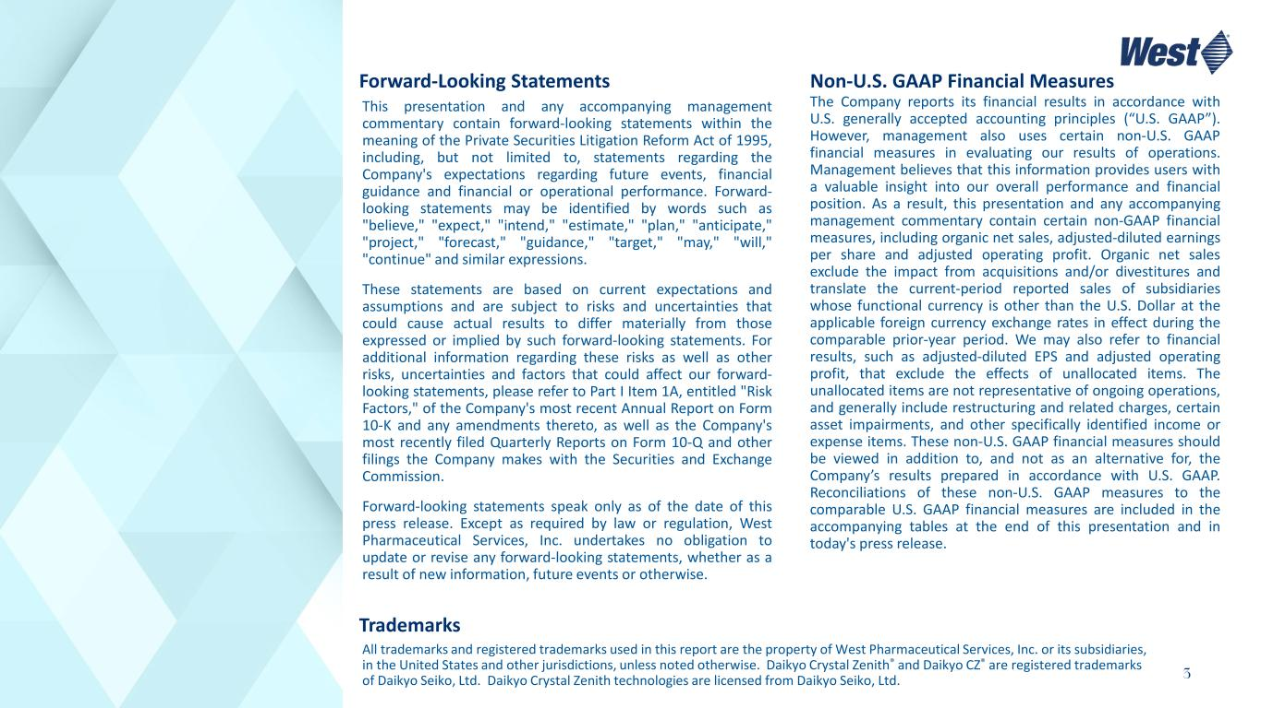
3 This presentation and any accompanying management commentary contain forward-looking statements within the meaning of the Private Securities Litigation Reform Act of 1995, including, but not limited to, statements regarding the Company's expectations regarding future events, financial guidance and financial or operational performance. Forward- looking statements may be identified by words such as "believe," "expect," "intend," "estimate," "plan," "anticipate," "project," "forecast," "guidance," "target," "may," "will," "continue" and similar expressions. These statements are based on current expectations and assumptions and are subject to risks and uncertainties that could cause actual results to differ materially from those expressed or implied by such forward-looking statements. For additional information regarding these risks as well as other risks, uncertainties and factors that could affect our forward- looking statements, please refer to Part I Item 1A, entitled "Risk Factors," of the Company's most recent Annual Report on Form 10-K and any amendments thereto, as well as the Company's most recently filed Quarterly Reports on Form 10-Q and other filings the Company makes with the Securities and Exchange Commission. Forward-looking statements speak only as of the date of this press release. Except as required by law or regulation, West Pharmaceutical Services, Inc. undertakes no obligation to update or revise any forward-looking statements, whether as a result of new information, future events or otherwise. The Company reports its financial results in accordance with U.S. generally accepted accounting principles (“U.S. GAAP”). However, management also uses certain non-U.S. GAAP financial measures in evaluating our results of operations. Management believes that this information provides users with a valuable insight into our overall performance and financial position. As a result, this presentation and any accompanying management commentary contain certain non-GAAP financial measures, including organic net sales, adjusted-diluted earnings per share and adjusted operating profit. Organic net sales exclude the impact from acquisitions and/or divestitures and translate the current-period reported sales of subsidiaries whose functional currency is other than the U.S. Dollar at the applicable foreign currency exchange rates in effect during the comparable prior-year period. We may also refer to financial results, such as adjusted-diluted EPS and adjusted operating profit, that exclude the effects of unallocated items. The unallocated items are not representative of ongoing operations, and generally include restructuring and related charges, certain asset impairments, and other specifically identified income or expense items. These non-U.S. GAAP financial measures should be viewed in addition to, and not as an alternative for, the Company’s results prepared in accordance with U.S. GAAP. Reconciliations of these non-U.S. GAAP measures to the comparable U.S. GAAP financial measures are included in the accompanying tables at the end of this presentation and in today's press release. Forward-Looking Statements Non-U.S. GAAP Financial Measures All trademarks and registered trademarks used in this report are the property of West Pharmaceutical Services, Inc. or its subsidiaries, in the United States and other jurisdictions, unless noted otherwise. Daikyo Crystal Zenith® and Daikyo CZ® are registered trademarks of Daikyo Seiko, Ltd. Daikyo Crystal Zenith technologies are licensed from Daikyo Seiko, Ltd. Trademarks

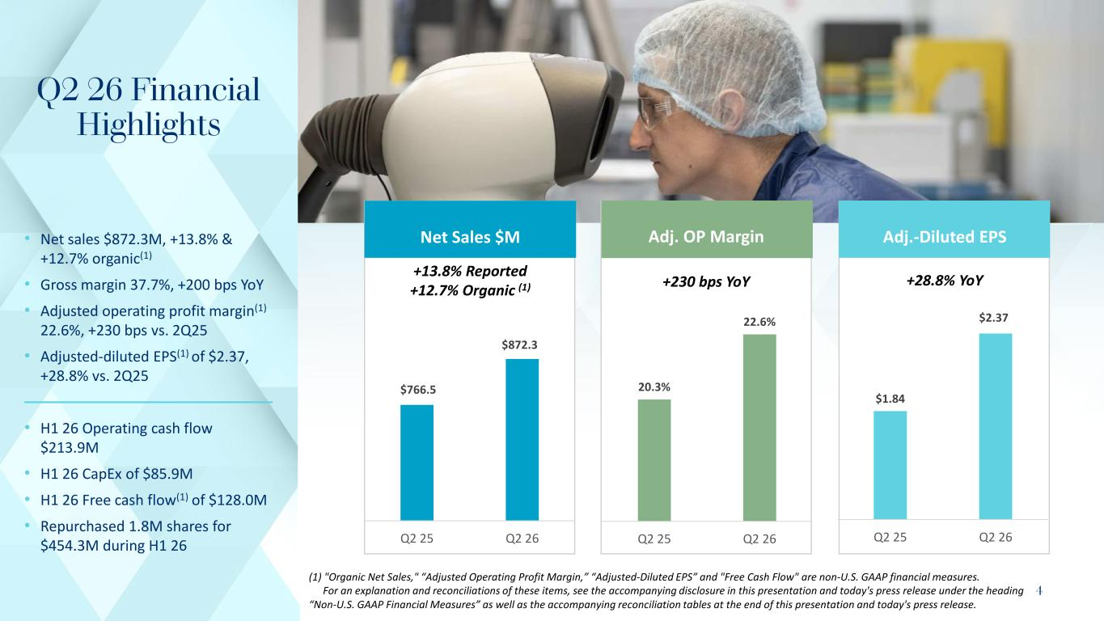
4 • Net sales $872.3M, +13.8% & +12.7% organic(1) • Gross margin 37.7%, +200 bps YoY​ • Adjusted operating profit margin(1) 22.6%, +230 bps vs. 2Q25 • Adjusted-diluted EPS(1) of $2.37, +28.8% vs. 2Q25 • H1 26 Operating cash flow $213.9M • H1 26 CapEx of $85.9M • H1 26 Free cash flow(1) of $128.0M • Repurchased 1.8M shares for $454.3M during H1 26 (1) "Organic Net Sales," “Adjusted Operating Profit Margin,” “Adjusted-Diluted EPS” and "Free Cash Flow" are non-U.S. GAAP financial measures. For an explanation and reconciliations of these items, see the accompanying disclosure in this presentation and today's press release under the heading “Non-U.S. GAAP Financial Measures” as well as the accompanying reconciliation tables at the end of this presentation and today's press release. Q2 26 Financial Highlights 20.3% 22.6% Q2 25 Q2 26 $1.84 $2.37 Q2 25 Q2 26 $766.5 $872.3 Q2 25 Q2 26 Net Sales $M Adj. OP Margin Adj.-Diluted EPS +28.8% YoY+230 bps YoY +13.8% Reported +12.7% Organic (1)

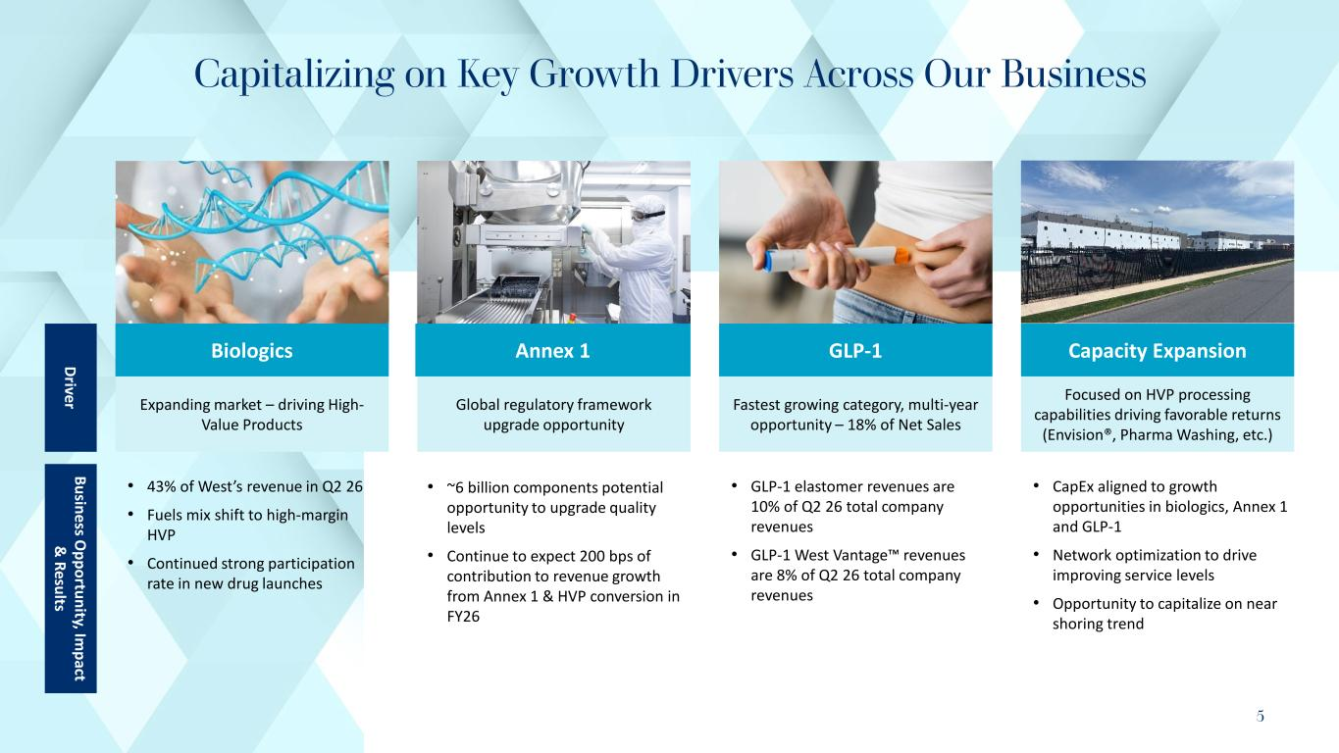
5 Capitalizing on Key Growth Drivers Across Our Business Biologics Expanding market – driving High- Value Products Global regulatory framework upgrade opportunity GLP-1 Fastest growing category, multi-year opportunity – 18% of Net Sales Capacity Expansion Focused on HVP processing capabilities driving favorable returns (Envision®, Pharma Washing, etc.) • 43% of West’s revenue in Q2 26 • Fuels mix shift to high-margin HVP • Continued strong participation rate in new drug launches • ~6 billion components potential opportunity to upgrade quality levels • Continue to expect 200 bps of contribution to revenue growth from Annex 1 & HVP conversion in FY26 • GLP-1 elastomer revenues are 10% of Q2 26 total company revenues • GLP-1 West Vantage revenues are 8% of Q2 26 total company revenues • CapEx aligned to growth opportunities in biologics, Annex 1 and GLP-1 • Network optimization to drive improving service levels • Opportunity to capitalize on near shoring trend Business O pportunity, Im pact & Results Driver Annex 1

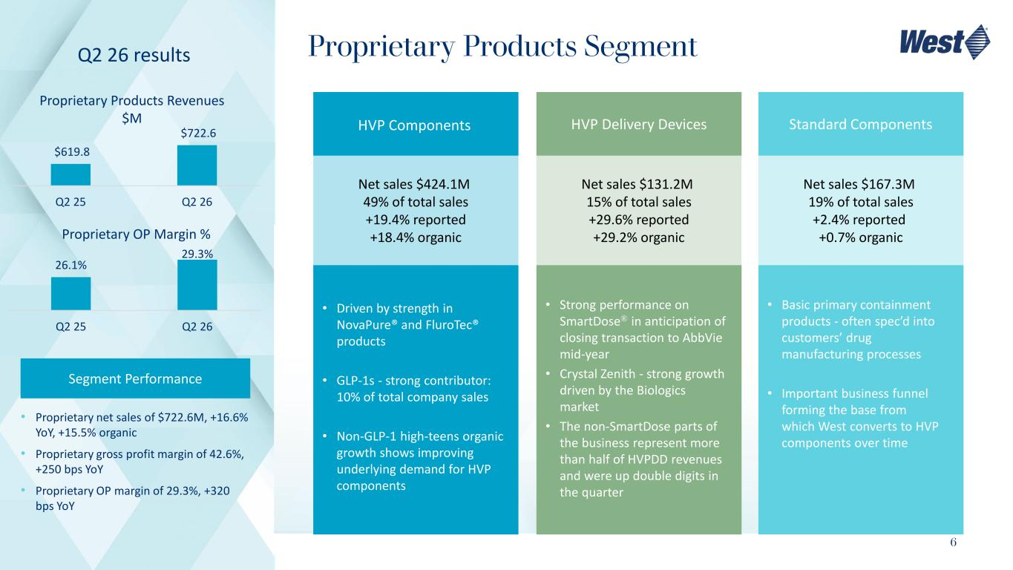
6 Proprietary Products Segment Segment Performance • Proprietary net sales of $722.6M, +16.6% YoY, +15.5% organic • Proprietary gross profit margin of 42.6%, +250 bps YoY • Proprietary OP margin of 29.3%, +320 bps YoY Proprietary Products Revenues $M $619.8 $722.6 Q2 25 Q2 26 Q2 26 results Proprietary OP Margin % 26.1% 29.3% Q2 25 Q2 26 Net sales $424.1M ​ 49% of total sales​ +19.4% reported​ +18.4% organic Net sales $131.2M ​ 15% of total sales​ +29.6% reported​ +29.2% organic Net sales $167.3M ​ 19% of total sales​ +2.4% reported ​ +0.7% organic • Driven by strength in NovaPure® and FluroTec® products • GLP-1s - strong contributor: 10% of total company sales • Non-GLP-1 high-teens organic growth shows improving underlying demand for HVP components​ • Strong performance on SmartDose® in anticipation of closing transaction to AbbVie mid-year • Crystal Zenith - strong growth driven by the Biologics market • The non-SmartDose parts of the business represent more than half of HVPDD revenues and were up double digits in the quarter • Basic primary containment products - often spec’d into customers’ drug manufacturing processes​ • Important business funnel forming the base from which West converts to HVP components over time​ HVP Components HVP Delivery Devices Standard Components

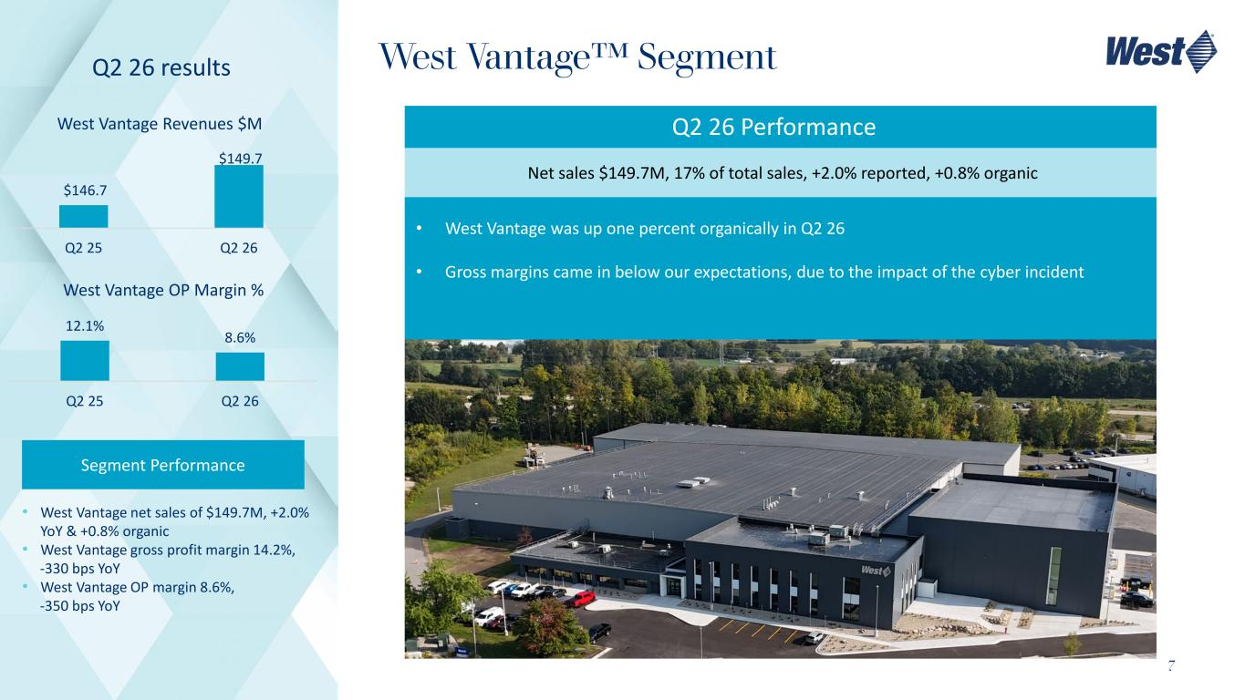
7 West Vantage Segment Segment Performance • West Vantage net sales of $149.7M, +2.0% YoY & +0.8% organic • West Vantage gross profit margin 14.2%, -330 bps YoY​ • West Vantage OP margin 8.6%, -350 bps YoY West Vantage Revenues $M $146.7 $149.7 Q2 25 Q2 26 Q2 26 results West Vantage OP Margin % 12.1% 8.6% Q2 25 Q2 26 Net sales $149.7M, 17% of total sales, +2.0% reported, +0.8% organic​ • West Vantage was up one percent organically in Q2 26 • Gross margins came in below our expectations, due to the impact of the cyber incident Q2 26 Performance

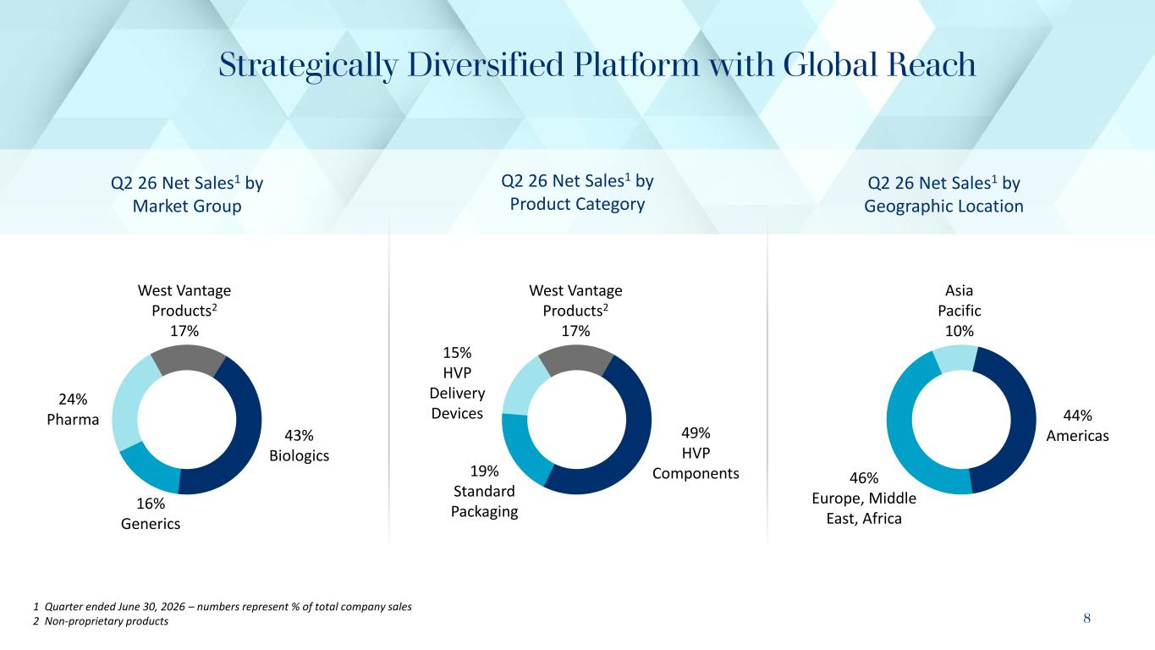
8 Strategically Diversified Platform with Global Reach 1 Quarter ended June 30, 2026 – numbers represent % of total company sales 2 Non-proprietary products 44% Americas 46% Europe, Middle East, Africa Asia Pacific 10% Q2 26 Net Sales1 by Geographic Location 49% HVP Components19% Standard Packaging 15% HVP Delivery Devices West Vantage Products2 17% Q2 26 Net Sales1 by Product Category 43% Biologics 16% Generics 24% Pharma Q2 26 Net Sales1 by Market Group West Vantage Products2 17%

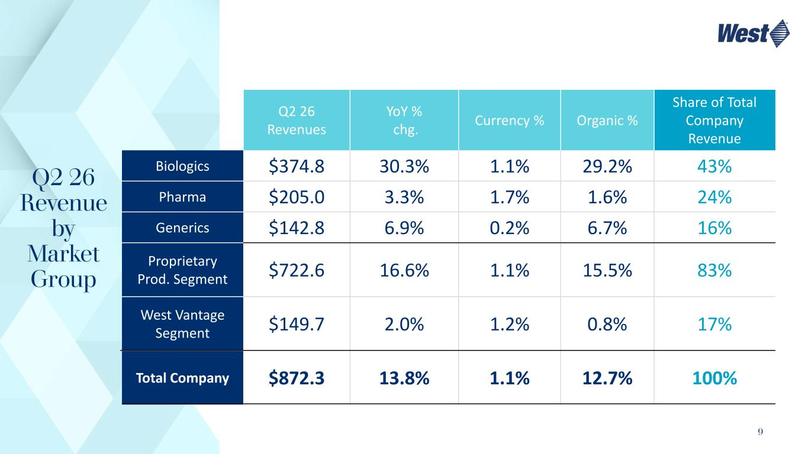
9 Q2 26 Revenue by Market Group Q2 26 Revenues YoY % chg. Currency % Organic % Share of Total Company Revenue Biologics $374.8 30.3% 1.1% 29.2% 43% Pharma $205.0 3.3% 1.7% 1.6% 24% Generics $142.8 6.9% 0.2% 6.7% 16% Proprietary Prod. Segment $722.6 16.6% 1.1% 15.5% 83% West Vantage Segment $149.7 2.0% 1.2% 0.8% 17% Total Company $872.3 13.8% 1.1% 12.7% 100%

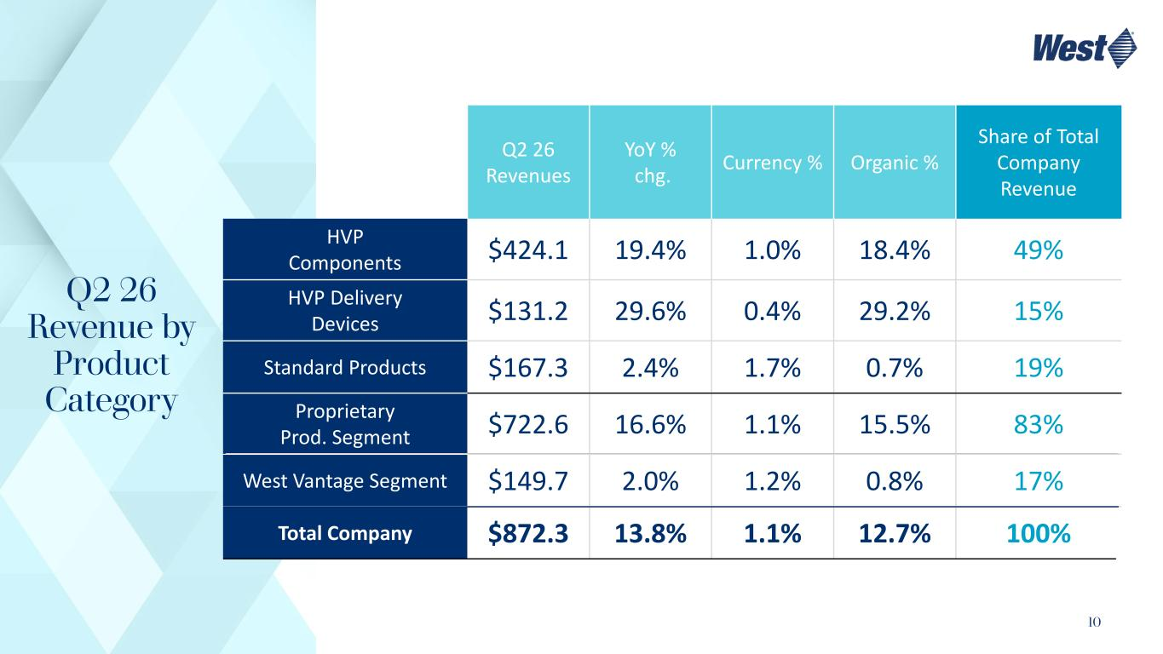
10 Q2 26 Revenue by Product Category Q2 26 Revenues YoY % chg. Currency % Organic % Share of Total Company Revenue HVP Components $424.1 19.4% 1.0% 18.4% 49% HVP Delivery Devices $131.2 29.6% 0.4% 29.2% 15% Standard Products $167.3 2.4% 1.7% 0.7% 19% Proprietary Prod. Segment $722.6 16.6% 1.1% 15.5% 83% West Vantage Segment $149.7 2.0% 1.2% 0.8% 17% Total Company $872.3 13.8% 1.1% 12.7% 100%

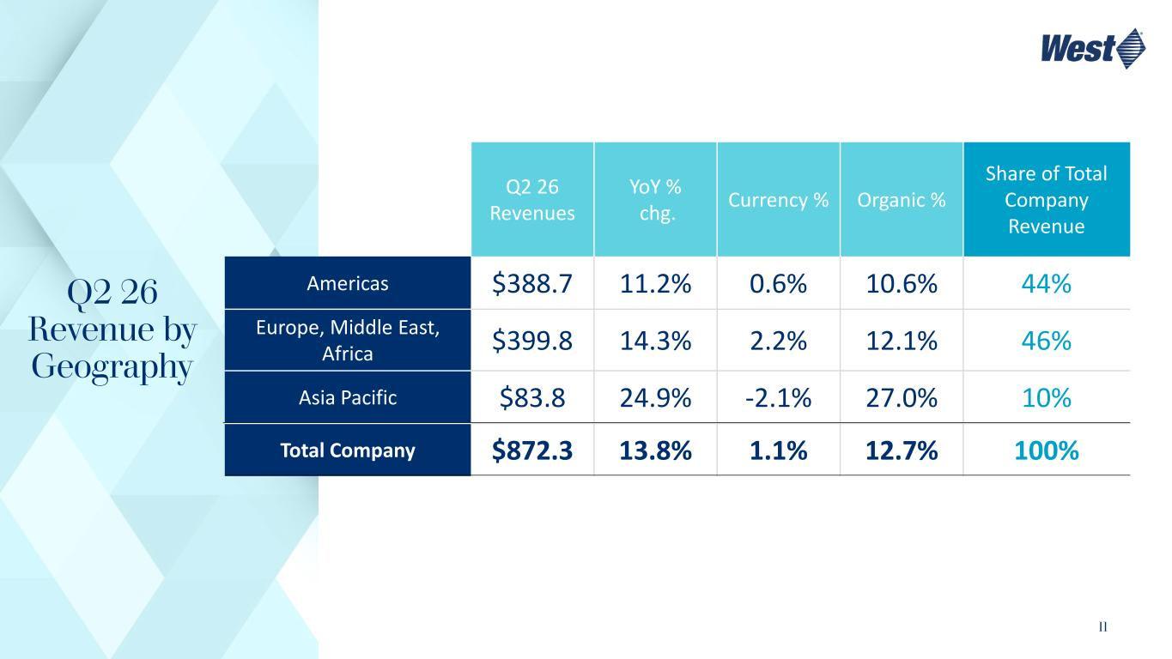
11 Q2 26 Revenue by Geography Q2 26 Revenues YoY % chg. Currency % Organic % Share of Total Company Revenue Americas $388.7 11.2% 0.6% 10.6% 44% Europe, Middle East, Africa $399.8 14.3% 2.2% 12.1% 46% Asia Pacific $83.8 24.9% -2.1% 27.0% 10% Total Company $872.3 13.8% 1.1% 12.7% 100%

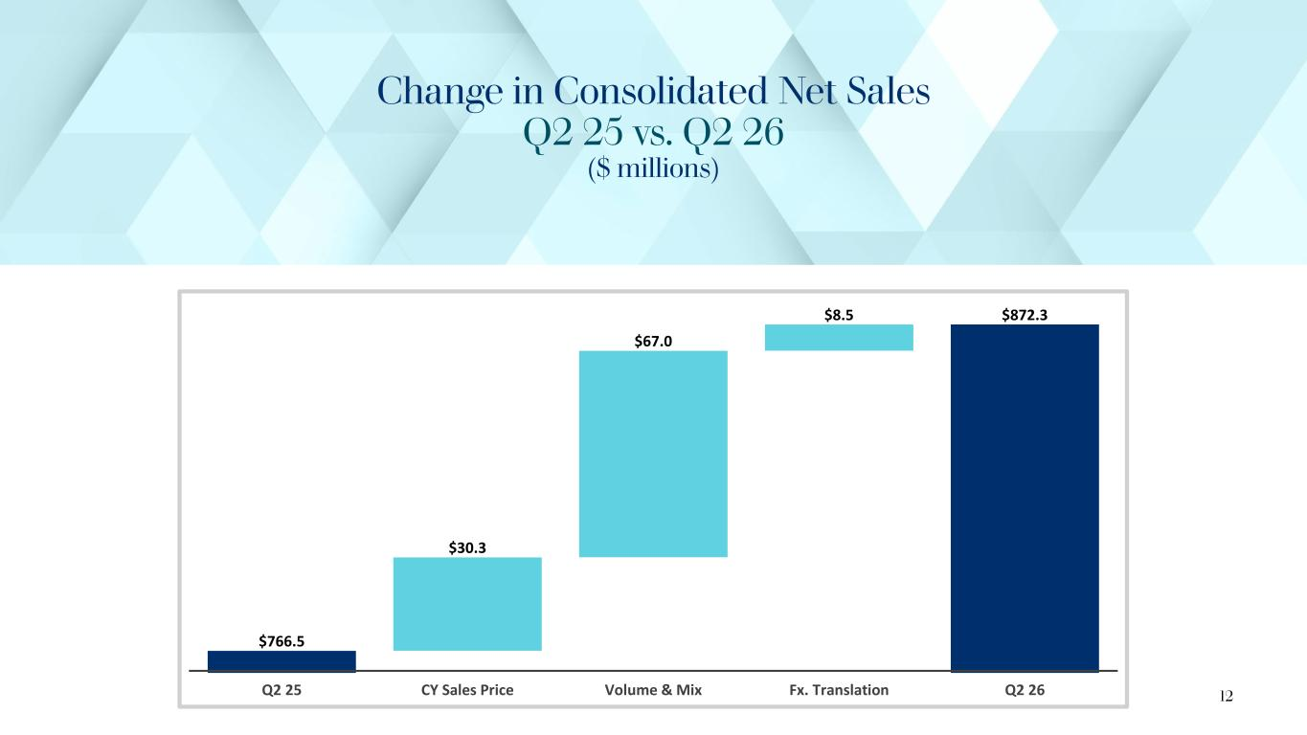
Change in Consolidated Net Sales Q2 25 vs. Q2 26 ($ millions) $766.5 $30.3 $67.0 $8.5 $872.3 Q2 25 CY Sales Price Volume & Mix Fx. Translation Q2 26 12

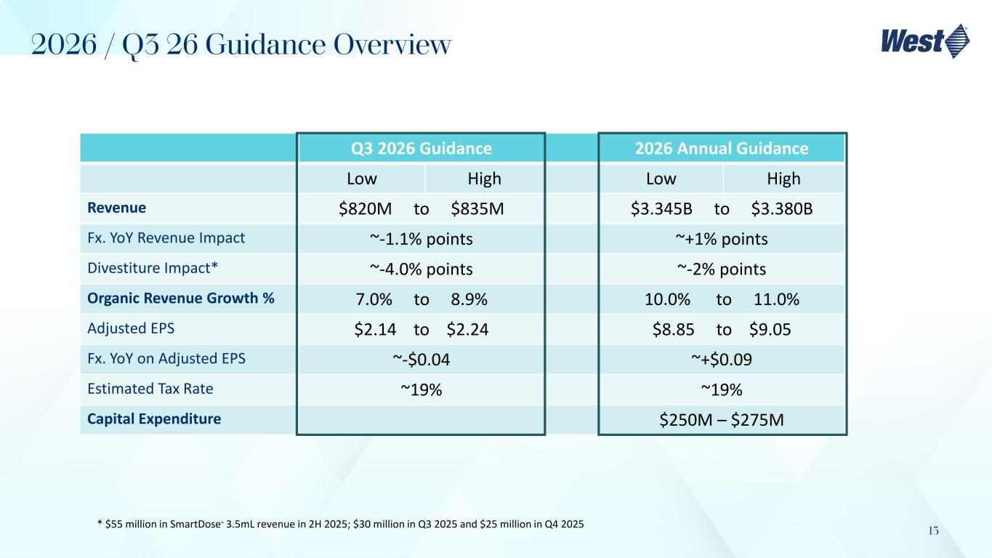
13 Q3 2026 Guidance 2026 Annual Guidance Low High Low High Revenue $820M to $835M $3.345B to $3.380B Fx. YoY Revenue Impact ~-1.1% points ~+1% points Divestiture Impact* ~-4.0% points ~-2% points Organic Revenue Growth % 7.0% to 8.9% 10.0% to 11.0% Adjusted EPS $2.14 to $2.24 $8.85 to $9.05 Fx. YoY on Adjusted EPS ~-$0.04 ~+$0.09 Estimated Tax Rate ~19% ~19% Capital Expenditure $250M – $275M 2026 / Q3 26 Guidance Overview * $55 million in SmartDose® 3.5mL revenue in 2H 2025; $30 million in Q3 2025 and $25 million in Q4 2025


Investor Relations contact: https://investor.westpharma.com /contact-investor-relations www.westpharma.com

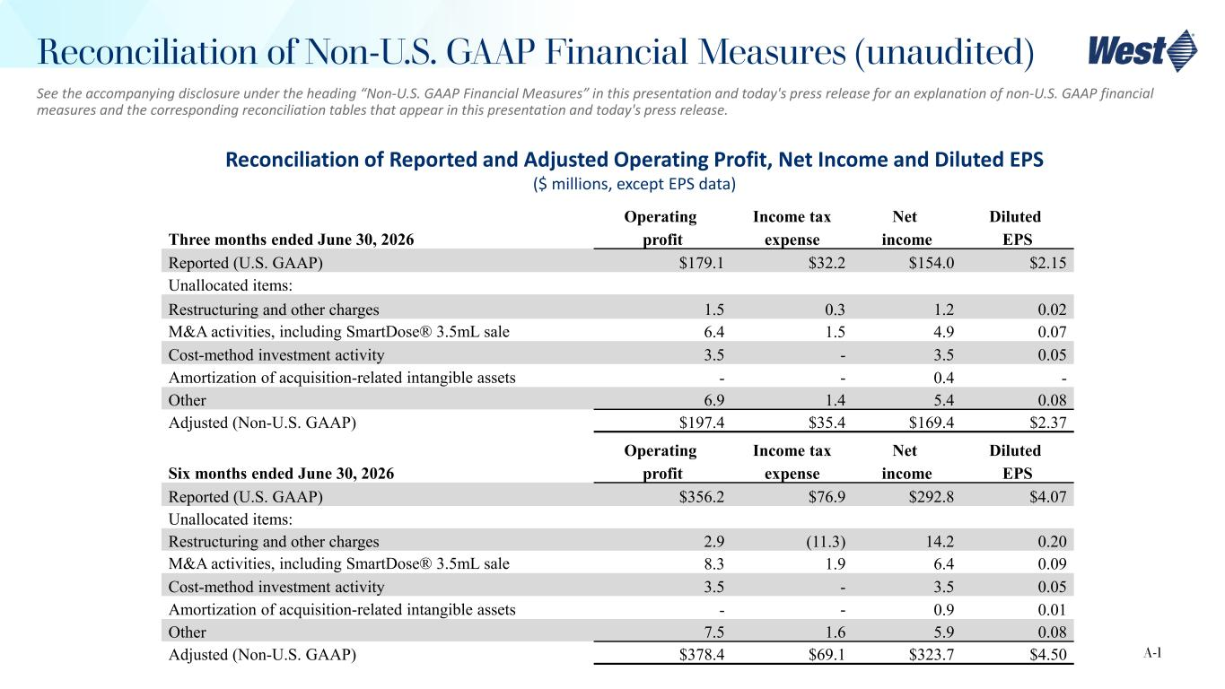
See the accompanying disclosure under the heading “Non-U.S. GAAP Financial Measures” in this presentation and today's press release for an explanation of non-U.S. GAAP financial measures and the corresponding reconciliation tables that appear in this presentation and today's press release. Reconciliation of Reported and Adjusted Operating Profit, Net Income and Diluted EPS ($ millions, except EPS data) Three months ended June 30, 2026 Operating profit Income tax expense Net income Diluted EPS Reported (U.S. GAAP) $179.1 $32.2 $154.0 $2.15 Unallocated items: Restructuring and other charges 1.5 0.3 1.2 0.02 M&A activities, including SmartDose® 3.5mL sale 6.4 1.5 4.9 0.07 Cost-method investment activity 3.5 - 3.5 0.05 Amortization of acquisition-related intangible assets - - 0.4 - Other 6.9 1.4 5.4 0.08 Adjusted (Non-U.S. GAAP) $197.4 $35.4 $169.4 $2.37 A-1 Reconciliation of Non-U.S. GAAP Financial Measures (unaudited) Six months ended June 30, 2026 Operating profit Income tax expense Net income Diluted EPS Reported (U.S. GAAP) $356.2 $76.9 $292.8 $4.07 Unallocated items: Restructuring and other charges 2.9 (11.3) 14.2 0.20 M&A activities, including SmartDose® 3.5mL sale 8.3 1.9 6.4 0.09 Cost-method investment activity 3.5 - 3.5 0.05 Amortization of acquisition-related intangible assets - - 0.9 0.01 Other 7.5 1.6 5.9 0.08 Adjusted (Non-U.S. GAAP) $378.4 $69.1 $323.7 $4.50

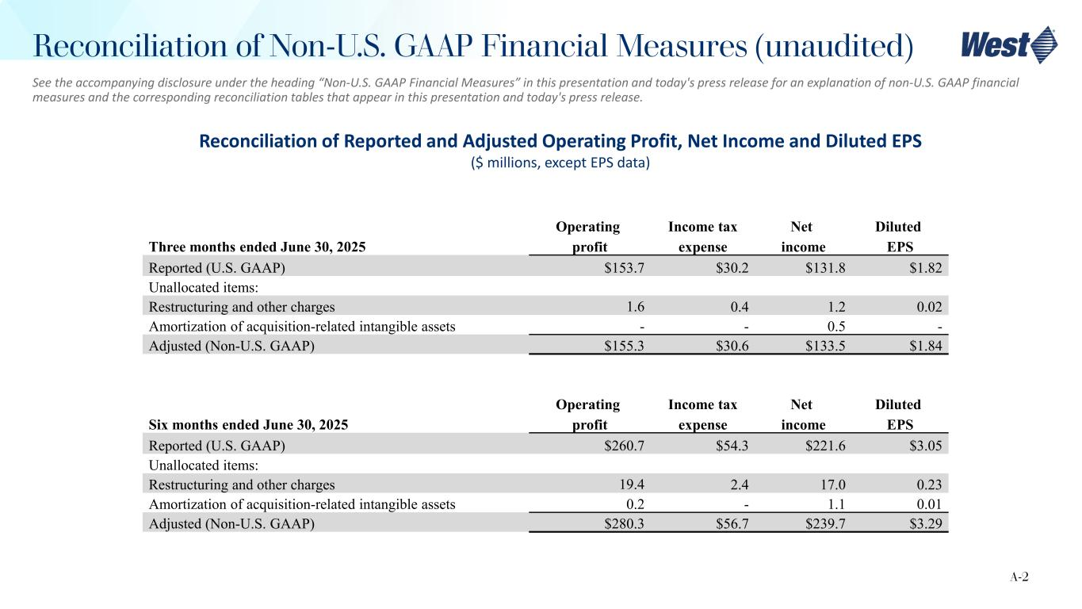
See the accompanying disclosure under the heading “Non-U.S. GAAP Financial Measures” in this presentation and today's press release for an explanation of non-U.S. GAAP financial measures and the corresponding reconciliation tables that appear in this presentation and today's press release. Reconciliation of Reported and Adjusted Operating Profit, Net Income and Diluted EPS ($ millions, except EPS data) Six months ended June 30, 2025 Operating profit Income tax expense Net income Diluted EPS Reported (U.S. GAAP) $260.7 $54.3 $221.6 $3.05 Unallocated items: Restructuring and other charges 19.4 2.4 17.0 0.23 Amortization of acquisition-related intangible assets 0.2 - 1.1 0.01 Adjusted (Non-U.S. GAAP) $280.3 $56.7 $239.7 $3.29 A-2 Reconciliation of Non-U.S. GAAP Financial Measures (unaudited) Three months ended June 30, 2025 Operating profit Income tax expense Net income Diluted EPS Reported (U.S. GAAP) $153.7 $30.2 $131.8 $1.82 Unallocated items: Restructuring and other charges 1.6 0.4 1.2 0.02 Amortization of acquisition-related intangible assets - - 0.5 - Adjusted (Non-U.S. GAAP) $155.3 $30.6 $133.5 $1.84

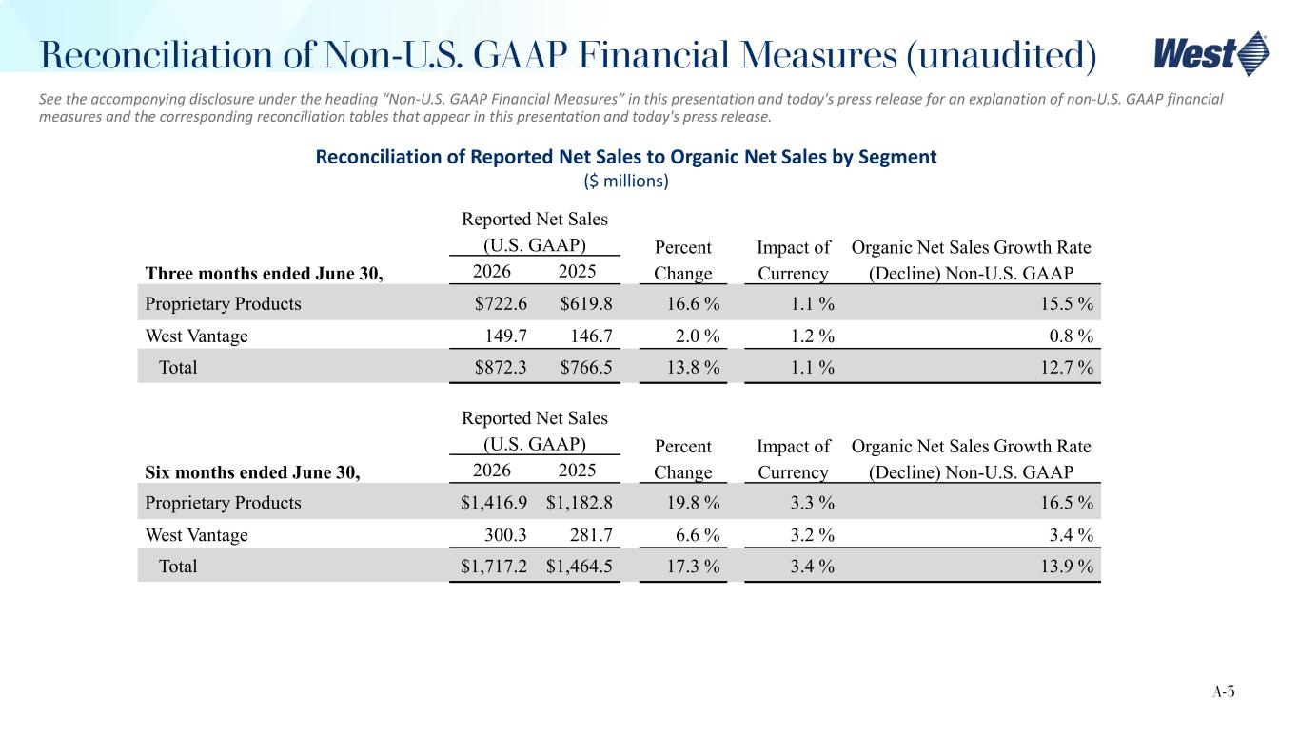
Reconciliation of Reported Net Sales to Organic Net Sales by Segment ($ millions) Three months ended June 30, Reported Net Sales (U.S. GAAP) Percent Change Impact of Currency Organic Net Sales Growth Rate (Decline) Non-U.S. GAAP2026 2025 Proprietary Products $722.6 $619.8 16.6 % 1.1 % 15.5 % West Vantage 149.7 146.7 2.0 % 1.2 % 0.8 % Total $872.3 $766.5 13.8 % 1.1 % 12.7 % A-3 Reconciliation of Non-U.S. GAAP Financial Measures (unaudited) See the accompanying disclosure under the heading “Non-U.S. GAAP Financial Measures” in this presentation and today's press release for an explanation of non-U.S. GAAP financial measures and the corresponding reconciliation tables that appear in this presentation and today's press release. Six months ended June 30, Reported Net Sales (U.S. GAAP) Percent Change Impact of Currency Organic Net Sales Growth Rate (Decline) Non-U.S. GAAP2026 2025 Proprietary Products $1,416.9 $1,182.8 19.8 % 3.3 % 16.5 % West Vantage 300.3 281.7 6.6 % 3.2 % 3.4 % Total $1,717.2 $1,464.5 17.3 % 3.4 % 13.9 %

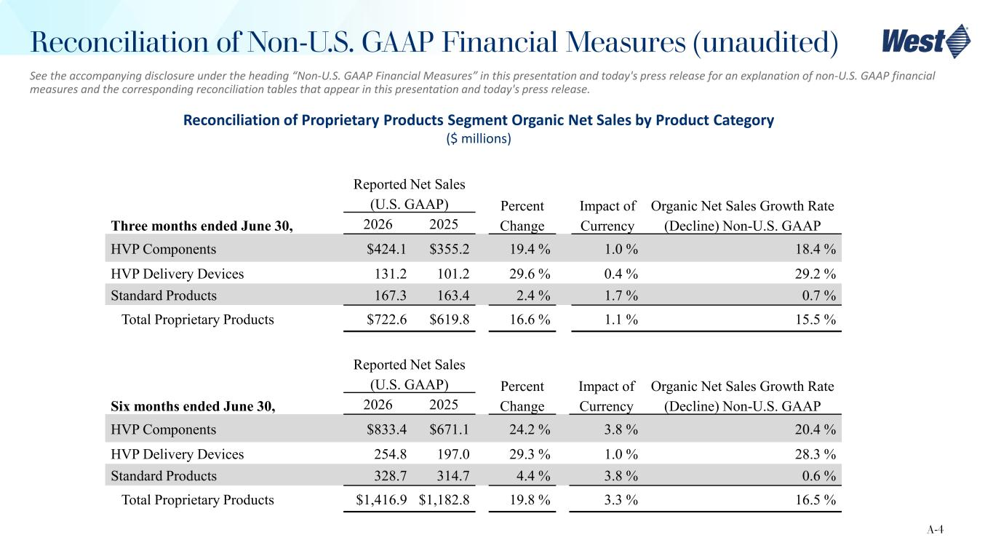
Reconciliation of Proprietary Products Segment Organic Net Sales by Product Category ($ millions) Six months ended June 30, Reported Net Sales (U.S. GAAP) Percent Change Impact of Currency Organic Net Sales Growth Rate (Decline) Non-U.S. GAAP2026 2025 HVP Components $833.4 $671.1 24.2 % 3.8 % 20.4 % HVP Delivery Devices 254.8 197.0 29.3 % 1.0 % 28.3 % Standard Products 328.7 314.7 4.4 % 3.8 % 0.6 % Total Proprietary Products $1,416.9 $1,182.8 19.8 % 3.3 % 16.5 % A-4 Reconciliation of Non-U.S. GAAP Financial Measures (unaudited) See the accompanying disclosure under the heading “Non-U.S. GAAP Financial Measures” in this presentation and today's press release for an explanation of non-U.S. GAAP financial measures and the corresponding reconciliation tables that appear in this presentation and today's press release. Three months ended June 30, Reported Net Sales (U.S. GAAP) Percent Change Impact of Currency Organic Net Sales Growth Rate (Decline) Non-U.S. GAAP2026 2025 HVP Components $424.1 $355.2 19.4 % 1.0 % 18.4 % HVP Delivery Devices 131.2 101.2 29.6 % 0.4 % 29.2 % Standard Products 167.3 163.4 2.4 % 1.7 % 0.7 % Total Proprietary Products $722.6 $619.8 16.6 % 1.1 % 15.5 %

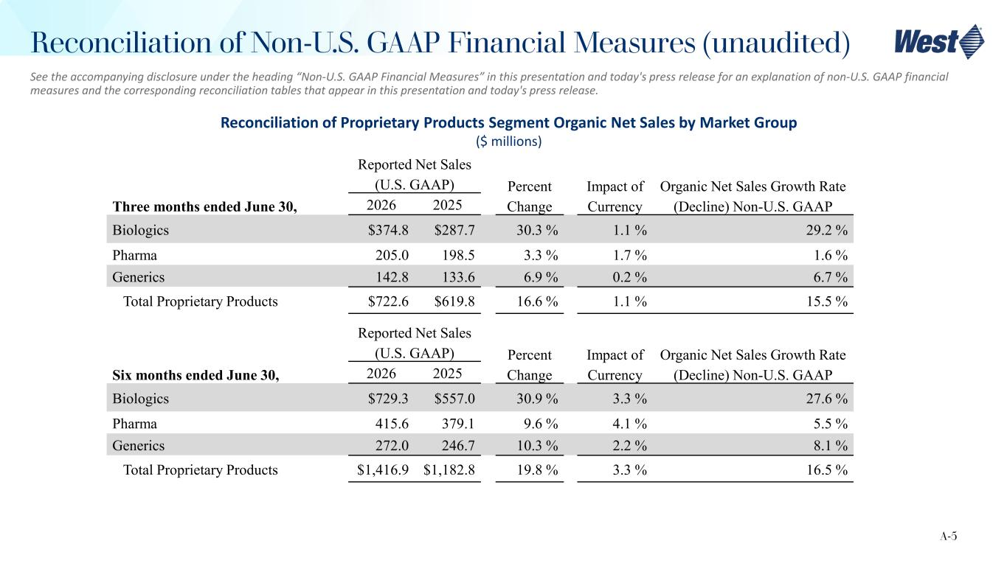
Reconciliation of Proprietary Products Segment Organic Net Sales by Market Group ($ millions) Three months ended June 30, Reported Net Sales (U.S. GAAP) Percent Change Impact of Currency Organic Net Sales Growth Rate (Decline) Non-U.S. GAAP2026 2025 Biologics $374.8 $287.7 30.3 % 1.1 % 29.2 % Pharma 205.0 198.5 3.3 % 1.7 % 1.6 % Generics 142.8 133.6 6.9 % 0.2 % 6.7 % Total Proprietary Products $722.6 $619.8 16.6 % 1.1 % 15.5 % A-5 See the accompanying disclosure under the heading “Non-U.S. GAAP Financial Measures” in this presentation and today's press release for an explanation of non-U.S. GAAP financial measures and the corresponding reconciliation tables that appear in this presentation and today's press release. Reconciliation of Non-U.S. GAAP Financial Measures (unaudited) Six months ended June 30, Reported Net Sales (U.S. GAAP) Percent Change Impact of Currency Organic Net Sales Growth Rate (Decline) Non-U.S. GAAP2026 2025 Biologics $729.3 $557.0 30.9 % 3.3 % 27.6 % Pharma 415.6 379.1 9.6 % 4.1 % 5.5 % Generics 272.0 246.7 10.3 % 2.2 % 8.1 % Total Proprietary Products $1,416.9 $1,182.8 19.8 % 3.3 % 16.5 %

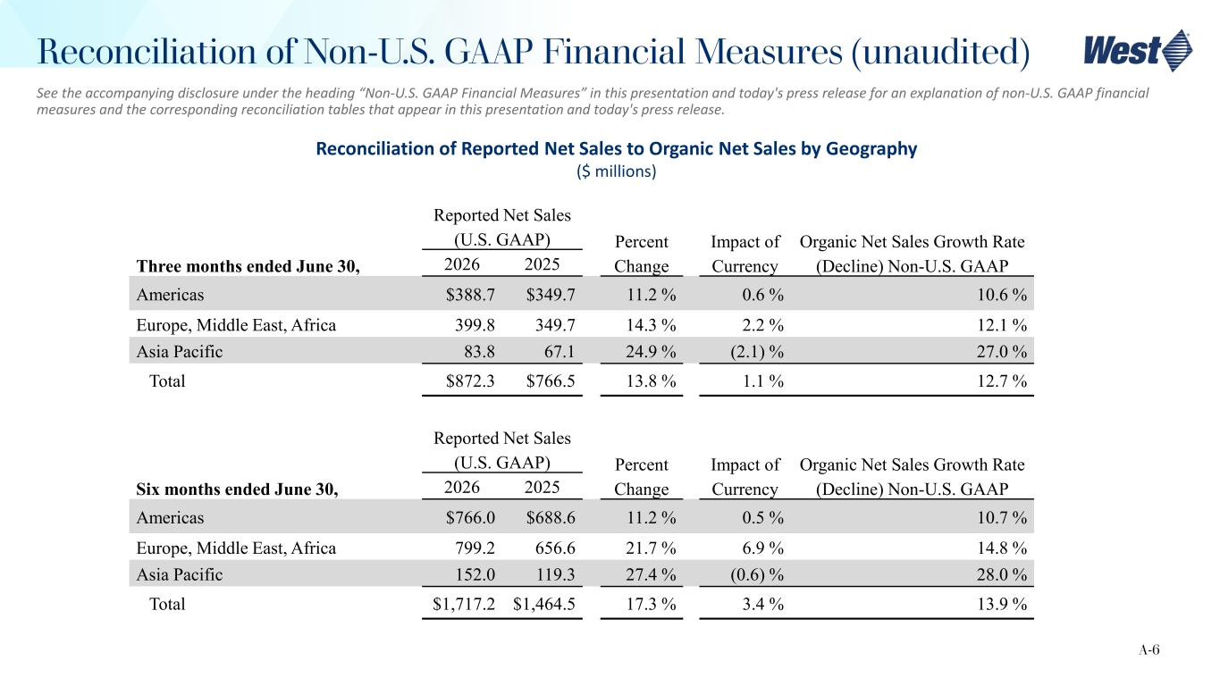
Reconciliation of Reported Net Sales to Organic Net Sales by Geography ($ millions) Six months ended June 30, Reported Net Sales (U.S. GAAP) Percent Change Impact of Currency Organic Net Sales Growth Rate (Decline) Non-U.S. GAAP2026 2025 Americas $766.0 $688.6 11.2 % 0.5 % 10.7 % Europe, Middle East, Africa 799.2 656.6 21.7 % 6.9 % 14.8 % Asia Pacific 152.0 119.3 27.4 % (0.6) % 28.0 % Total $1,717.2 $1,464.5 17.3 % 3.4 % 13.9 % A-6 See the accompanying disclosure under the heading “Non-U.S. GAAP Financial Measures” in this presentation and today's press release for an explanation of non-U.S. GAAP financial measures and the corresponding reconciliation tables that appear in this presentation and today's press release. Reconciliation of Non-U.S. GAAP Financial Measures (unaudited) Three months ended June 30, Reported Net Sales (U.S. GAAP) Percent Change Impact of Currency Organic Net Sales Growth Rate (Decline) Non-U.S. GAAP2026 2025 Americas $388.7 $349.7 11.2 % 0.6 % 10.6 % Europe, Middle East, Africa 399.8 349.7 14.3 % 2.2 % 12.1 % Asia Pacific 83.8 67.1 24.9 % (2.1) % 27.0 % Total $872.3 $766.5 13.8 % 1.1 % 12.7 %

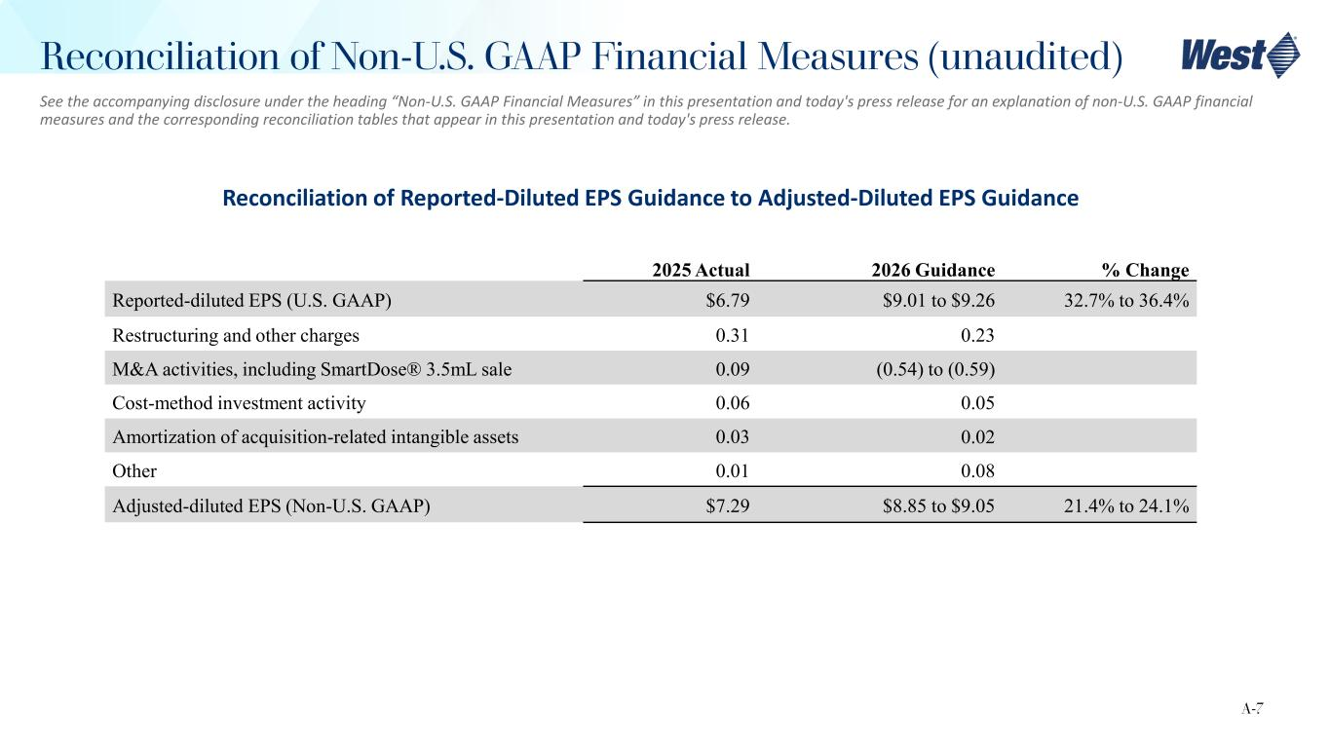
Reconciliation of Reported-Diluted EPS Guidance to Adjusted-Diluted EPS Guidance 2025 Actual 2026 Guidance % Change Reported-diluted EPS (U.S. GAAP) $6.79 $9.01 to $9.26 32.7% to 36.4% Restructuring and other charges 0.31 0.23 M&A activities, including SmartDose® 3.5mL sale 0.09 (0.54) to (0.59) Cost-method investment activity 0.06 0.05 Amortization of acquisition-related intangible assets 0.03 0.02 Other 0.01 0.08 Adjusted-diluted EPS (Non-U.S. GAAP) $7.29 $8.85 to $9.05 21.4% to 24.1% A-7 Reconciliation of Non-U.S. GAAP Financial Measures (unaudited) See the accompanying disclosure under the heading “Non-U.S. GAAP Financial Measures” in this presentation and today's press release for an explanation of non-U.S. GAAP financial measures and the corresponding reconciliation tables that appear in this presentation and today's press release.

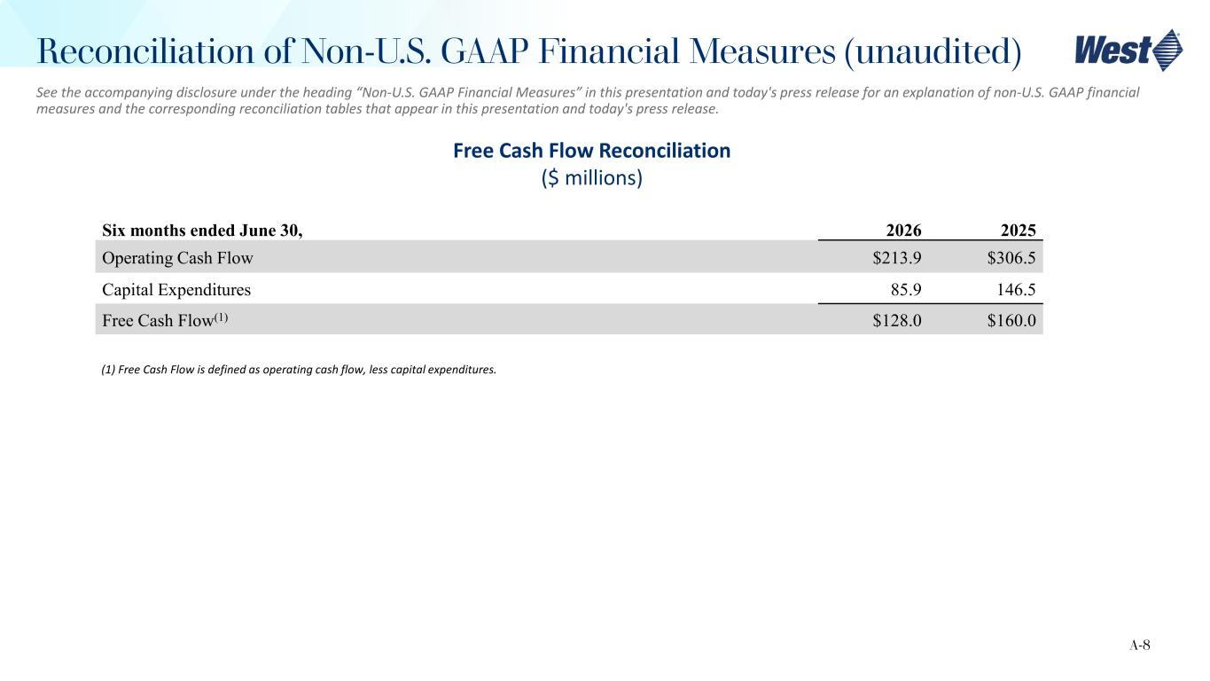
Free Cash Flow Reconciliation ($ millions) Six months ended June 30, 2026 2025 Operating Cash Flow $213.9 $306.5 Capital Expenditures 85.9 146.5 Free Cash Flow(1) $128.0 $160.0 (1) Free Cash Flow is defined as operating cash flow, less capital expenditures. A-8 Reconciliation of Non-U.S. GAAP Financial Measures (unaudited) See the accompanying disclosure under the heading “Non-U.S. GAAP Financial Measures” in this presentation and today's press release for an explanation of non-U.S. GAAP financial measures and the corresponding reconciliation tables that appear in this presentation and today's press release.

