UNITED STATES
SECURITIES AND EXCHANGE COMMISSION
Washington, D.C. 20549

FORM 8-K

CURRENT REPORT
Pursuant to Section 13 or 15(d) of The Securities Exchange Act of 1934

Date of Report (Date of earliest event reported) – May 7, 2026

WEST PHARMACEUTICAL SERVICES, INC.
(Exact name of registrant as specified in its charter)
Pennsylvania |  |  |  |  |  | 1-8036 |  |  |  |  |  | 23-1210010
(State or other jurisdiction  of incorporation) |  |  |  |  |  | (Commission File Number) |  |  |  |  |  | (IRS Employer  Identification No.)
530 Herman O. West Drive, Exton, PA |  |  |  |  |  |  |  |  |  |  |  | 19341-1147
(Address of principal executive offices) |  |  |  |  |  |  |  |  |  |  |  | (Zip Code)
Registrant’s telephone number, including area code: 610-594-2900
Not Applicable
(Former name or address, if changed since last report.)
Check the appropriate box below if the Form 8-K filing is intended to simultaneously satisfy the filing obligation of the registrant under any of the following provisions (see General Instruction A.2. below):
☐ |  |  | Written communications pursuant to Rule 425 under the Securities Act (17 CFR 230.425)
☐ |  |  | Soliciting material pursuant to Rule 14a-12 under the Exchange Act (17 CFR 240.14a-12)
☐ |  |  | Pre-commencement communications pursuant to Rule 14d-2(b) under the Exchange Act (17 CFR 240.14d-2(b))
☐ |  |  | Pre-commencement communications pursuant to Rule 13e-4(c) under the Exchange Act (17 CFR 240.13e-4(c))
Securities registered pursuant to Section 12(b) of the Act:
Title of each class |  |  | Trading Symbol |  |  | Name of each exchange on which registered
Common Stock, par value $0.25 per share |  |  | WST |  |  | New York Stock Exchange
Indicate by check mark whether the registrant is an emerging growth company as defined in Rule 405 of the Securities Act of 1933 (§230.405 of this chapter) or Rule 12b-2 of the Securities Exchange Act of 1934 (§240.12b-2 of this chapter).
Emerging growth company ☐
If an emerging growth company, indicate by check mark if the registrant has elected not to use the extended transition period for complying with any new or revised financial accounting standards provided pursuant to Section 13(a) of the Exchange Act. ☐

1

Item 1.05 Material Cybersecurity Incidents.

On May 7, 2026, West Pharmaceutical Services, Inc. (the “Company”) determined that the Company has experienced a material cybersecurity attack, in which certain data was exfiltrated by an unauthorized party and certain systems were encrypted. Upon initial detection of an intrusion on May 4, 2026, the Company promptly activated its incident response protocols, including proactively taking systems offline globally for containment purposes, notifying law enforcement, and engaging external cyber-forensic experts. The Company’s investigation into the nature and scope of the incident remains ongoing, including the extent of the data affected. The Company has taken steps intended to mitigate the risk of dissemination of the exfiltrated data.

The incident and the Company’s proactive response have temporarily disrupted the Company’s business operations globally. While the Company has restored its core enterprise systems, and critical processes for shipping, receiving, and manufacturing have restarted at some sites with restoration of the remaining sites in process, the timeline for a complete restoration has not yet been finalized.

The incident’s material impact on the Company’s financial condition and results of operations, if any, has not been determined at the time of filing.

Forward-Looking Statements

This Current Report on Form 8-K contains forward-looking statements within the meaning of the Private Securities Litigation Reform Act of 1995, including, but not limited to, statements regarding the Company's expectations regarding future events, actions or performance related to the cybersecurity incident, including the results of the Company’s ongoing investigation thereof and the impact of the cybersecurity incident on the Company, and its financial or operational performance. Forward-looking statements may be identified by words such as "believe," "expect," "intend," "estimate," "plan," "anticipate," "project," "forecast," "guidance," "target," "may," "will," "continue" and similar expressions.

These statements are based on current expectations and assumptions and are subject to risks and uncertainties that could cause actual results to differ materially from those expressed or implied by such forward-looking statements. For additional information regarding these risks as well as other risks, uncertainties and factors that could affect our forward-looking statements, please refer to Part I Item 1A, entitled "Risk Factors," of the Company's most recent Annual Report on Form 10-K and any amendments thereto, as well as the Company's most recently filed Quarterly Reports on Form 10-Q and other filings the Company makes with the Securities and Exchange Commission.

Forward-looking statements speak only as of the date of this Current Report on Form 8-K. Except as required by law or regulation, West Pharmaceutical Services, Inc. undertakes no obligation to update or revise any forward-looking statements, whether as a result of new information, future events or otherwise.

Item 7.01 Regulation FD Disclosure.

A copy of the Company’s statement on its website regarding this matter is furnished as Exhibit 99.1 to this report and is incorporated into this Item 7.01 by reference thereto.

The information in this Item 7.01 of this Current Report on Form 8-K, including the exhibit furnished pursuant to Item 99.1, shall not be deemed “filed” for the purposes of Section 18 of the Securities Exchange Act of 1934, as amended (the “Exchange Act”) or otherwise subject to the liabilities under that Section. Furthermore, the information in this Item 7.01 of this Current Report on Form 8-K, including the exhibit furnished pursuant to Item 99.1, shall not be deemed to be incorporated by reference into the filings of the Company under the Securities Act of 1933, as amended, or the Exchange Act, regardless of any general incorporation language contained in such filing.

Item 9.01 Financial Statements and Exhibits.
(d) |  |  | Exhibit No. |  |  | Description
 |  |  | 99.1 |  |  | West Pharmaceutical Services, Inc. Company Website Statement, dated May 11, 2026 (furnished, not filed).
 |  |  | 104 |  |  | The cover page from the Company’s Current Report on Form 8-K, dated May 7, 2026, formatted in Inline XBRL.

2

SIGNATURE

Pursuant to the requirements of the Securities Exchange Act of 1934, the registrant has duly caused this report to be signed on its behalf by the undersigned hereunto duly authorized.

Date: May 11, 2026 |  |  | WEST PHARMACEUTICAL SERVICES, INC.
By: |  |  | /s/ Norman D. Finch Jr.
 |  |  | Norman D. Finch Jr.
 |  |  | Senior Vice President, General Counsel and Corporate Secretary

3

EXHIBIT INDEX

Exhibit No. |  |  |  |  |  | Description
99.1 |  |  |  |  |  | West Pharmaceutical Services, Inc. Company Website Statement, dated May 11, 2026 (furnished, not filed).
104 |  |  |  |  |  | The cover page from the Company’s Current Report on Form 8-K, dated May 7, 2026, formatted in Inline XBRL.
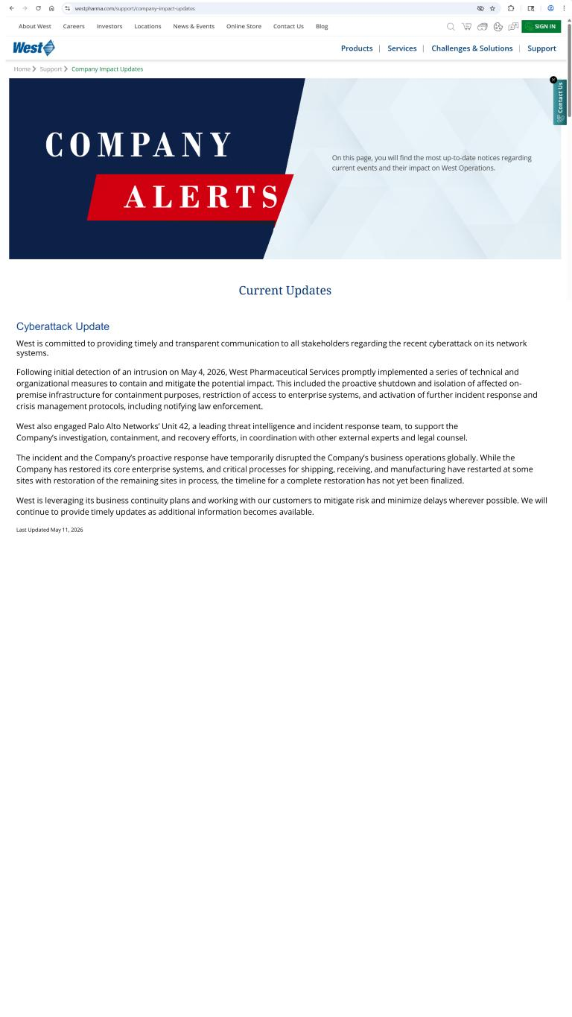
4
West is committed to providing timely and transparent communication to all stakeholders regarding the recent cyberattack on its network systems. Following initial detection of an intrusion on May 4, 2026, West Pharmaceutical Services promptly implemented a series of technical and organizational measures to contain and mitigate the potential impact. This included the proactive shutdown and isolation of affected on- premise infrastructure for containment purposes, restriction of access to enterprise systems, and activation of further incident response and crisis management protocols, including notifying law enforcement. West also engaged Palo Alto Networks’ Unit 42, a leading threat intelligence and incident response team, to support the Company’s investigation, containment, and recovery efforts, in coordination with other external experts and legal counsel. The incident and the Company’s proactive response have temporarily disrupted the Company’s business operations globally. While the Company has restored its core enterprise systems, and critical processes for shipping, receiving, and manufacturing have restarted at some sites with restoration of the remaining sites in process, the timeline for a complete restoration has not yet been finalized. West is leveraging its business continuity plans and working with our customers to mitigate risk and minimize delays wherever possible. We will continue to provide timely updates as additional information becomes available. Last Updated May 11, 2026 Cyberattack Update

